**Mitsubishi Elevator** **Backup and restoration**

**To**

|  |
| --- |
| [Mitsubishi eyes 20 percent market share in elevator space](https://www.google.com/url?sa=i&url=https://www.freepressjournal.in/business/mitsubishi-eyes-20-percent-market-share-in-elevator-space&psig=AOvVaw0-LeAlLOs6ajs5Qq1W-xae&ust=1605778826375000&source=images&cd=vfe&ved=0CAIQjRxqFwoTCLiQ47fmi-0CFQAAAAAdAAAAABAD) |

**Document version 1.0**

**By**



**CLASSIFICATION: C ONFIDENTIAL**

**ATTENTION:**

**This proposal contains information from DigitalTrack Solutions that is confidential and privileged. The information is intended for the private use of Mitsubishi Elevator By accepting this proposal, you agree to keep the contents in confidence and not copy, disclose, or distribute this without written request to and written confirmation from Digital Track Solutions Pvt Ltd. If you are not the intended recipient, be aware that any disclosure, copying, or distribution of the contents of this document is prohibited.**

**Document information:**

|  |  |
| --- | --- |
| **Company** | **DigitalTrack solution Pvt Ltd.** |
| **Document Title** | **Backup and restoration** |
| **Customer Name** | **Mitsubishi Elevator India Pvt Limited** |
| **Date** | **29 Mar 2022** |
| **Location** | **Bangalore** |
| **No of Pages** | **96** |
| **Document Type** | **General** |

|  |  |  |  |
| --- | --- | --- | --- |
| **Document History** | | | |
| **Date** | Version | Name | Notes |
| 29/03/2022 | V 1.0 |  | Mitsubishi elevator backup and Restoration Plan |

**Index:**

|  |  |  |
| --- | --- | --- |
| **S/L No.** | **Description** | **Page No.** |
| 1 | **Executive Summary** | 4 |
| 2 | **Summary of Present Backup** | 5 |
| 3 | **List of VHD and Data Base Backup Restored.** | 6 |
| 4 | **Primary AD VHD Backup Restoration Process** | 7 - 14 |
| 5 | **Secondary AD VHD Backup Restoration Process** | 15 – 20 |
| 6 | **Exchange Mail VHD Backup Restoration Process** | 21 – 29 |
| 7 | **Exchange Mail Client Access VHD Backup Restoration Process** | 30 – 35 |
| 8 | **Veritas Tape Backup Restoration Process** | 36 – 49 |
| 9 | **IMPAS Application VHD Backup Restoration Process** | 50 - 56 |
| 10 | **Web proxy IWSVA VHD Backup Restoration Process** | 57 - 61 |
| 11 | **Antivirus-New VHD Backup Restoration Process** | 62 - 68 |
| 12 | **IMPAS Data Base (imec-DB2) & Trend Encryption: DB1 Restoration Process** | 69 – 81 |
| 13 | **IMEC-MDM VHD Backup Restoration Process** | 82 - 88 |
| 14 | **Veritas file Server Backup Restoration Process** | 89 - 96 |

**1.Executive Summary:**

We wish to thank **Mitsubishi Elevator Pvt. Ltd** for inviting us to propose the **Backup and restoration.**

This report describes the Solution for the **Backup and restoration.**

Digital Track Solutions is specialized in providing Information Security & Storage Solutions and services.

Digital Track Solutions customer base is more than 1000 customers across diverse industries such as Government, ISP’s, Banking & Financial institutions, Airlines and Large Corporates.

Digital Track Solutions offers holistic Enterprise Security Technology solutions covering all areas such as Content/Data and Application Security, Infrastructure Security, Identity Life-cycle Management, Security and Vulnerability Management leading to Governance.

Digital Track Solutions, being a vendor neutral organization has a basket of technologies and has handpicked selected technologies from the basket which are best of breed and specialized in specific areas.

We value the trust you place in a business relationship with us.

Thank you.

**2.Summary of Present Backup**

|  |  |  |  |  |  |  |  |
| --- | --- | --- | --- | --- | --- | --- | --- |
| **VM** | **Host** | **VM IP** | **Hosted Application Details** | **Backup Status** | **VHD Backup Online** | **Media** | **VHD Manual Backup Offline** |
| **Number** | **Name** | **Address** | **(Yes / No )** | **(Yes / No )** | **HDD / Tape** | **(Yes / No )** |
| 1 | imec-fabs002 **- No VM** | 10.236.179.131 | Factory File Server / Veritas Application | Yes | No | Tape | No |
| 2 | IMEC-FABV001 | 10.236.179.134 | Secondary AD server | Yes | Yes | Tape |
| 3 | IMEC-FABV002 | 10.236.179.135 | Rom writing server | Yes | Yes | Tape |
| 4 | IMEC-FABV008 | 10.236.179.142 | PDM production | Yes | Yes | Tape |
| 5 | IMEC-FABV009 | 10.236.179.143 | PDM Development | Yes | Yes | Tape |
| 6 | IMEC-FABV010 |  | Tiff Server | Yes | Yes | Tape |
| 7 | IMEC-FABC011 | 10.236.179.150 | IMPAS Data Base (imec-DB2) | Yes | Yes | HDD |
| 8 | IMEC-FABV003 | 10.236.179.136 | AutoCAD drafting tool | No | No | No |
| 9 | IMEC-Impas | 10.236.156.33 | Impas Application server | No | No | HDD | Manual Backup |
| 10 | IMEC-WEBPROXY_NEW | 172.16.0.5 | Webproxy IWSVA | Yes | No | HDD | Manual Backup |
| 11 | IMEC-DB1 | 10.236.156.36 | Trend Encryption | Yes | No | HDD | Manual Backup |
| 12 | IMEC-AD | 10.236.156.30 | Primary AD | No | No | HDD | Manual Backup |
| 13 | IMEC-AV | 10.236.156.32 | Antivirus-New | No | No | HDD | Manual Backup |
| 14 | IMEC-EXCSRV01 | 10.236.156.31 | Exchange Mail | Yes | No | Tape/HDD | Manual Backup |
| 15 | IMEC-EXCSRV02 | 10.236.156.24 | Exchange Client access | No | No | HDD | Manual Backup |
| 16 | IMEC-FS | 10.236.156.35 | File Server | Yes | No | Tape | Manual Backup |
| 17 | IMEC-MDM | 10.236.156.15 | Mobile device | No | No | HDD | Manual Backup |

**3.List of VHD and Data Base Backup Restored.**

|  |  |  |  |  |  |  |
| --- | --- | --- | --- | --- | --- | --- |
| **VM** | **Host** | **VM IP** | **Hosted Application Details** | **Backup Status** | **VHD Backup Online** | **Media** |
| **Number** | **Name** | **Address** | **(Yes / No )** | **(Yes / No )** | **HDD / Tape** |
| 1 | imec-fabs002 **- No VM** | 10.236.179.131 | Factory File Server / Veritas Application | Yes | No | Tape |
| 2 | IMEC-FABV001 | 10.236.179.134 | Secondary AD server | Yes | Yes | Tape |
| 3 | IMEC-FABC011 | 10.236.179.150 | IMPAS Data Base (imec-DB2) | Yes | Yes | HDD |
| 4 | IMEC-Impas | 10.236.156.33 | Impas Application server | No | No | HDD |
| 5 | IMEC-WEBPROXY_NEW | 172.16.0.5 | Webproxy IWSVA | Yes | No | HDD |
| 6 | IMEC-DB1 | 10.236.156.36 | Trend Encryption | Yes | No | HDD |
| 7 | IMEC-AD | 10.236.156.30 | Primary AD | No | No | HDD |
| 8 | IMEC-AV | 10.236.156.32 | Antivirus-New | No | No | HDD |
| 9 | IMEC-EXCSRV01 | 10.236.156.31 | Exchange Mail | Yes | No | Tape/HDD |
| 10 | IMEC-EXCSRV02 | 10.236.156.24 | Exchange Client access | No | No | HDD |
| 11 | IMEC-FS | 10.236.156.35 | File Server | Yes | No | Tape |
| 12 | IMEC-MDM | 10.236.156.15 | Mobile device | No | No | HDD |

**4) Primary AD VHD Backup restoration Process**

|  |  |  |  |  |  |  |  |
| --- | --- | --- | --- | --- | --- | --- | --- |
| Manual Backup Restoration | | | | | | | |
| SL. No | Host Name | Host | VM IP | Operating System | Hosted Application Details | Backup Type | Restoration Time |
| 1 | IMEC-AD | VM | 10.236.156.30 | Server 2008 | AD Server | Manual | 1. mins |

Right click on Hyper-V Manager, select New and Virtual machine.

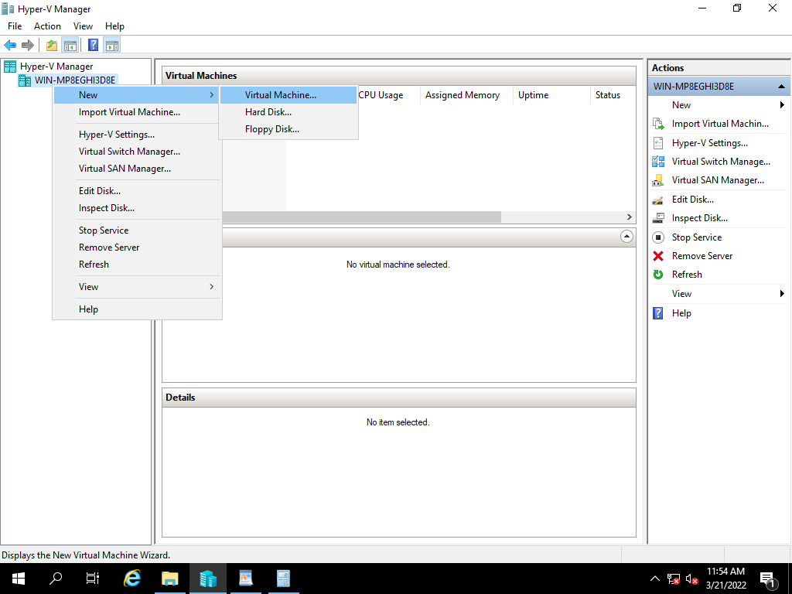

Select Next,

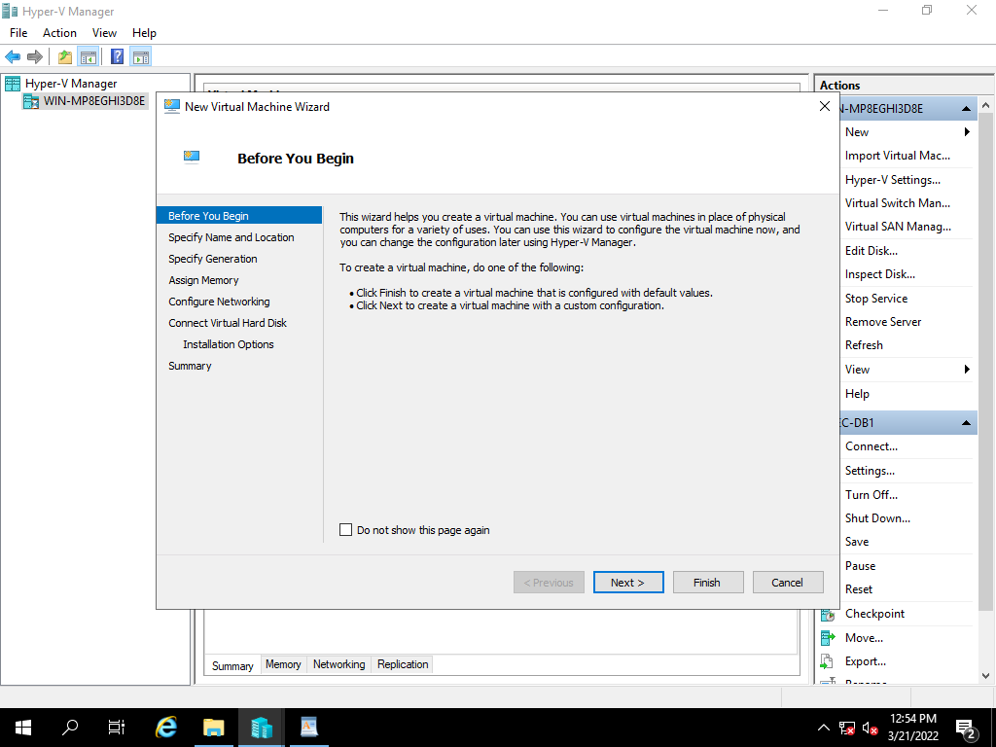

Specify the name of the server and click on Next,

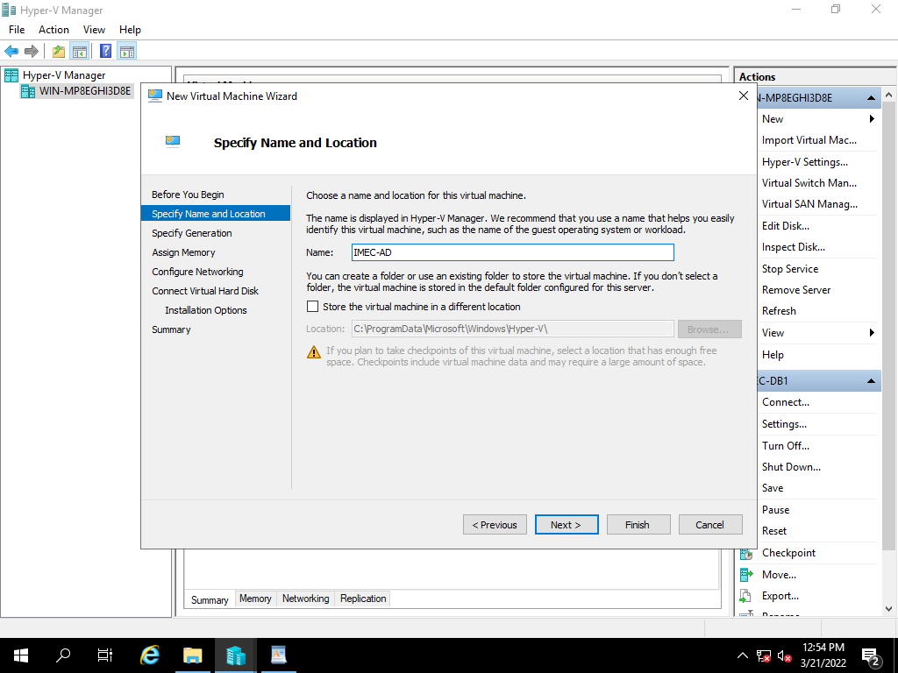

Specify the Generation of virtual machine based on existing, click on Next

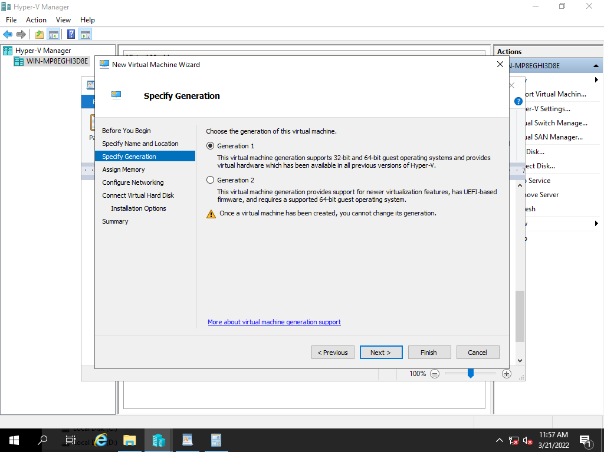

Assign the RAM Size Based on existing server, and click on Next

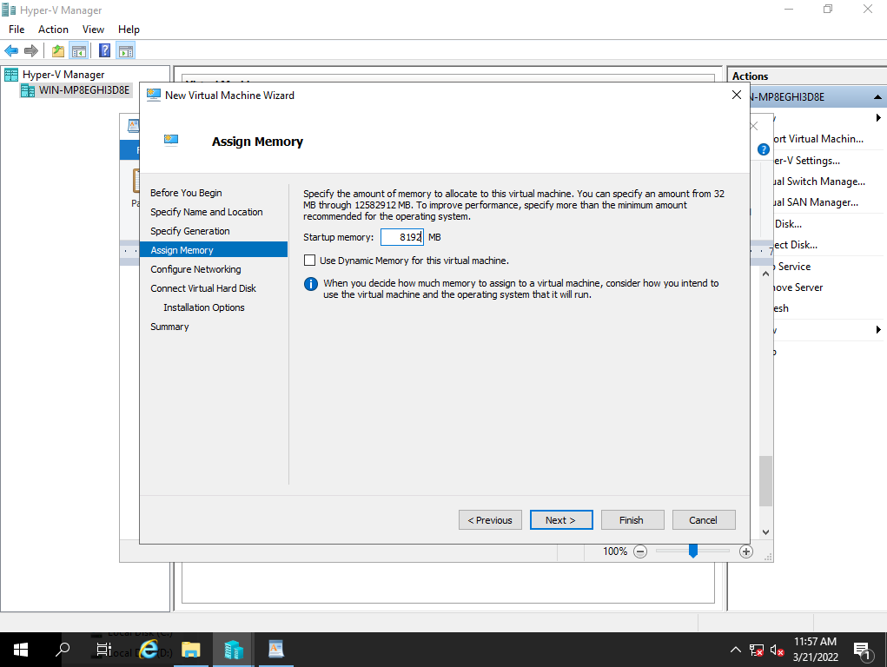

Select the network adopter based on VH Configuration and click on next.

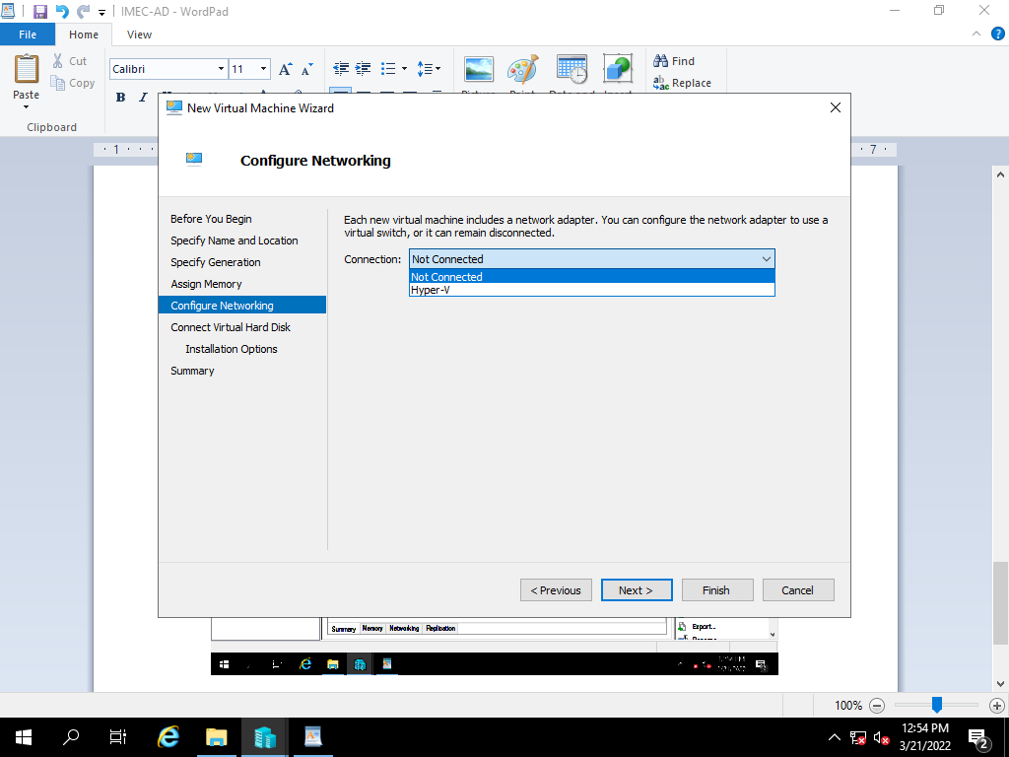

Select the use an existing virtual hard disk option and click on browse.

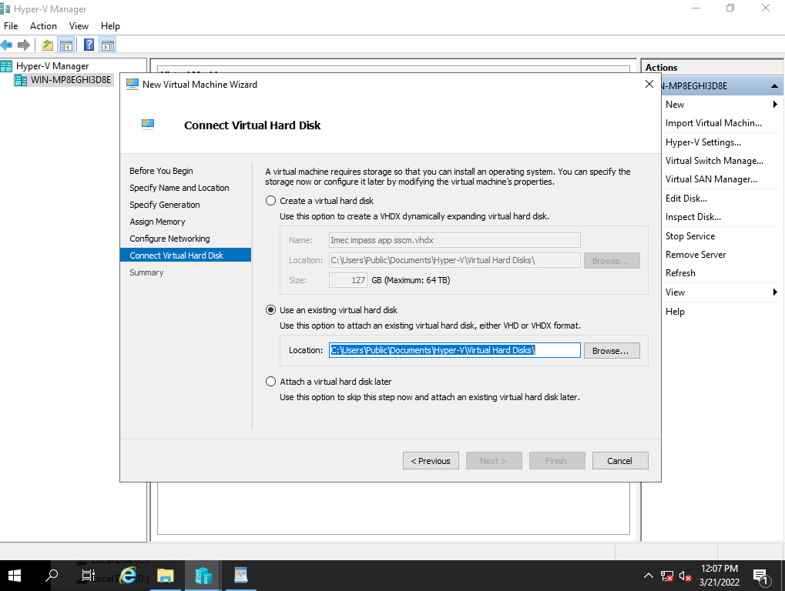

Browse and select the file and click on open

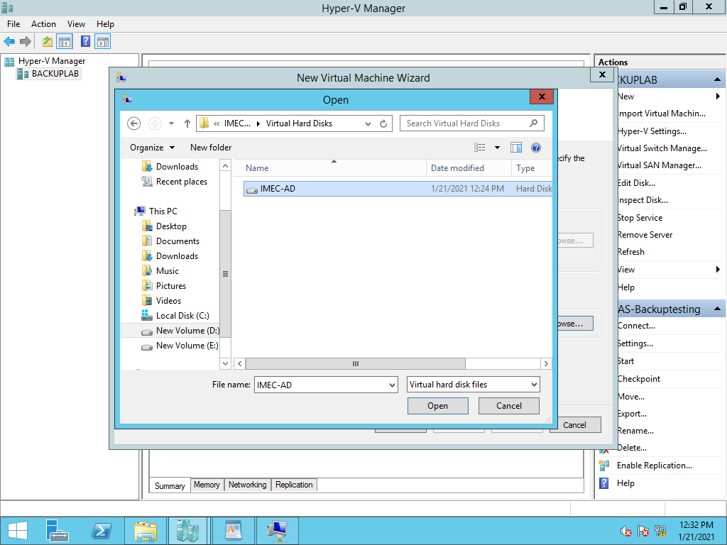

After selecting the file path, click on Next.

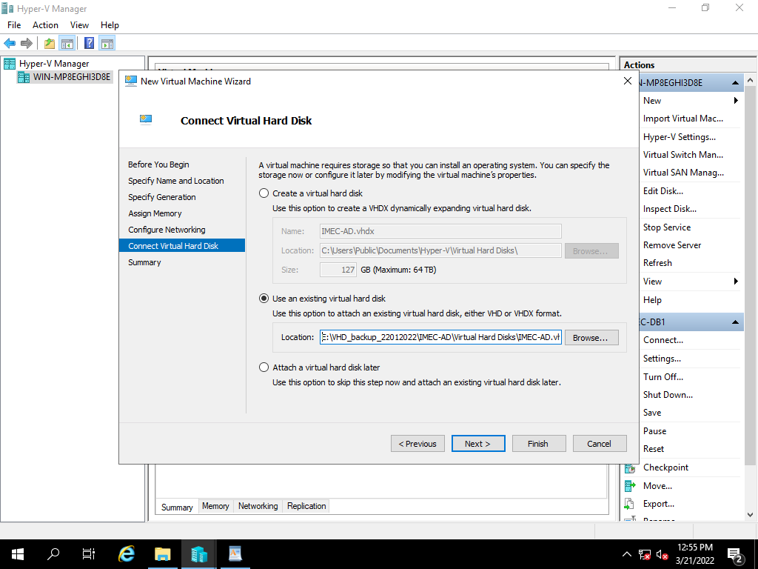

Review the summary and click finish to create a virtual machine.

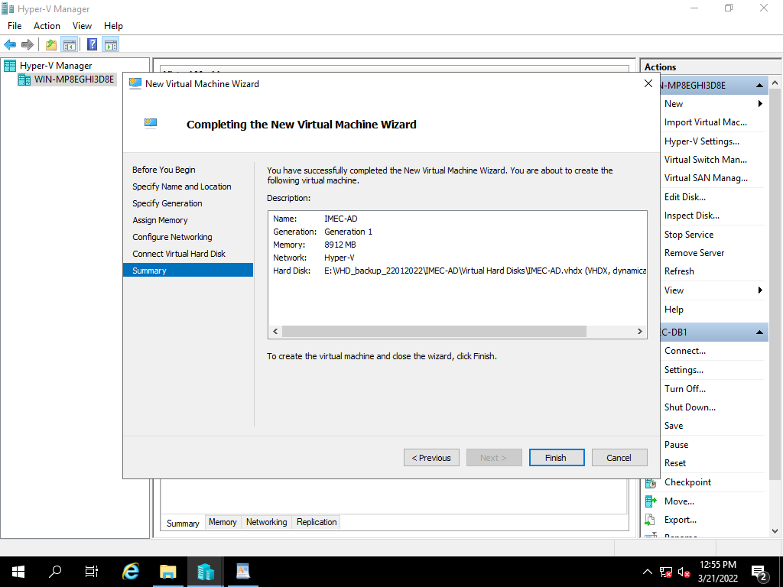

Power on the created Restore VM

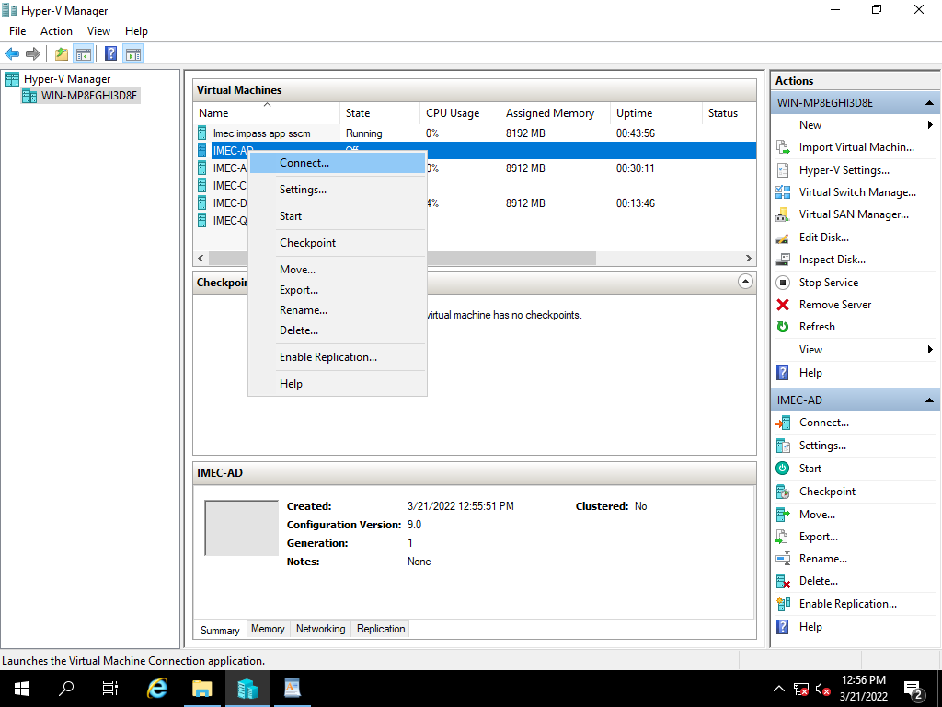

Click on start to power on the VM

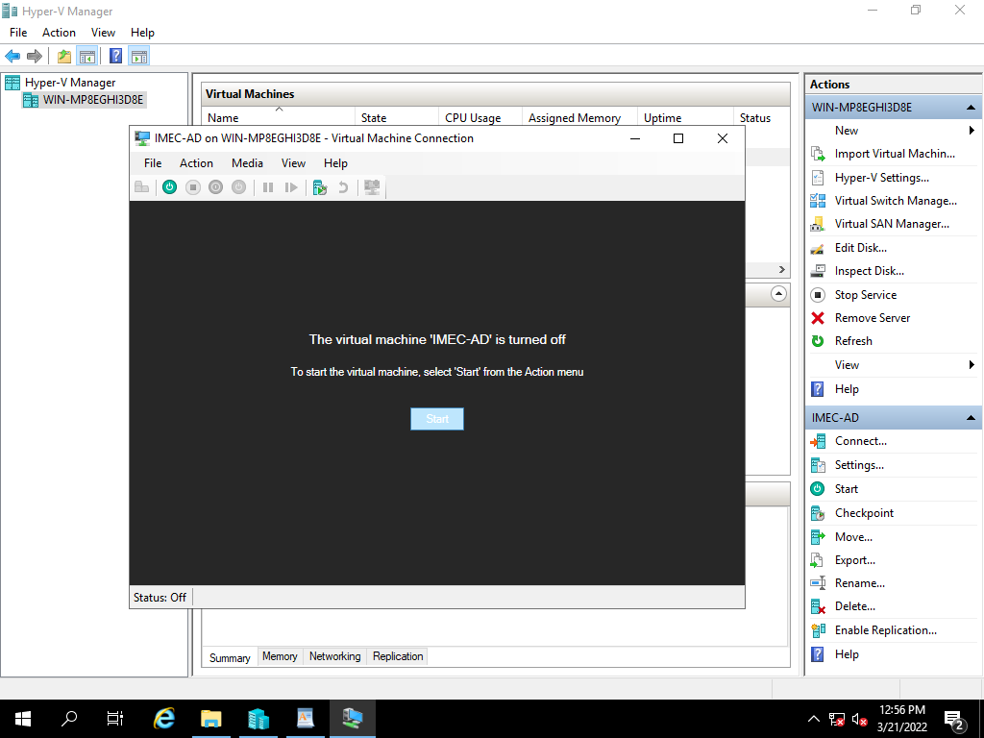

Server detail verification

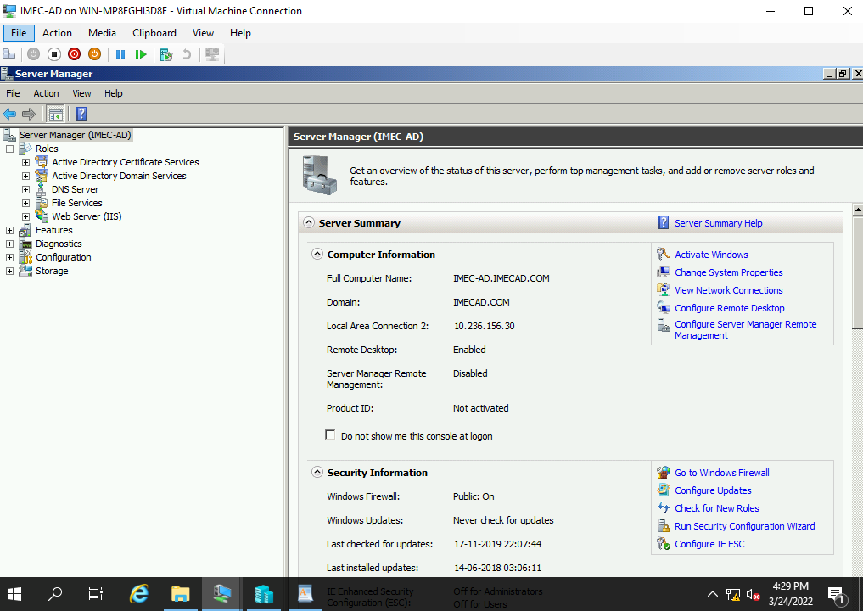

List of users and groups on IMAC

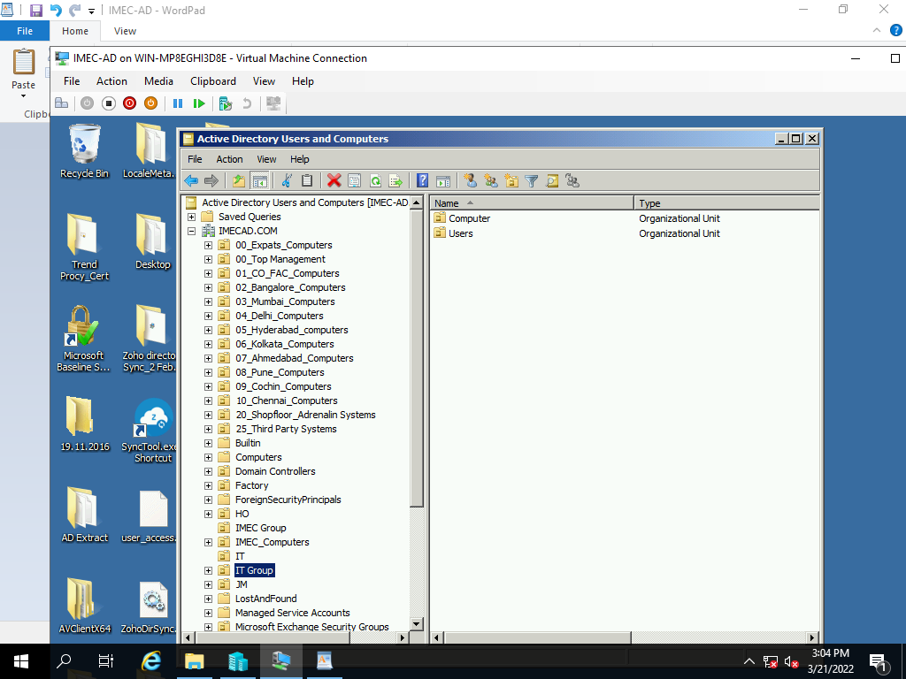

**5) Secondary AD VHD Backup Restoration Process**

|  |  |  |  |  |  |  |  |  |
| --- | --- | --- | --- | --- | --- | --- | --- | --- |
| Manual Backup Restoration | | | | | | | | |
| SL. No | Host Name | Host | VM IP | Operating System | Hosted Application Details | Backup Type | Restoration Time |
| 2 | IMEC-FABV001 | VM | 10.236.156.134 | Server 2012 | Secondary AD Server | Manual | 1. mins |

Right click on Hyper-V Manager, select New and Virtual machine.



Select Next,



Specify the name of the server and click on Next,

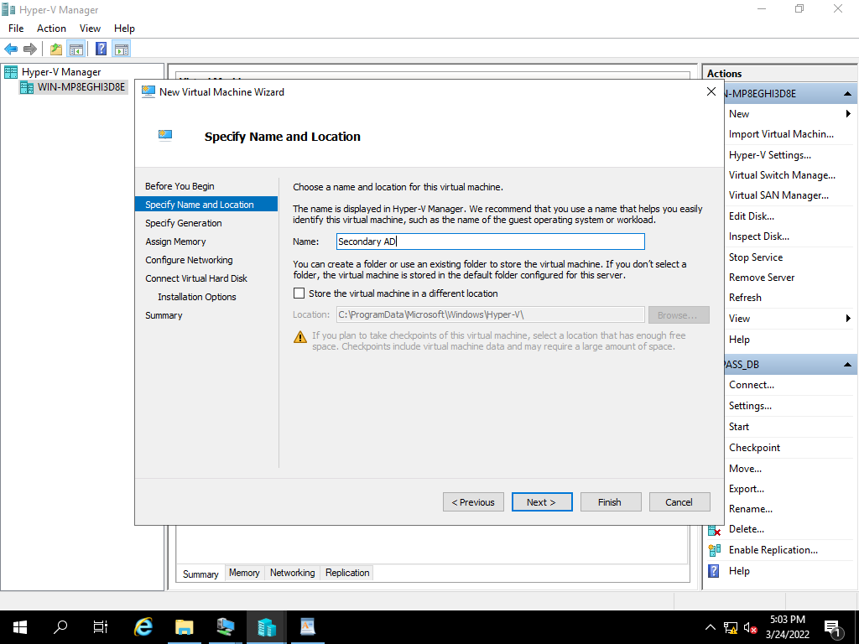

Specify the Generation of virtual machine based on existing, click on Next



Assign the RAM Size Based on existing server, and click on Next



Select the network adopter based on VH Configuration and click on next.

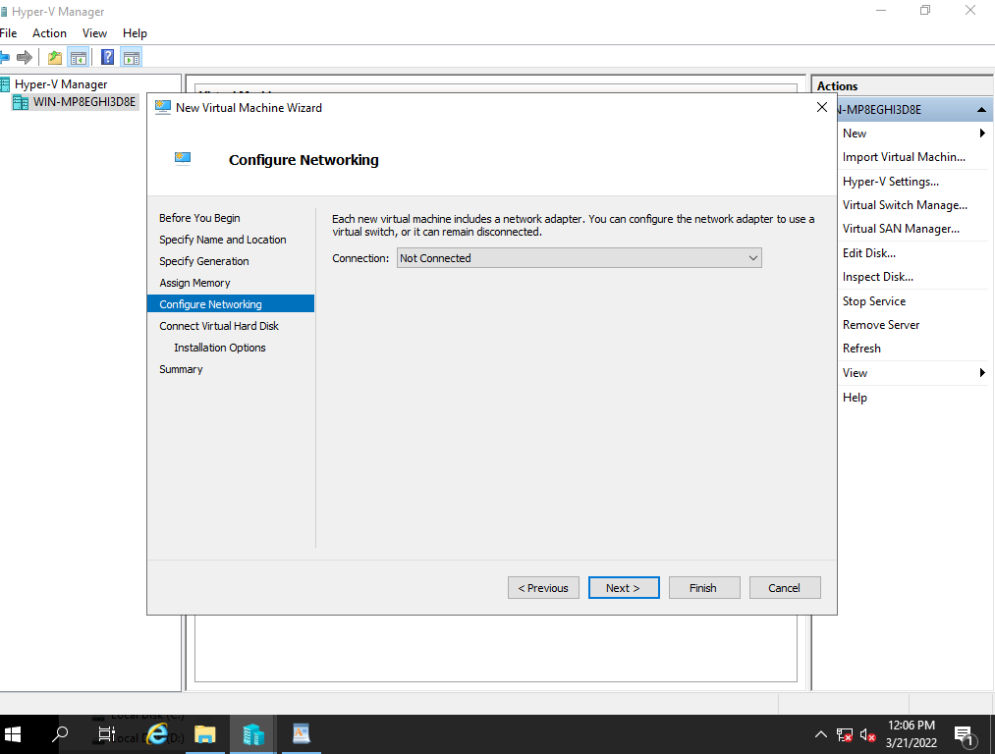

Select the use an existing virtual hard disk option and click on browse.



After selecting the file path, click on Next.

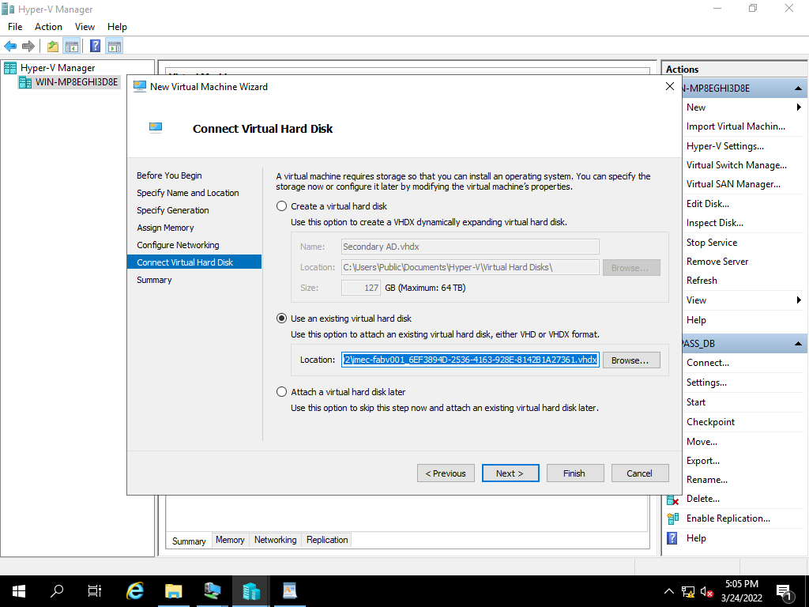

Review the summary and click finish to create a virtual machine.

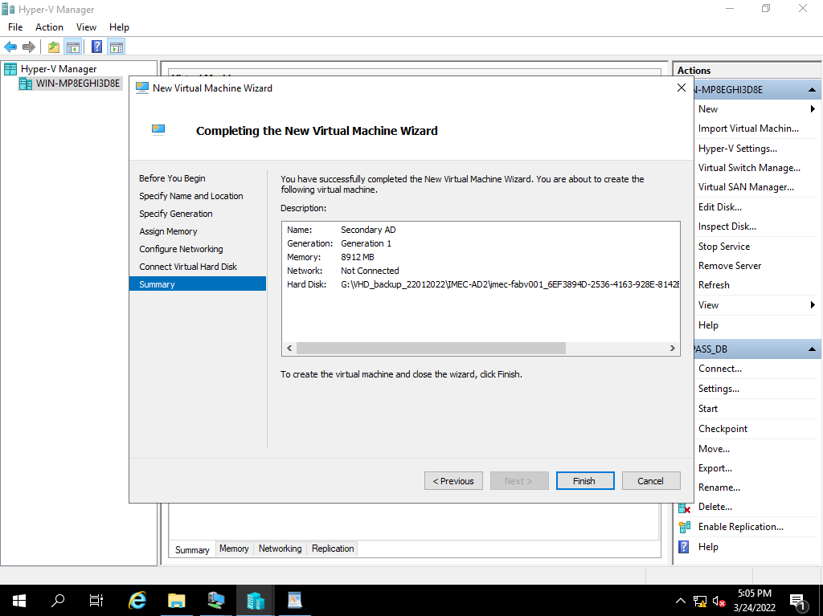

Power on the created Restore VM

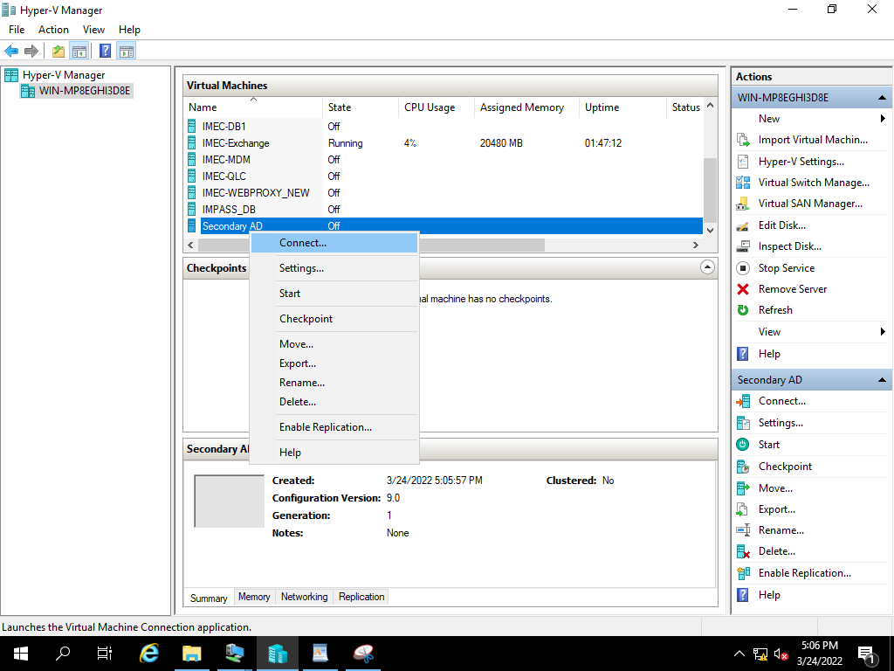

Click on start to power on the Vm

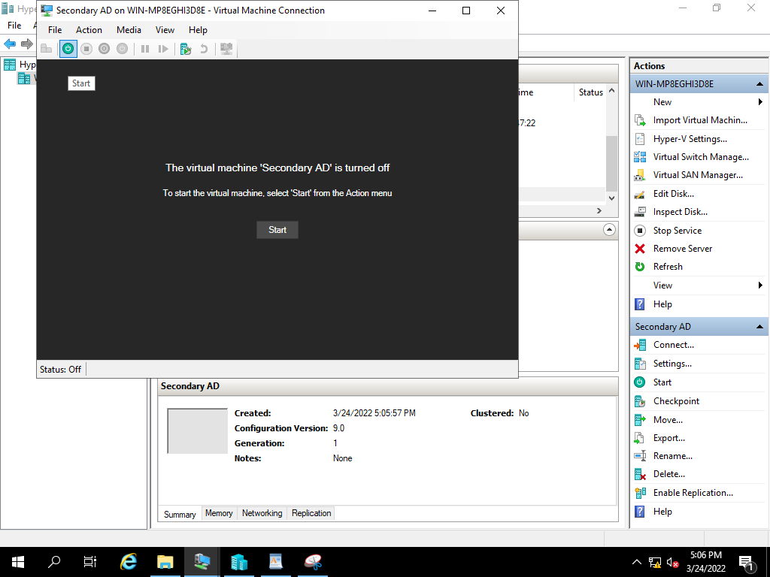

**6) Exchange Mail VHD Backup Restoration Process**

|  |  |  |  |  |  |  |  |
| --- | --- | --- | --- | --- | --- | --- | --- |
| **Manual Backup Restoration** | | | | | | | |
| SL. No | Host Name | Host | VM IP | Operating System | Hosted Application Details | Backup Type | Restoration Time | |
| 3 | IMEC-EXCSRV01 | VM | 10.236.156.31 | Server 2008 | Exchange Mail | Manual | 1. mins | |

Right click on Hyper-V Manager, select New and Virtual machine.

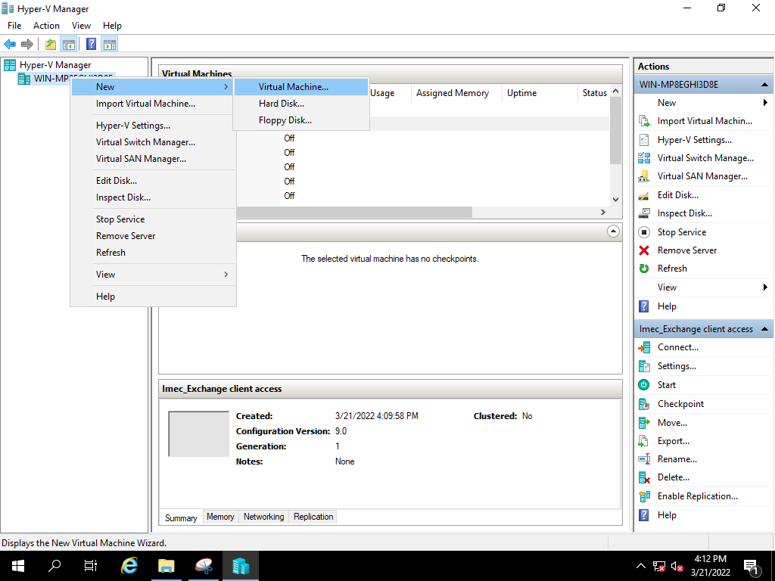

Select Next,



Specify the name of the server and click on Next,

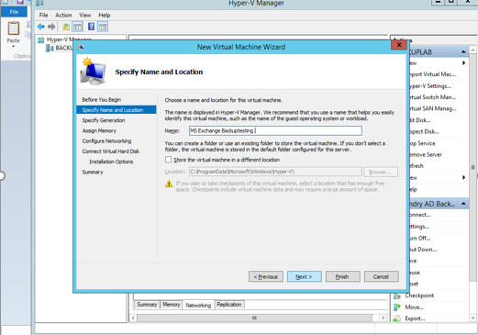

Specify the Generation of virtual machine based on existing, click on Next

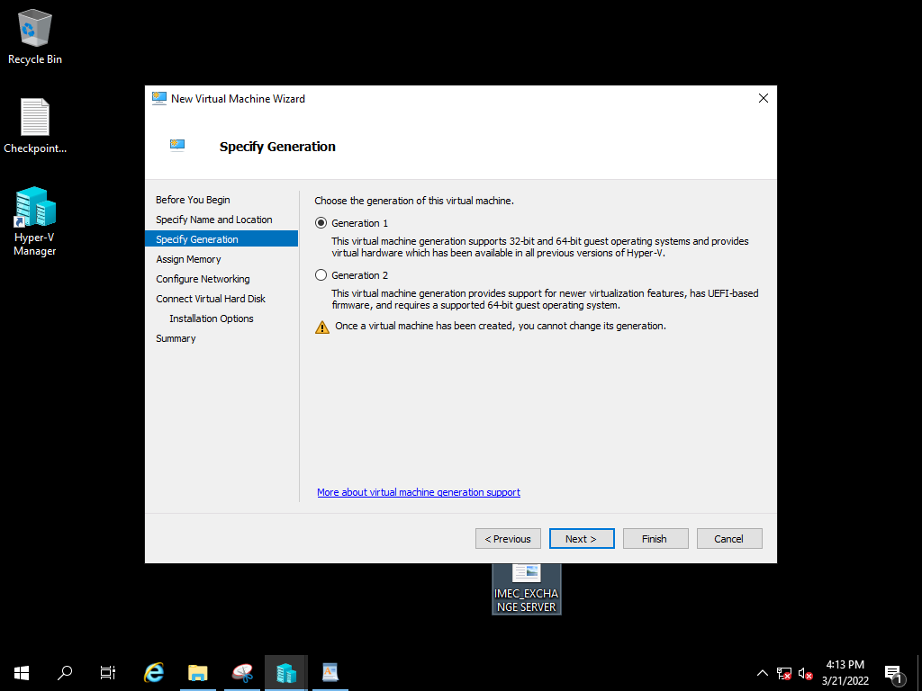

Assign the RAM Size Based on existing server, and click on Next

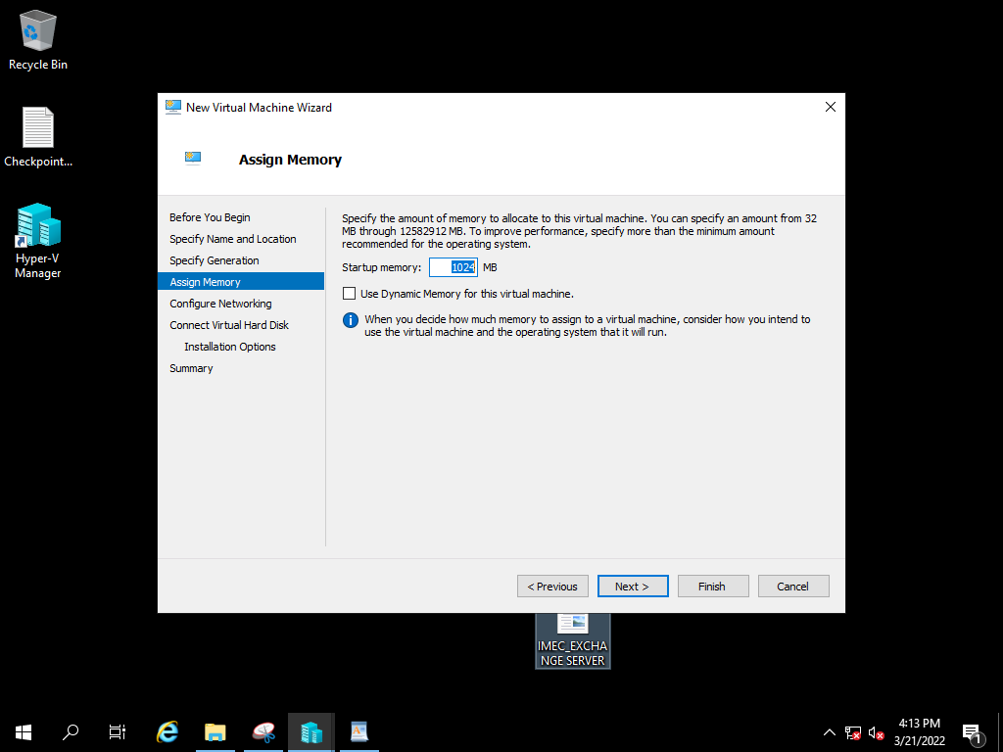

Select the network adopter based on VH Configuration and click on next.

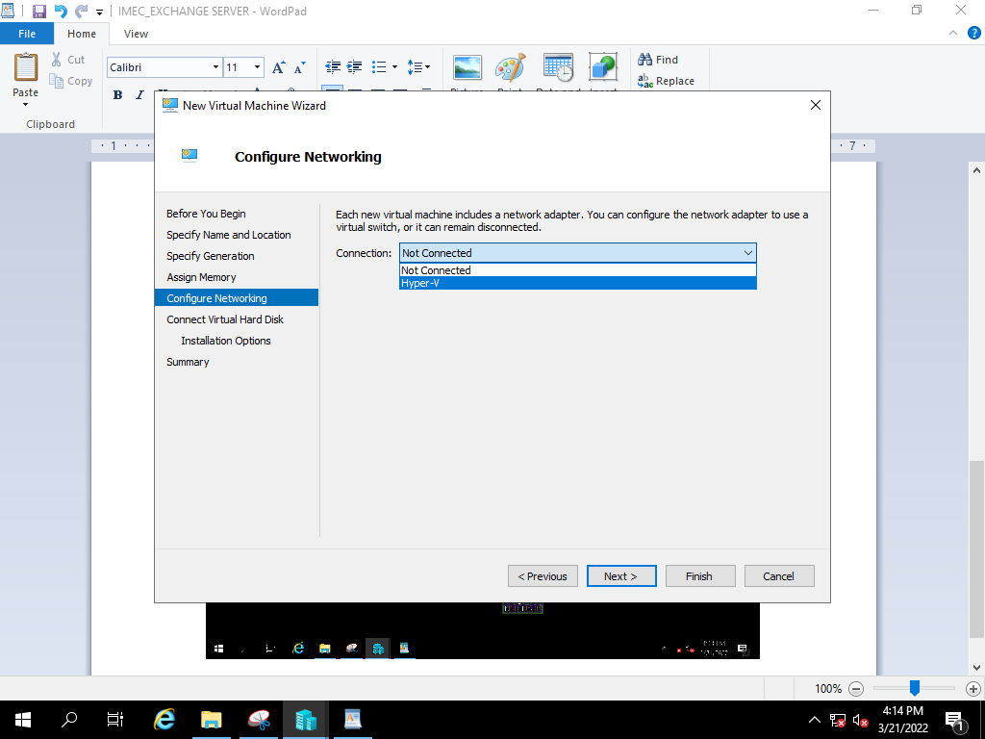

select the use an existing virtual hard disk option and click on browse. 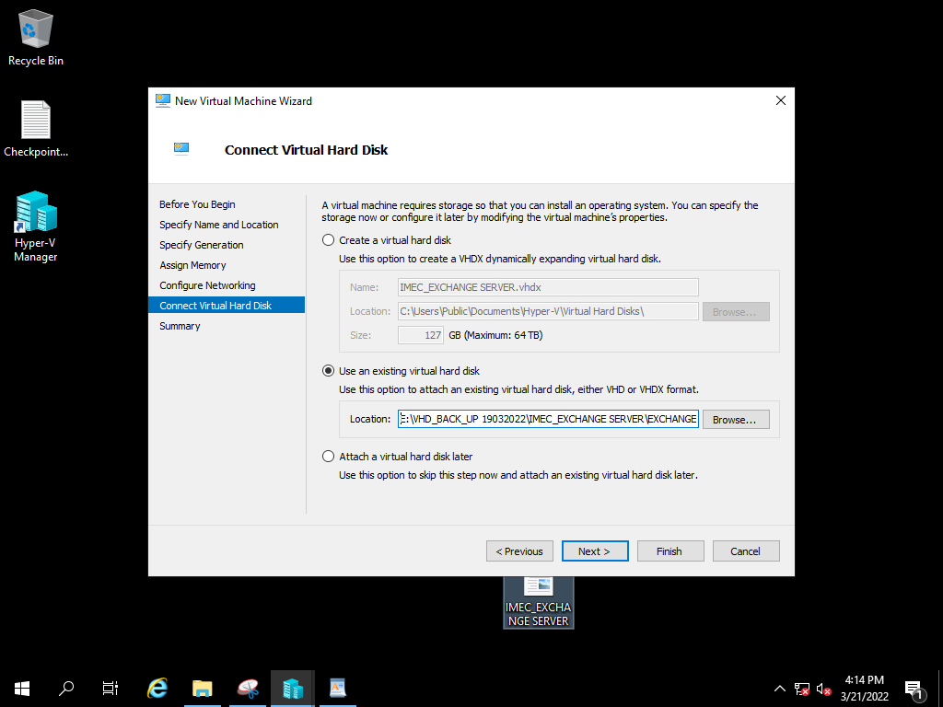

After selecting the file path, click on Next.

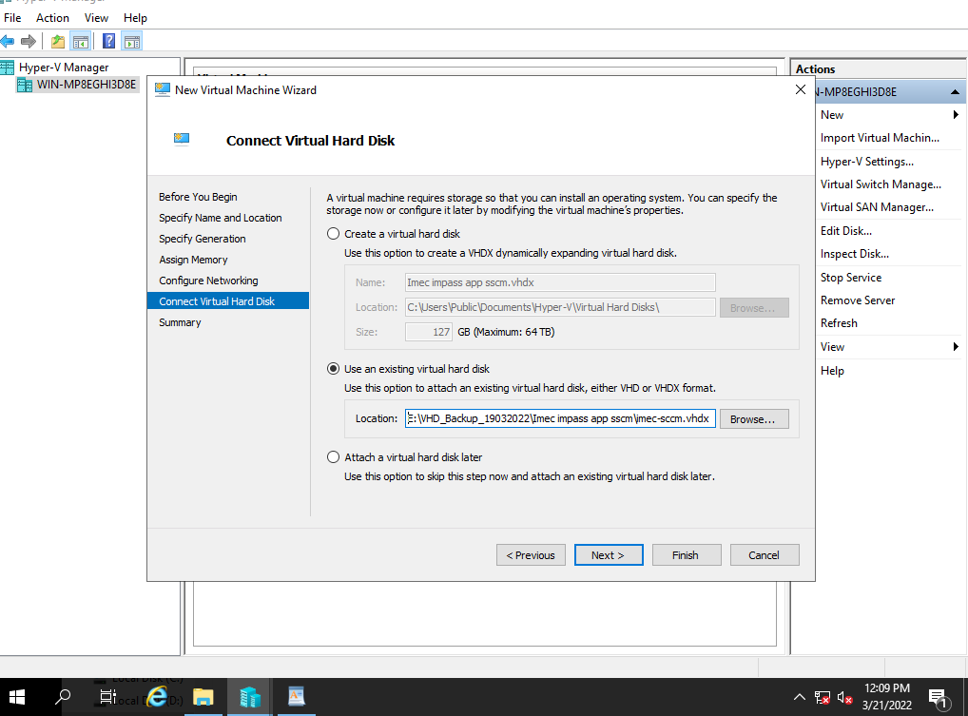

Review the summary and click finish to create a virtual machine.

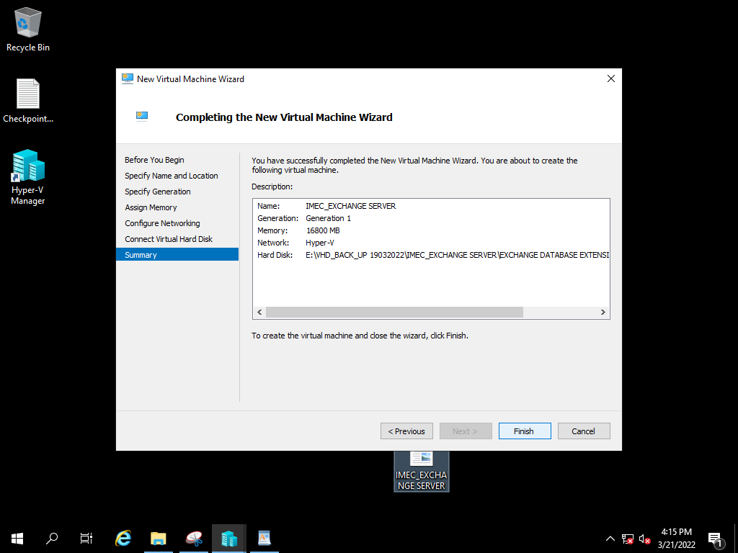

For Adding Database to newly created Exchange VM, select the VM and right click on it and select

Settings option.

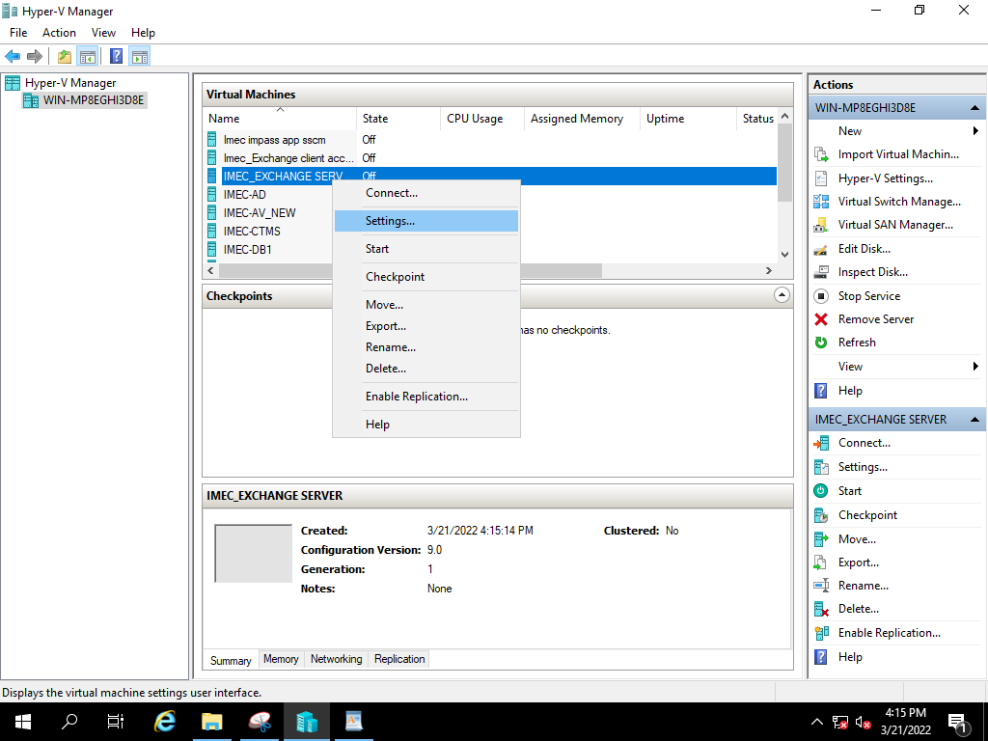

Select Hard Drive option in IDE Controller and click on OK.

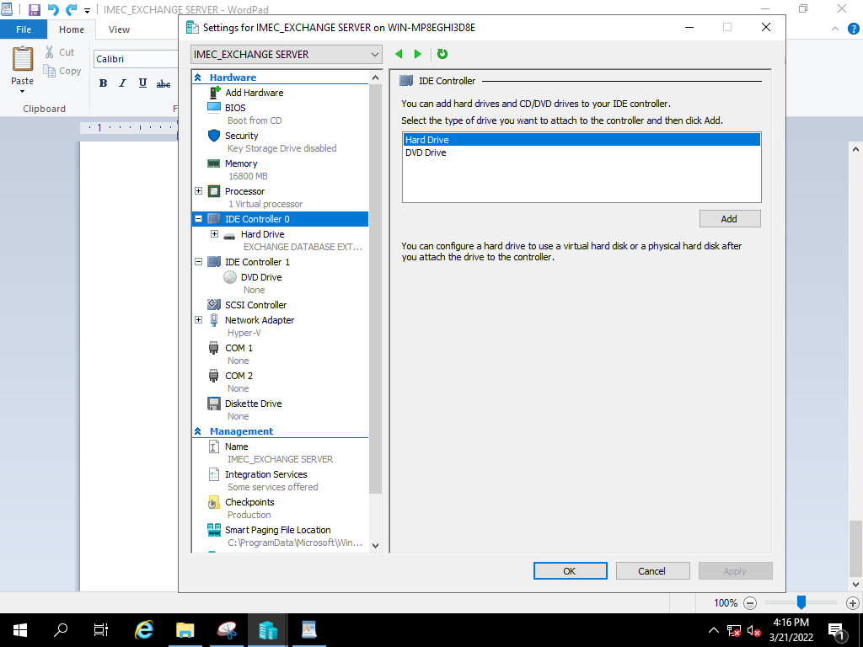

Browse and select the file path of VHD.

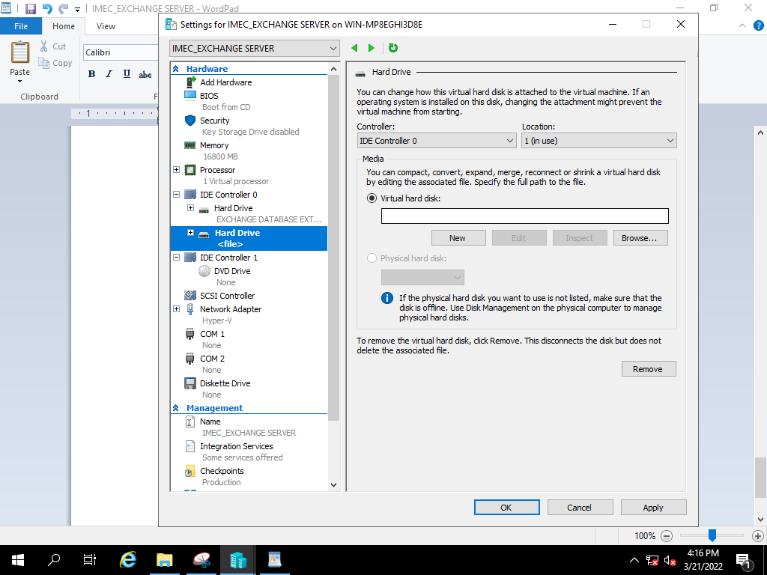

After selecting the file path. Click Apply to configure the DB.

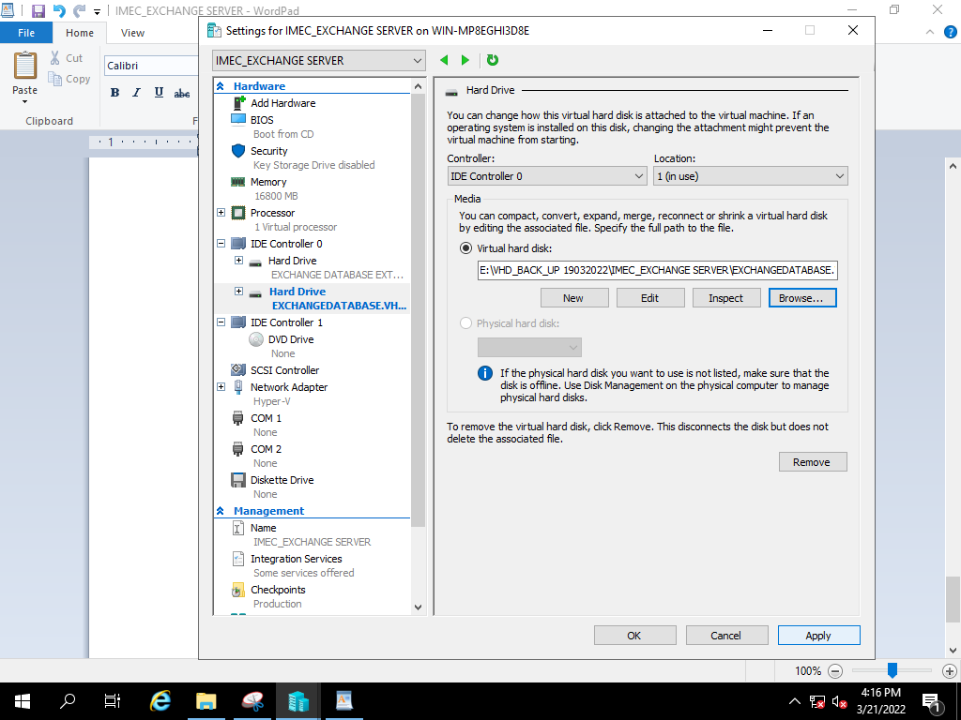

After power on VM, Verifying Mailbox Database and User List.

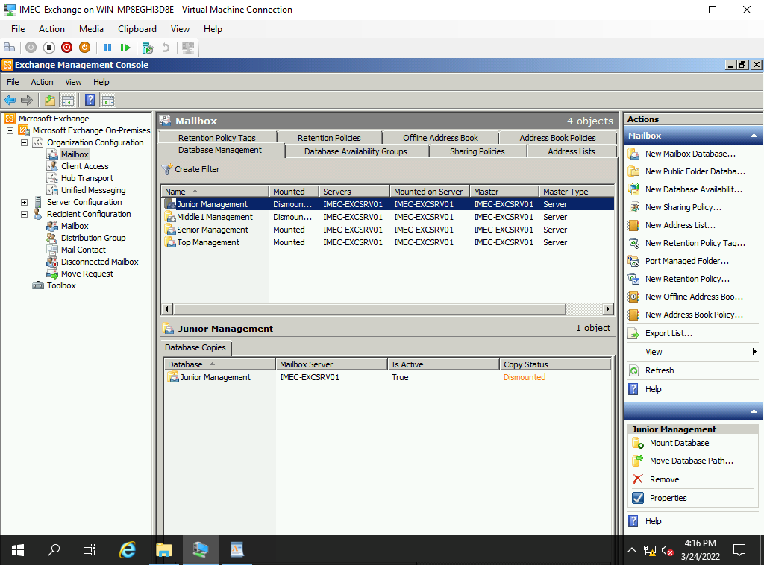

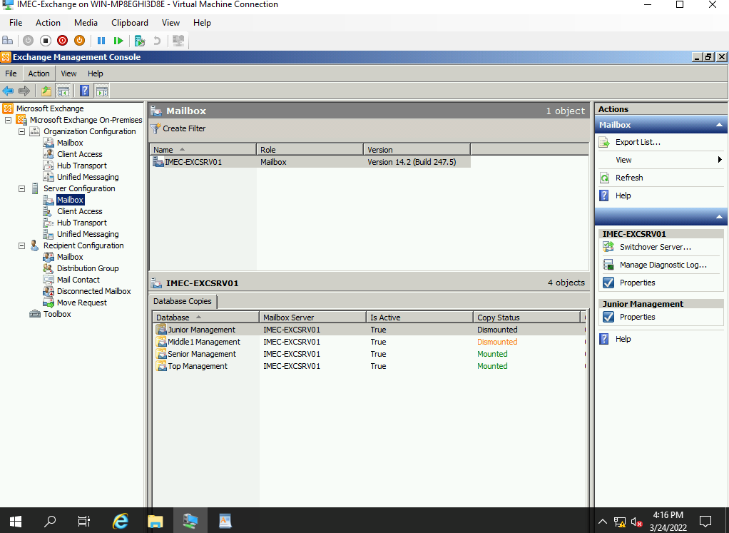

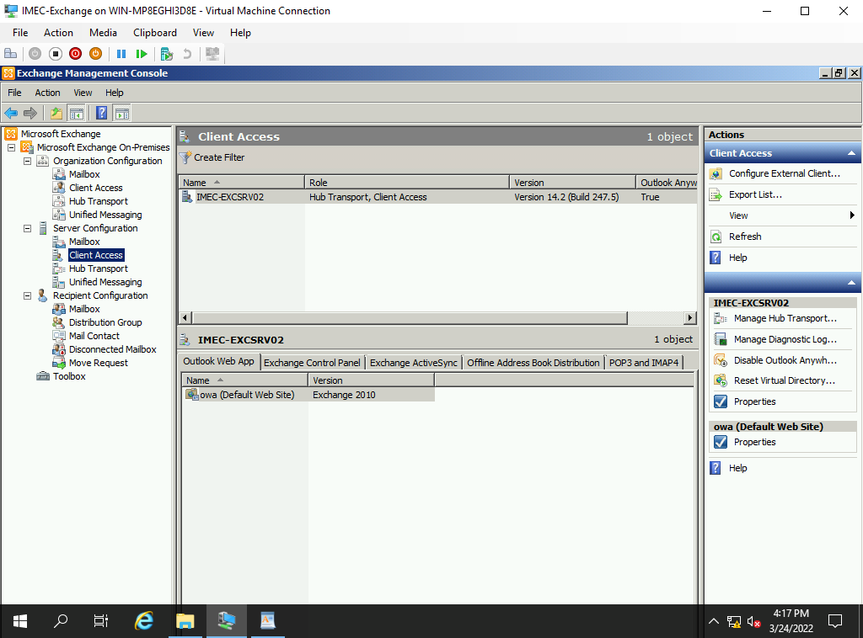

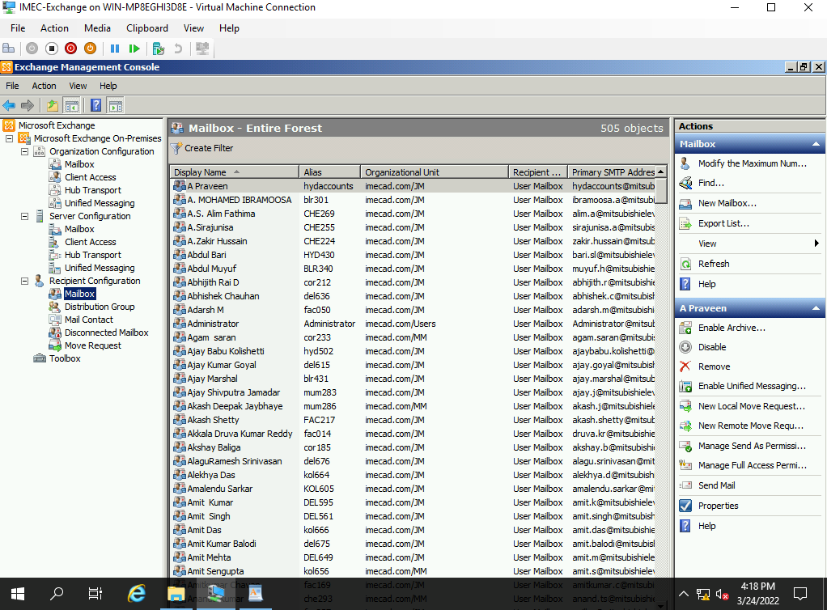

**7) Exchange Client Access VHD Backup Restoration Process**

|  |  |  |  |  |  |  |  |
| --- | --- | --- | --- | --- | --- | --- | --- |
| Manual Backup Restoration | | | | | | | |
| SL. No | Host Name | Host | VM IP | Operating System | Hosted Application Details | Backup Type | Restoration Time |
| 4 | IMEC-EXCSRV02 | VM | 10.236.156.24 | Server 2008 | Exchange Client access | Manual | 1. mins |

Right click on Hyper-V Manager, select New and Virtual machine.

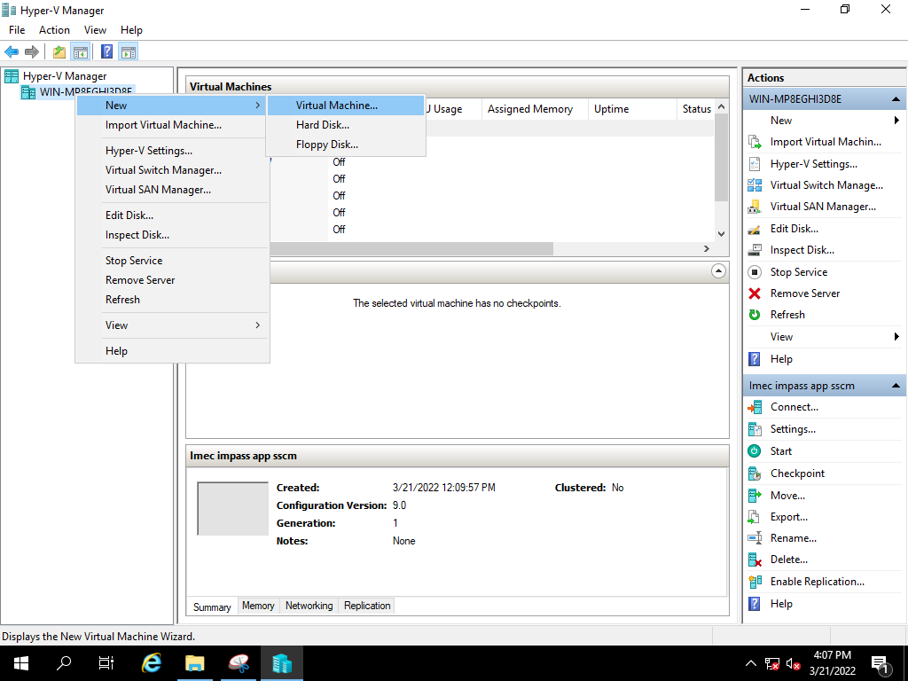

Select Next,

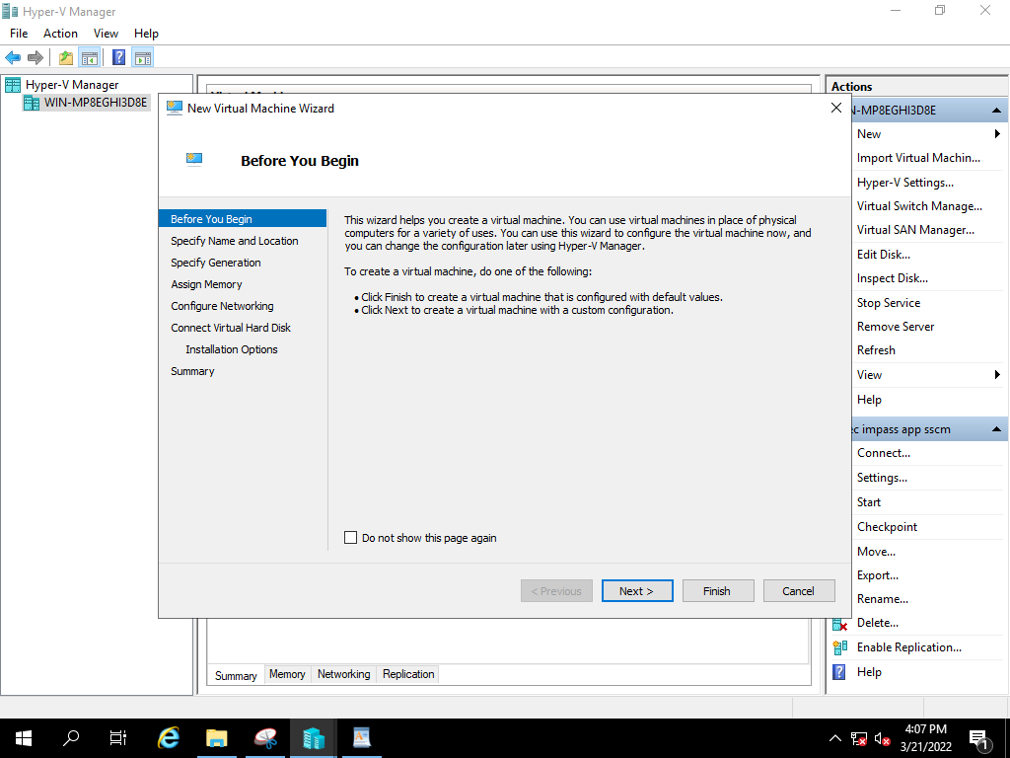

Specify the name of the server and click on Next,

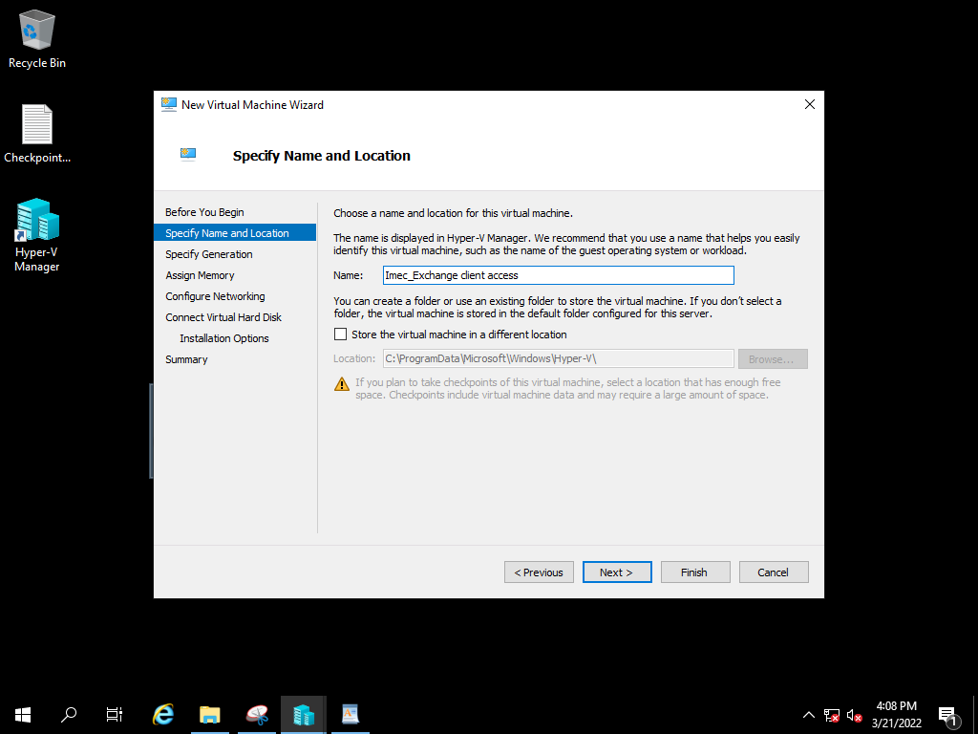

Specify the Generation of virtual machine based on existing, click on Next

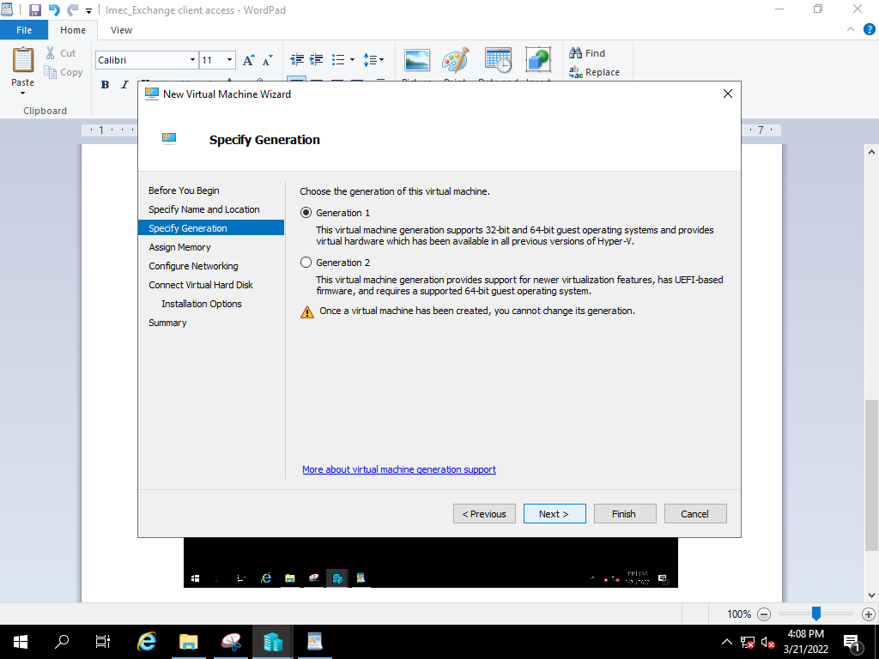

Assign the RAM Size Based on existing server, and click on Next

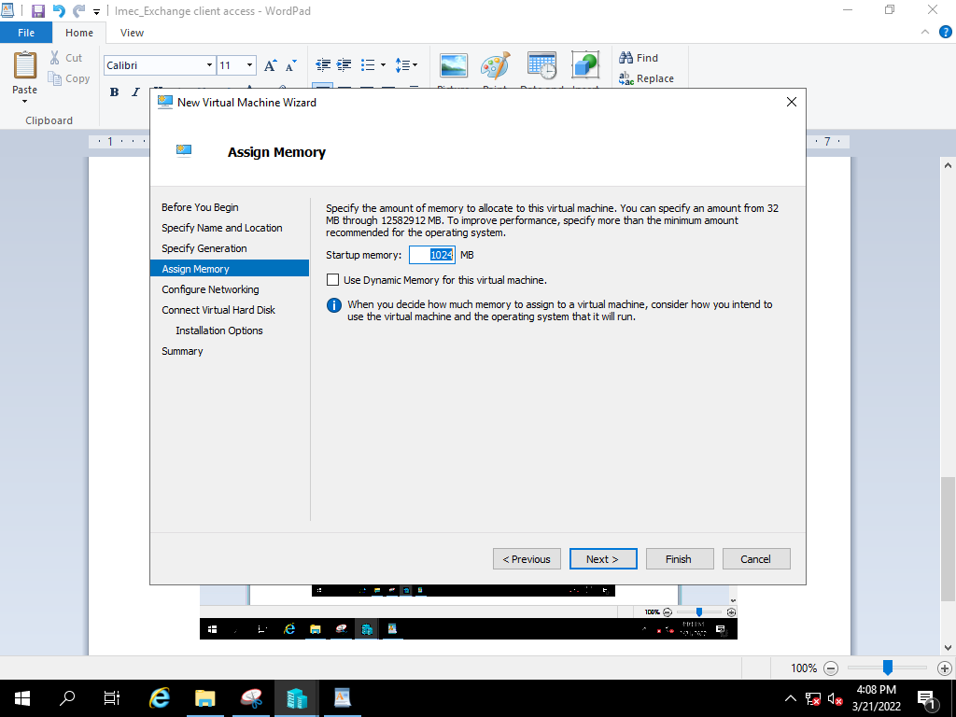

Select the network adopter based on VH Configuration and click on next.

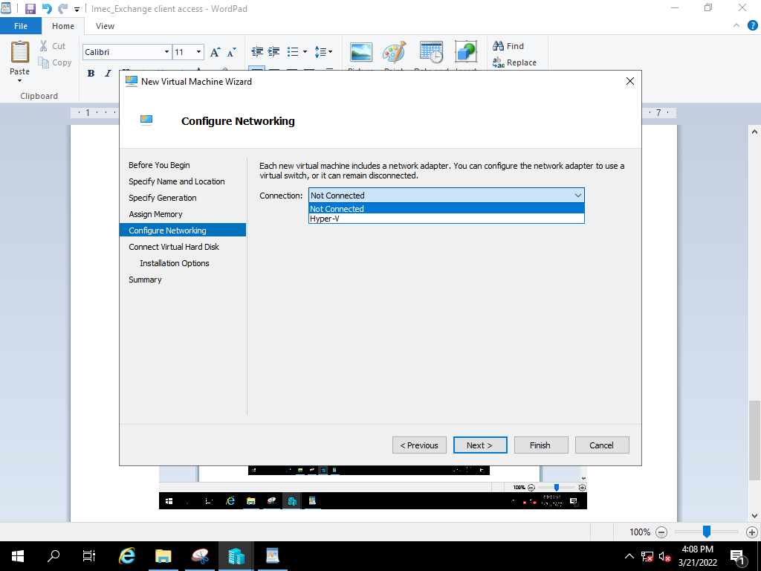

Select the use an existing virtual hard disk option and click on browse.

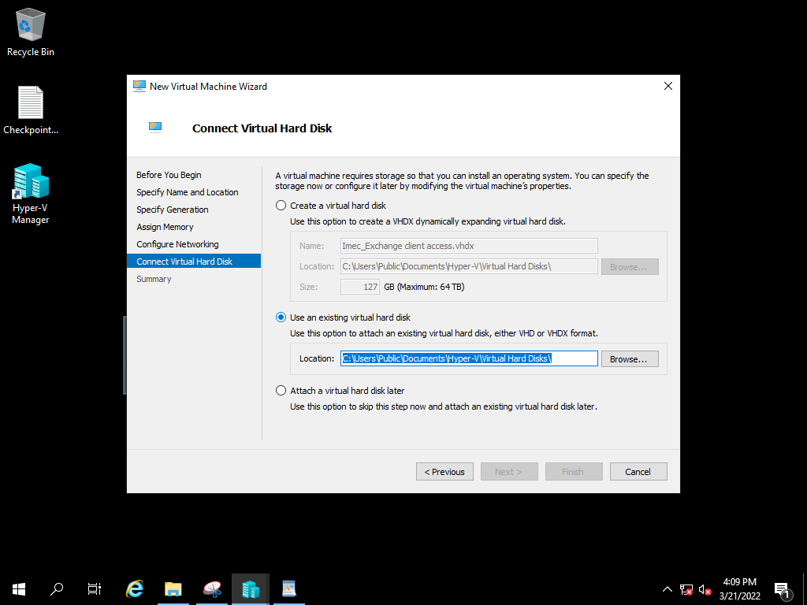

After selecting the file path, click on Next.

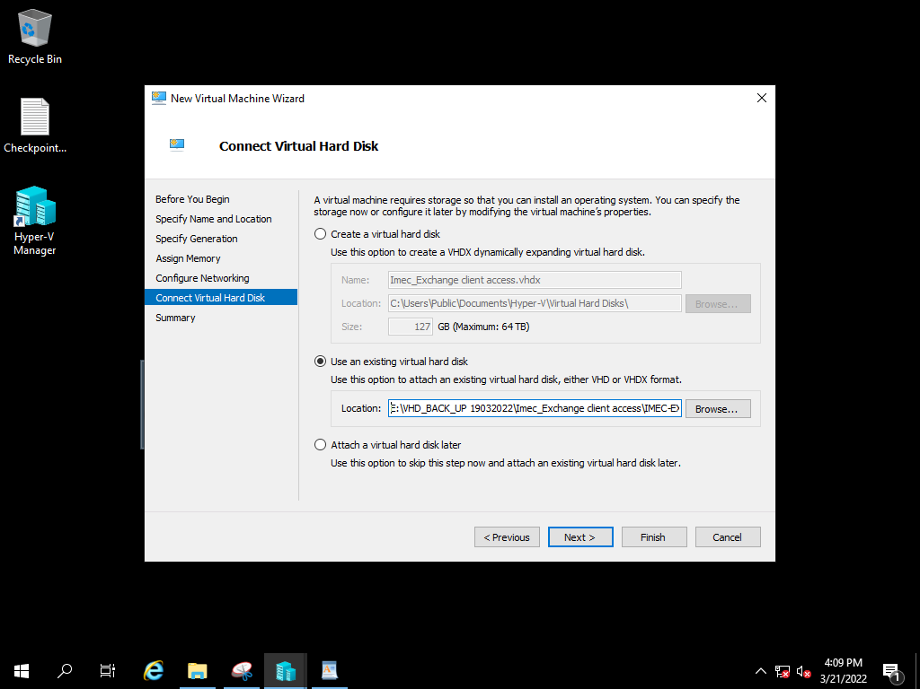

Review the summary and click finish to create a virtual machine.

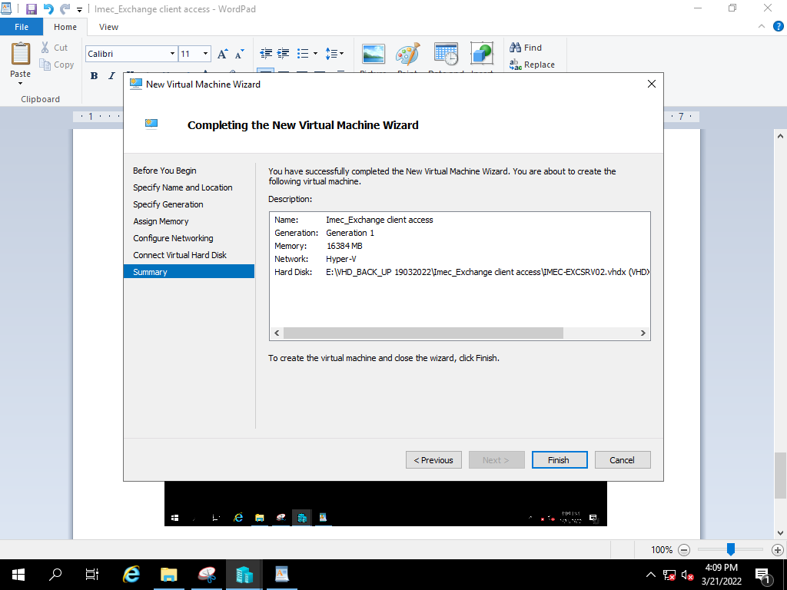

Power on the created Restore VM

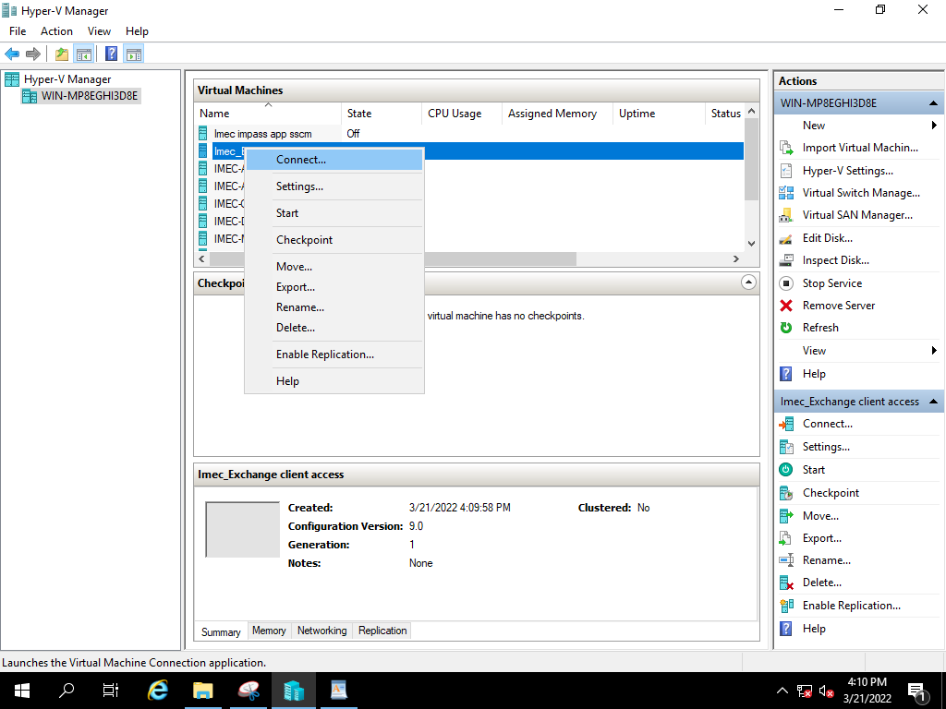

Click on start to power on VM

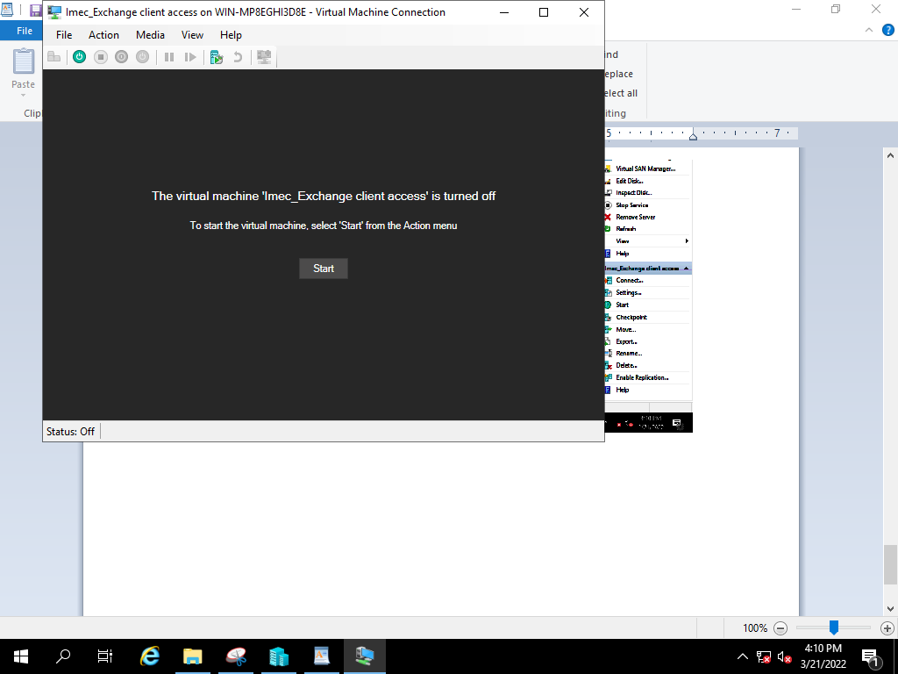

**8) Veritas Tape VHD Backup Restoration Process**

|  |  |  |  |  |  |  |  |
| --- | --- | --- | --- | --- | --- | --- | --- |
| Manual Backup Restoration | | | | | | | |
| SL. No | Host Name | Host | VM IP | Operating System | Hosted Application Details | Backup Type | Restoration Time |
| 5 | imec-fabs002-NO VM | Physical | 10.236.179.131 | Server 2008 | Factory File Server / Veritas | Manual | 1. mins |

In the console, select the server want to restore.

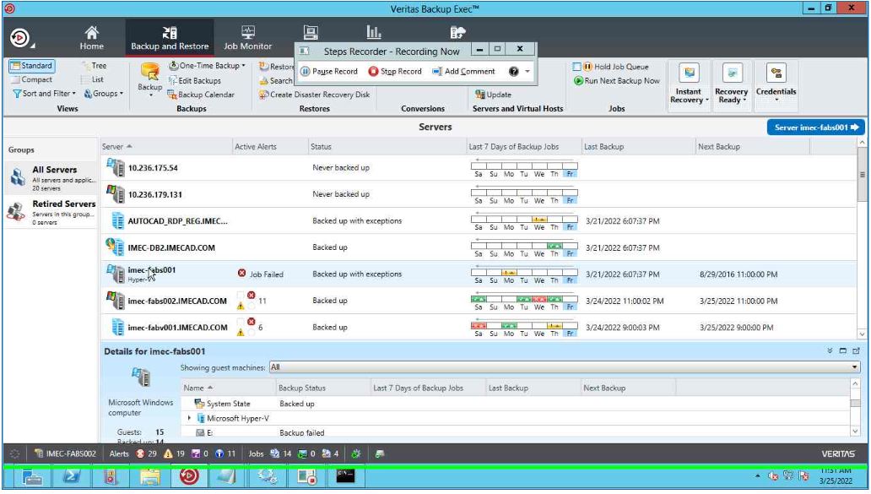

Right click on server and select Restore option.

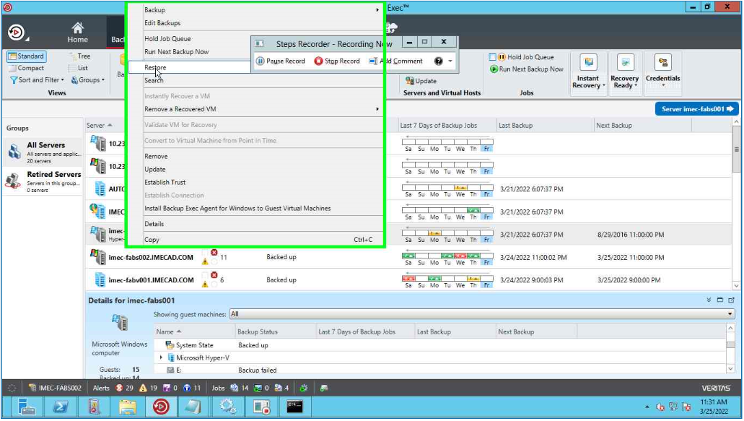

Select Microsoft Hyper- v data and click Next

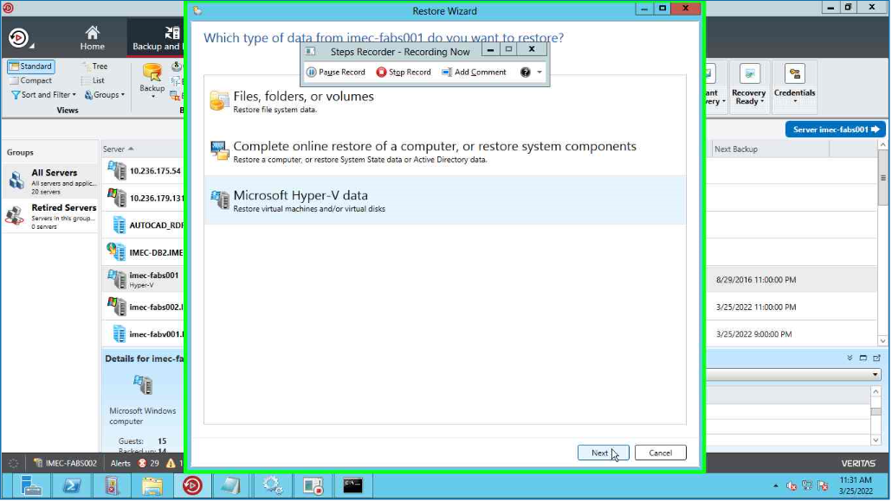

Expand the Hyper-V server and select the VM Need to restore and click Next.

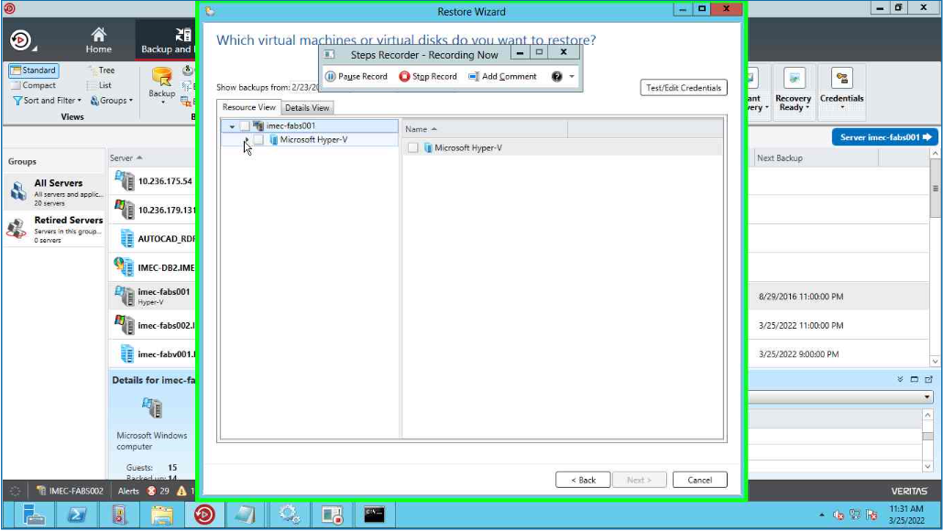

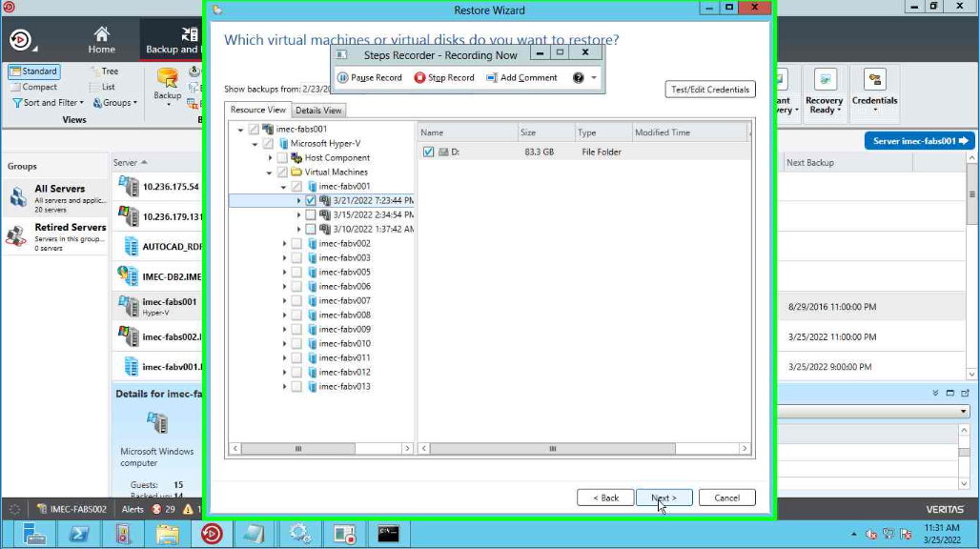

Select the destination server need to restore

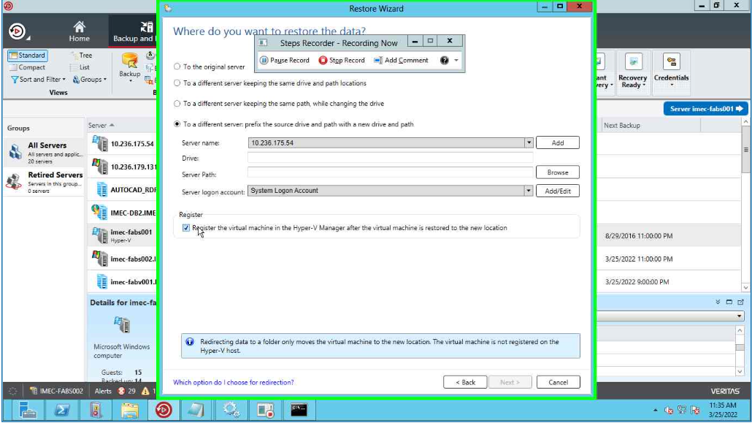

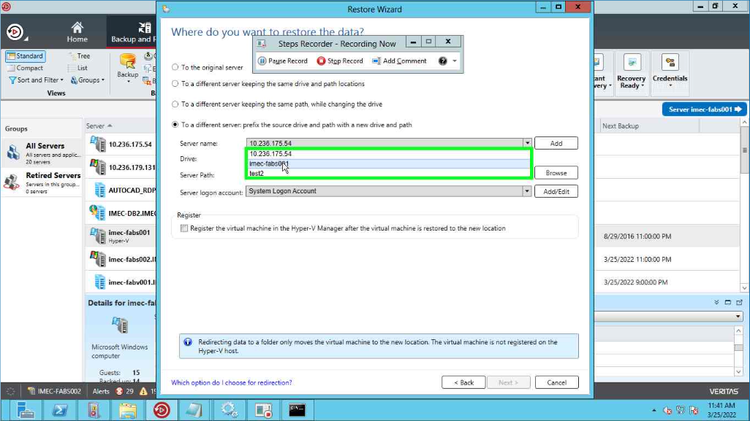

Browse the destination server path and click on Ok.

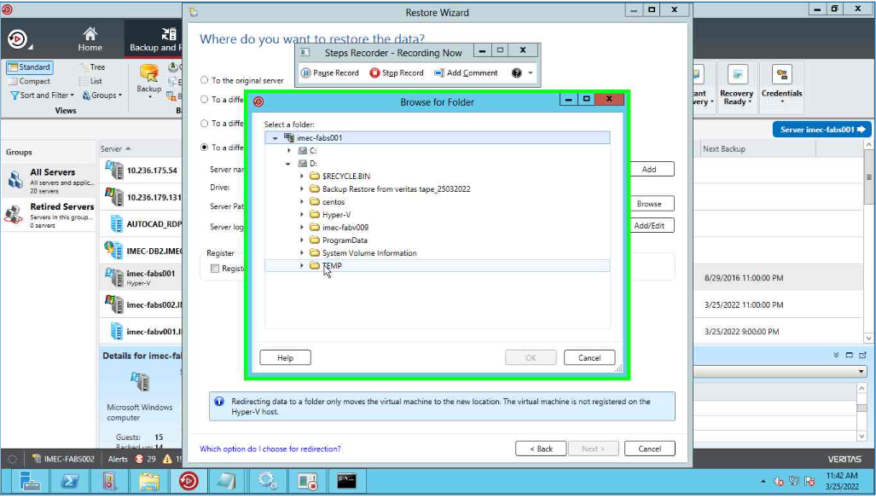

After select the destination server and path , click on Next

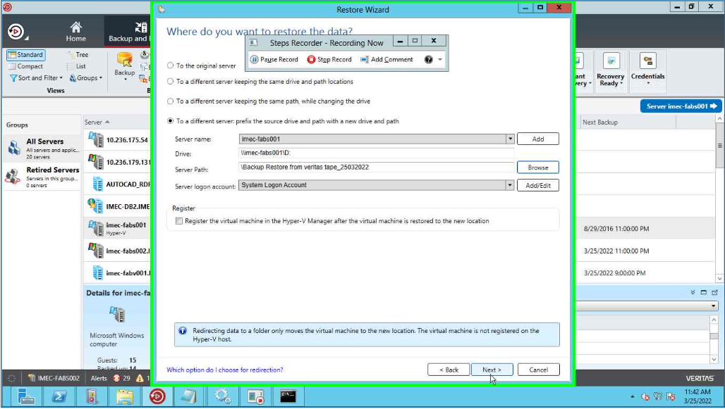

If we want notification after completion of restore job, select the name and click on Next.

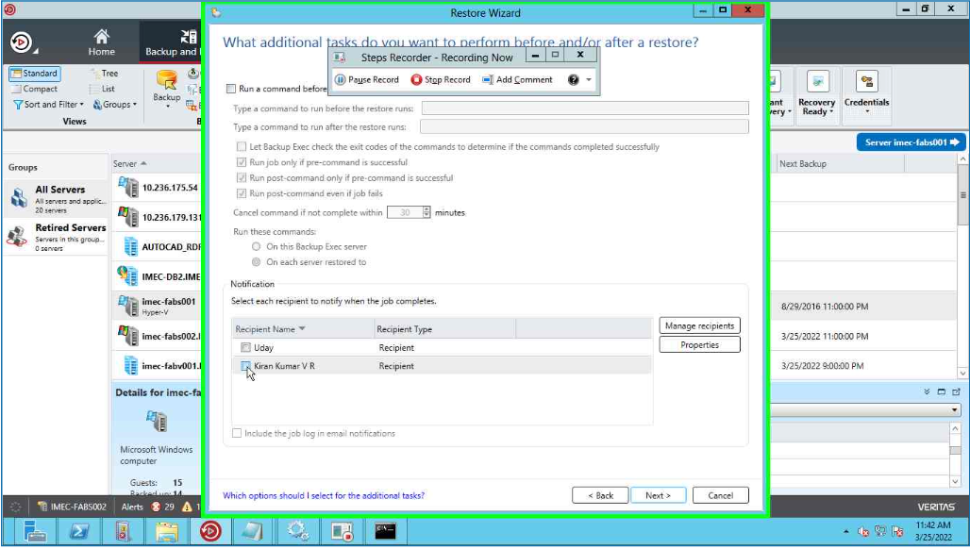

Select the schedule of the restore job and click on Next.

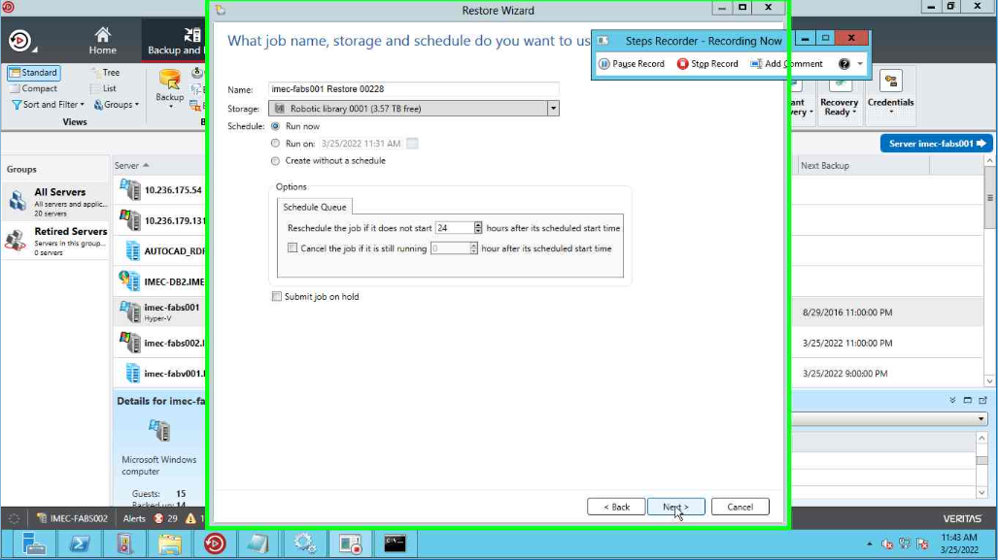

Review the restore job summary and click on finish

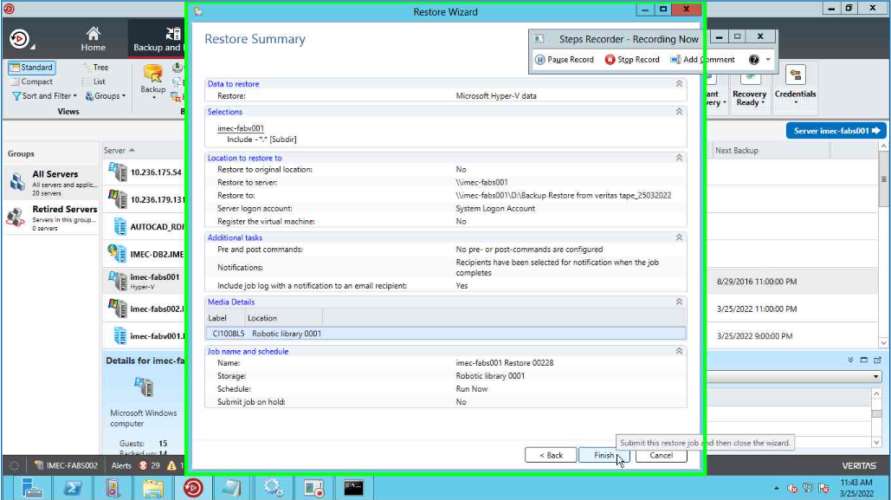

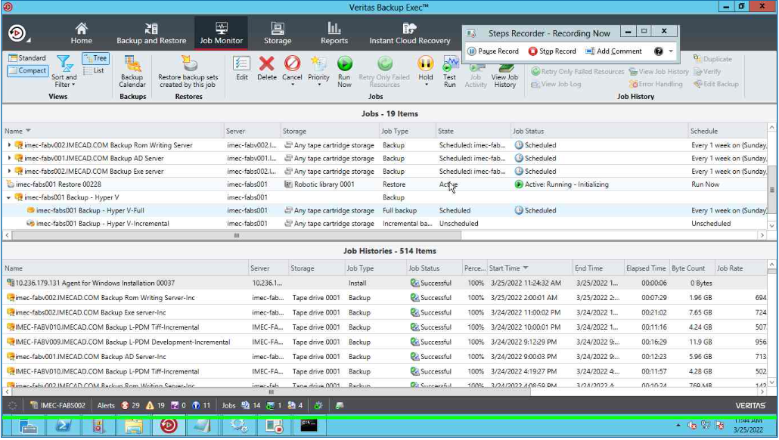

Right click on Hyper-V Manager, select New and Virtual machine.

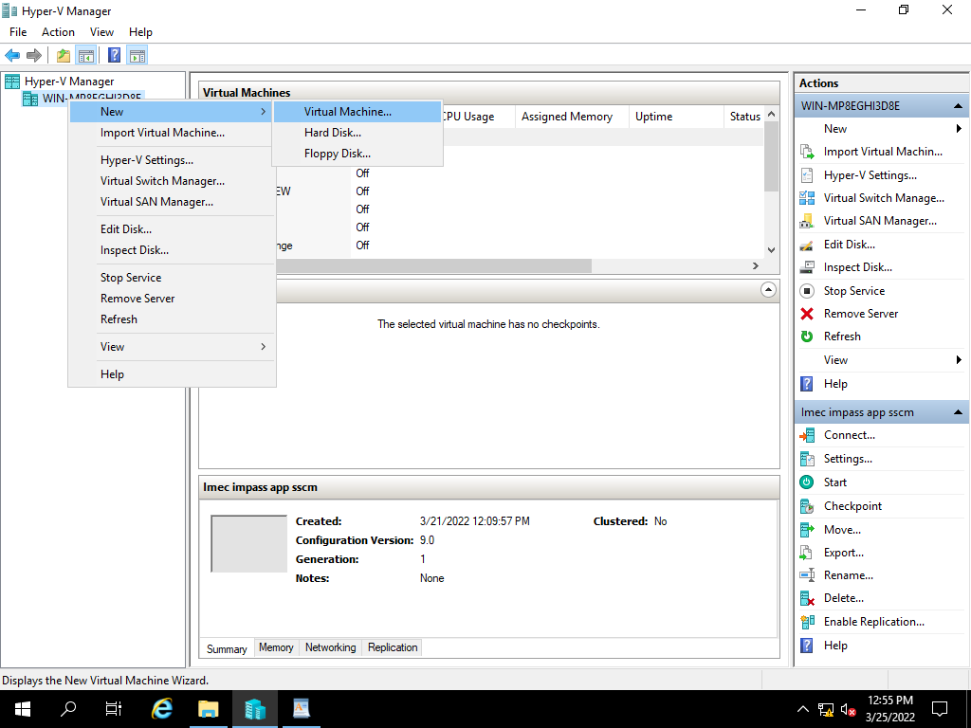

Select Next,

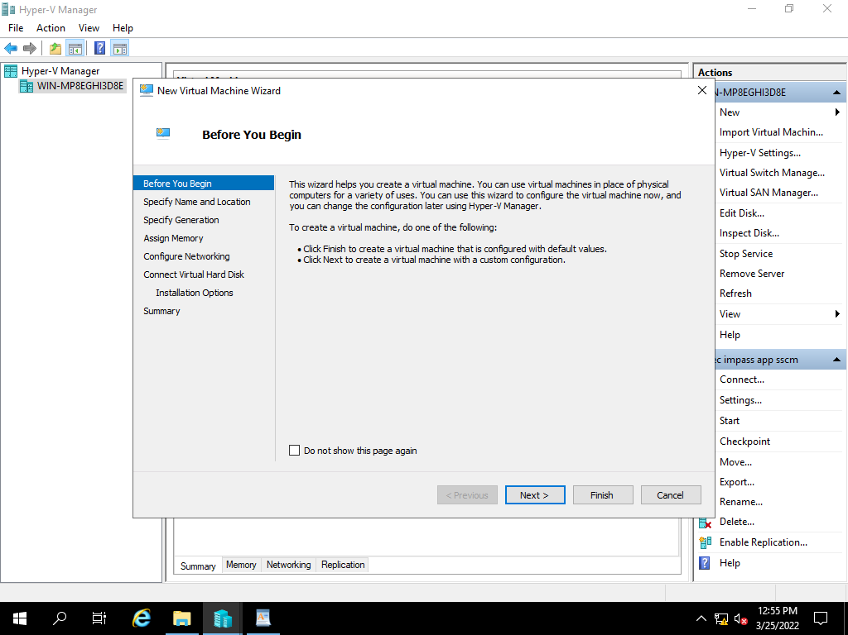

Specify the name of the server and click on Next,

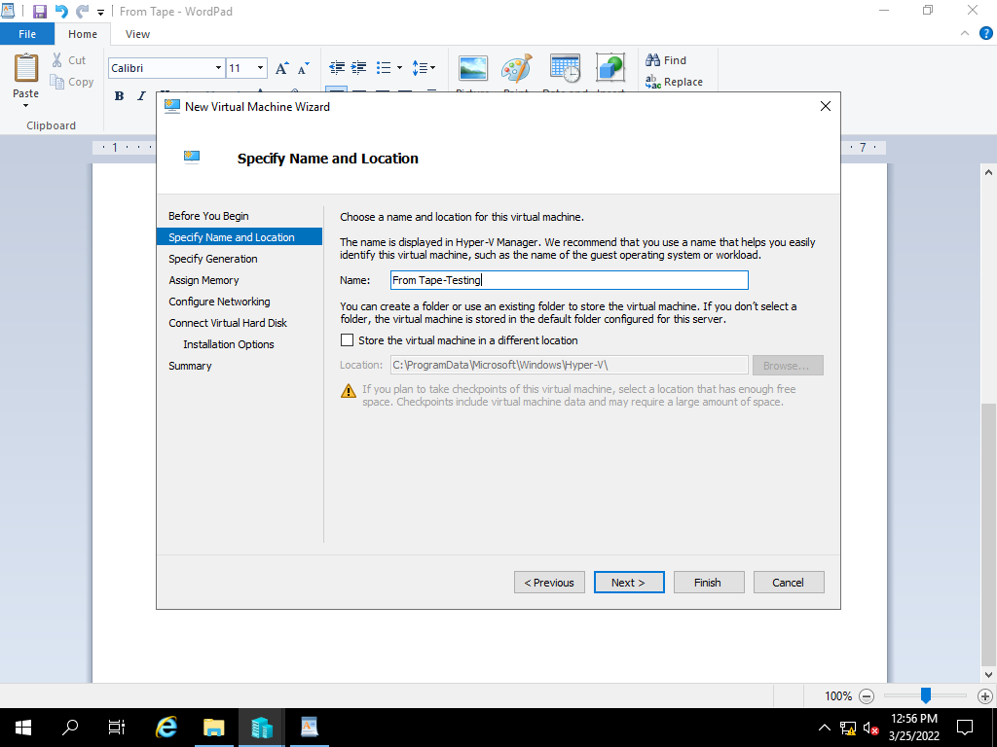

Specify the Generation of virtual machine based on existing, click on Next

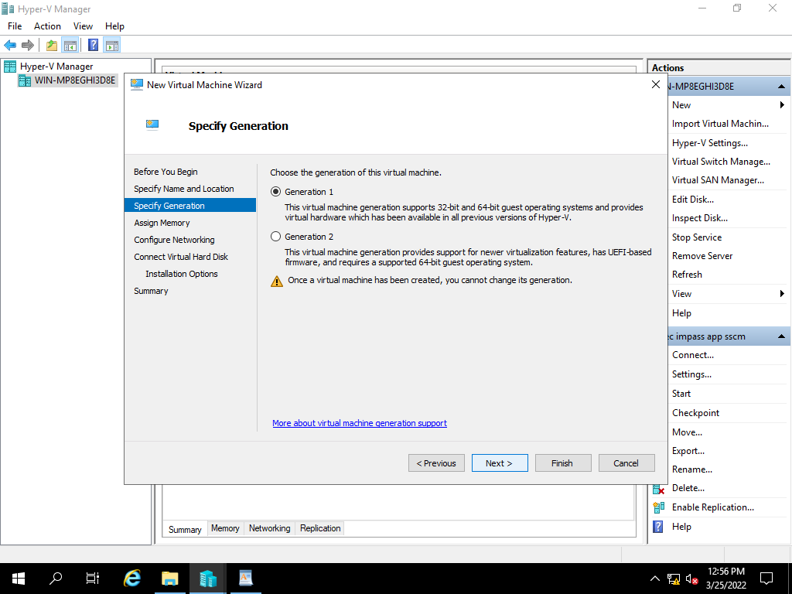

Assign the RAM Size Based on existing server, and click on Next

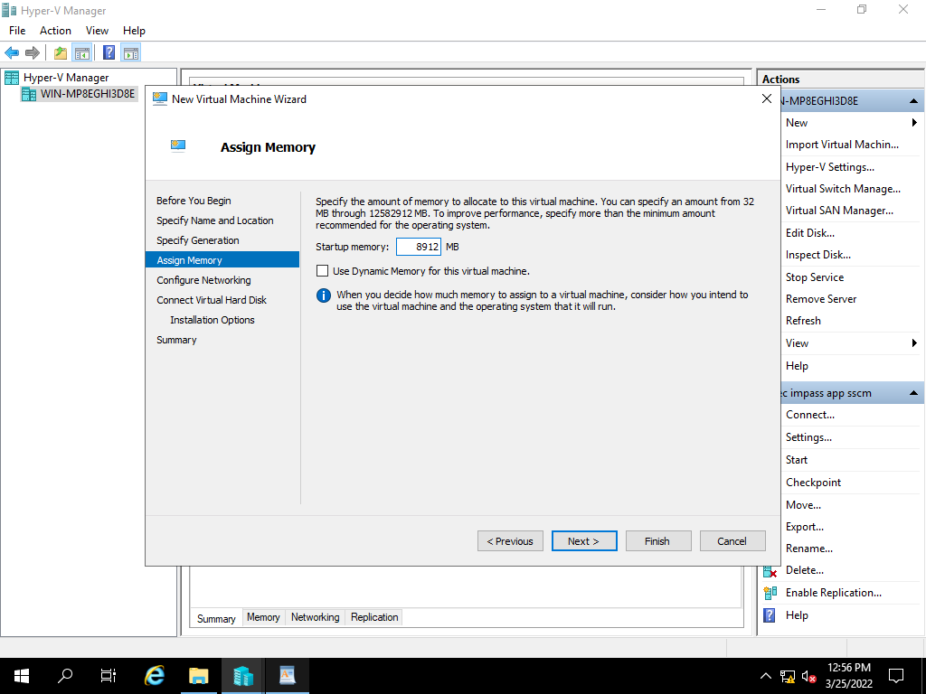

Select the network adopter based on VH Configuration and click on next.

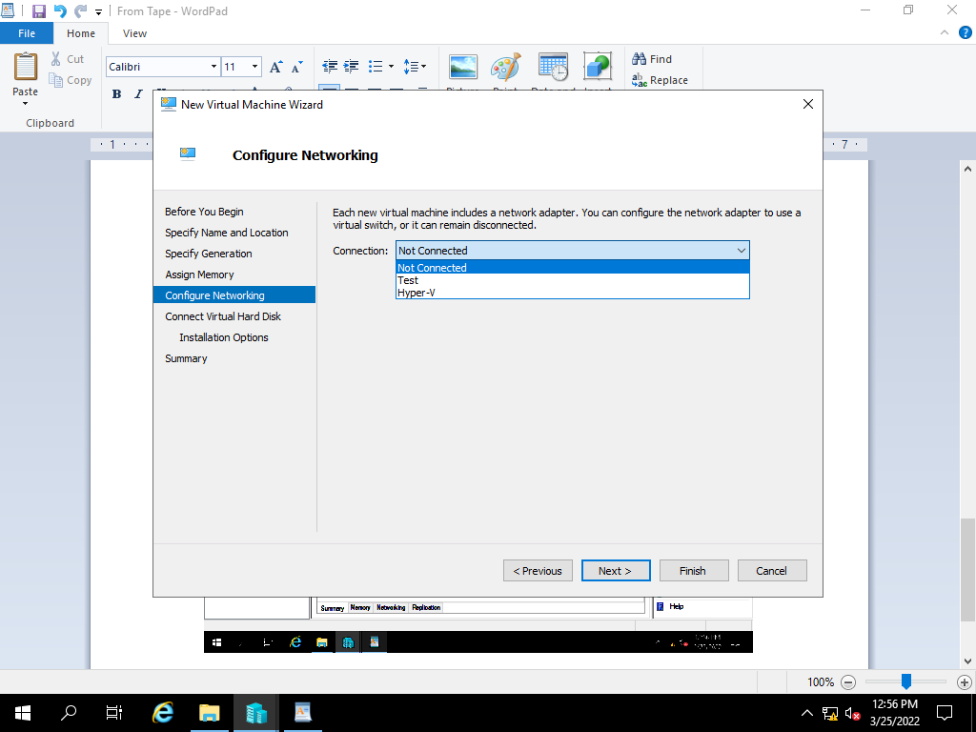

Select the use an existing virtual hard disk option and click on browse.

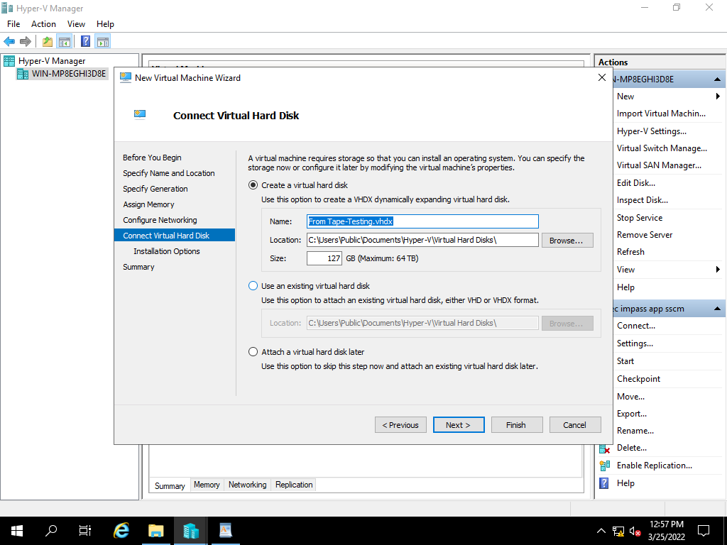

Browse the file path, click on open.

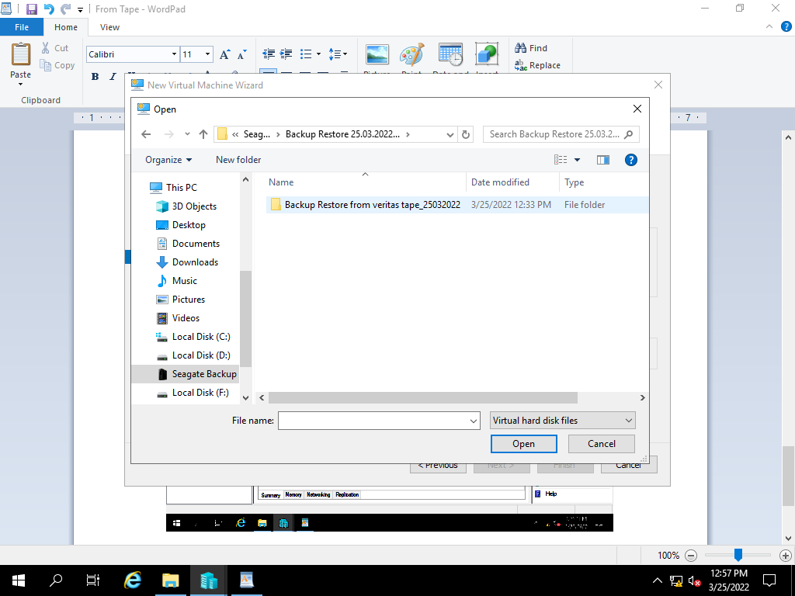

After selecting the file path, click on Next

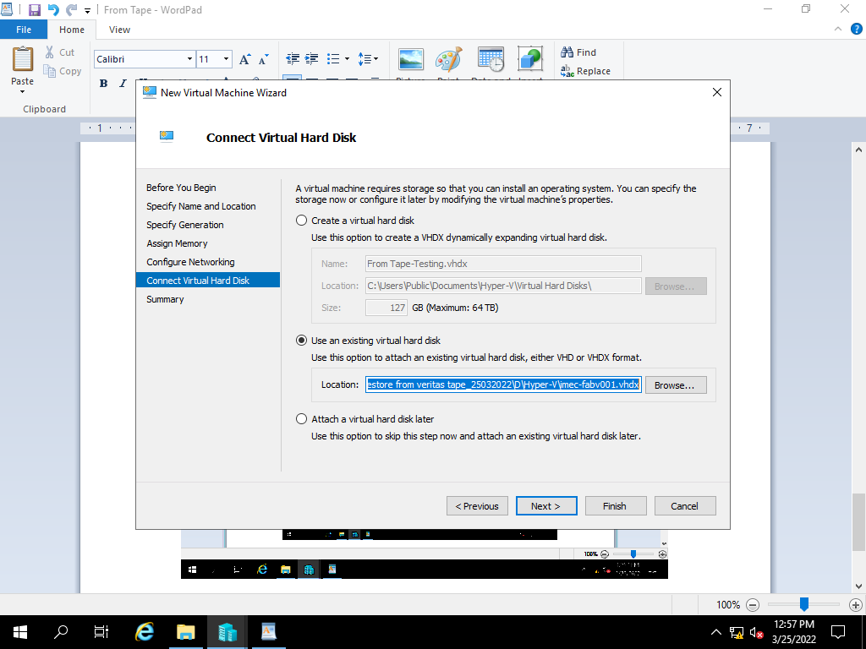

Review the summary and click finish to create a virtual machine.

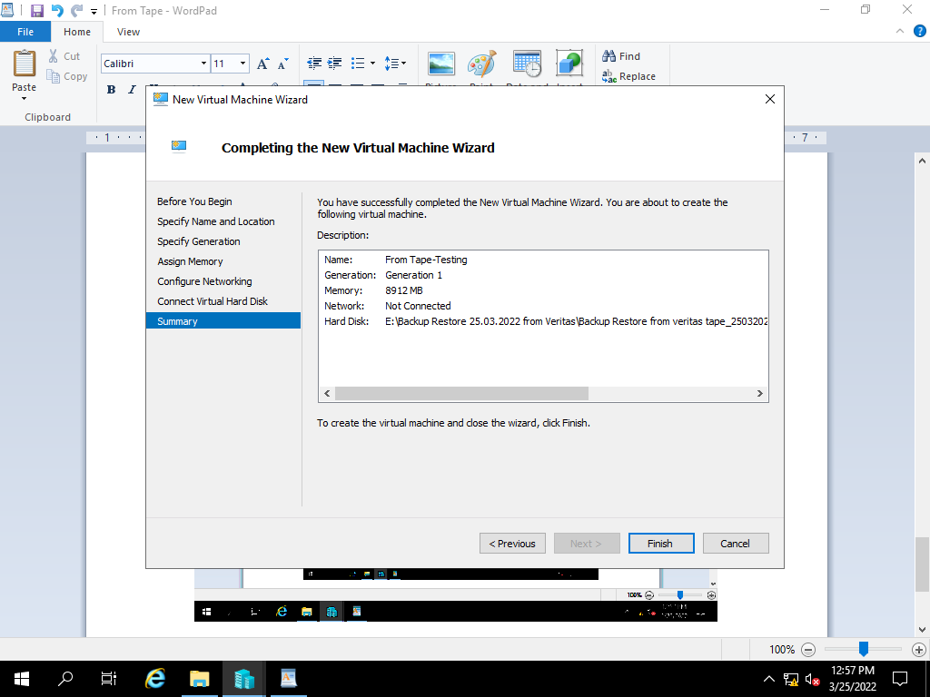

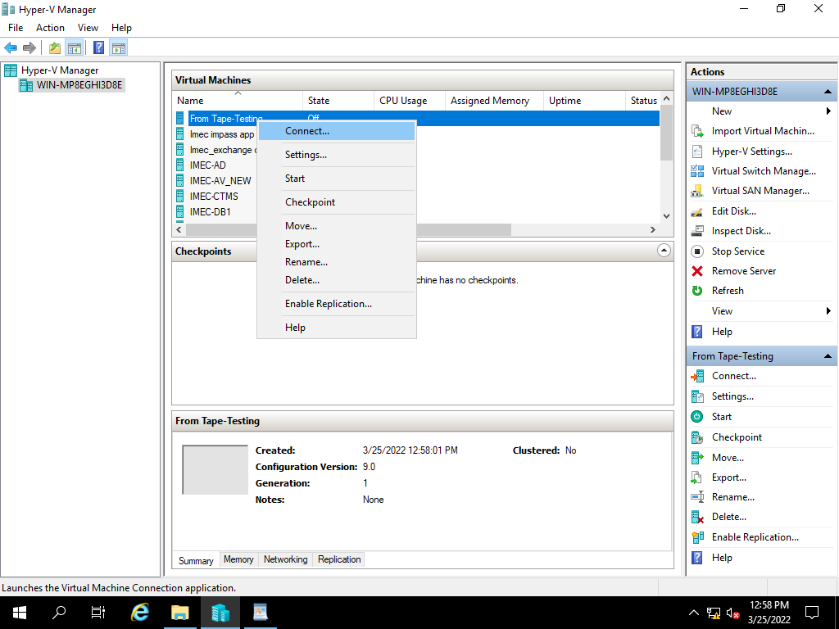

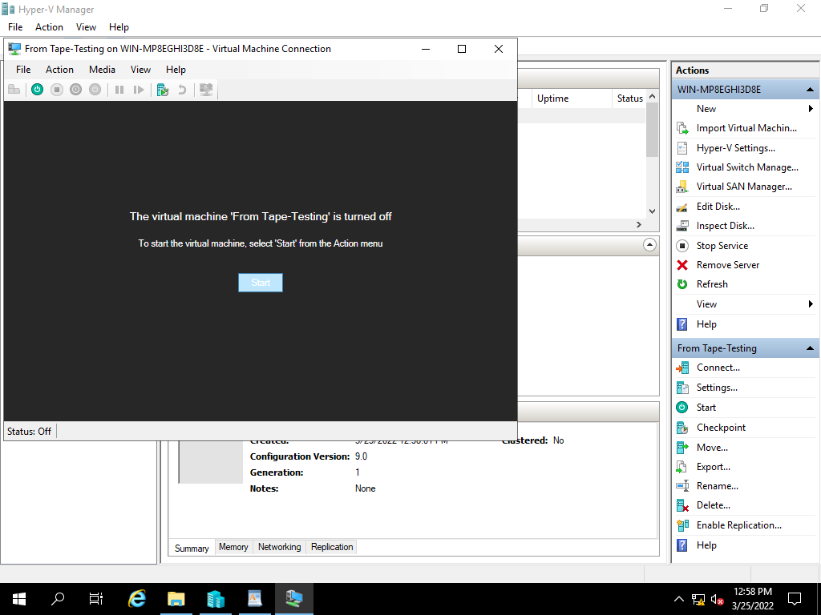

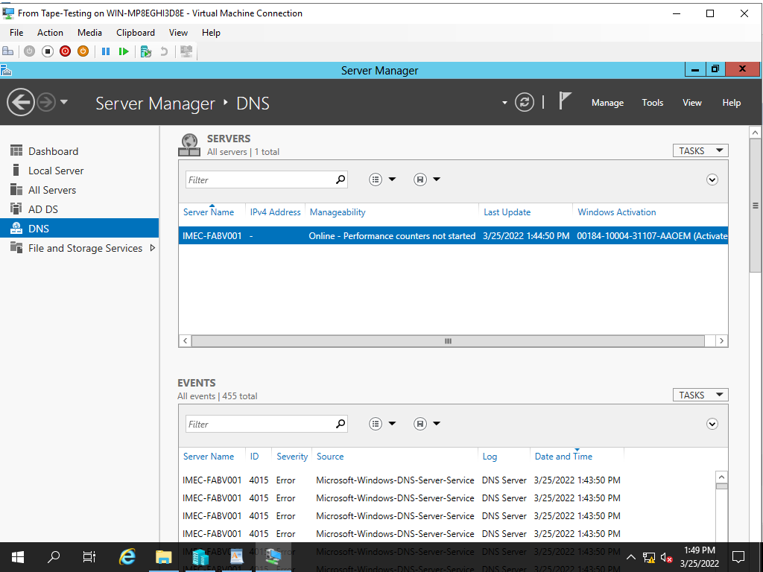

**9) Impas Application VHD Backup Restoration Process**

|  |  |  |  |  |  |  |  |
| --- | --- | --- | --- | --- | --- | --- | --- |
| Manual Backup Restoration | | | | | | | |
| SL. No | Host Name | Host | VM IP | Operating System | Hosted Application Details | Backup Type | Restoration Time | |
| 6 | IMEC-Impas | VM | 10.236.156.33 | Server 2008 | Impas Application server | Manual | 1. mins | |

Right click on Hyper-V Manager, select New and Virtual machine.



Select Next,



Specify the name of the server and click on Next,

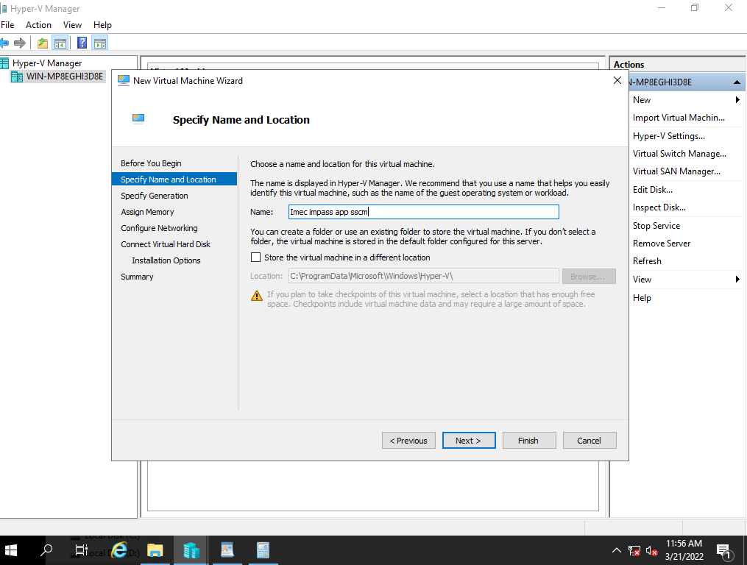

Specify the Generation of virtual machine based on existing, click on Next



Assign the RAM Size Based on existing server, and click on Next



Select the network adopter based on VH Configuration and click on next.



Select the use an existing virtual hard disk option and click on browse.



Browse and select the file and click on open

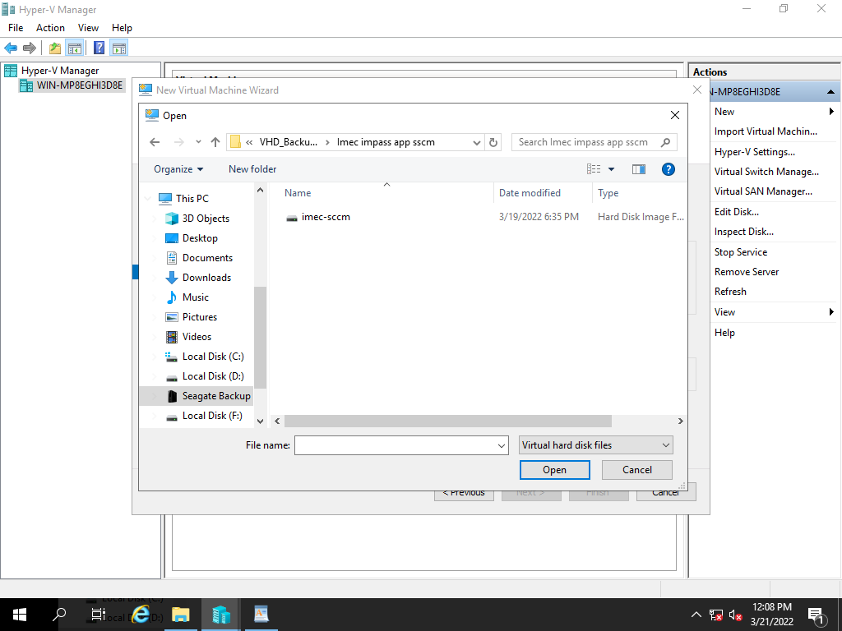

After selecting the file path, click on Next.



Review the summary and click finish to create a virtual machine.

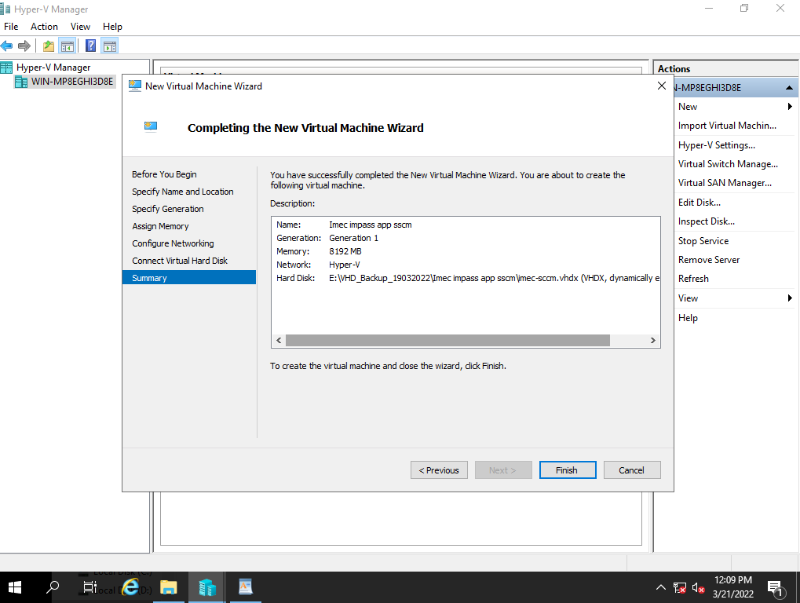

Power on the created Restore VM

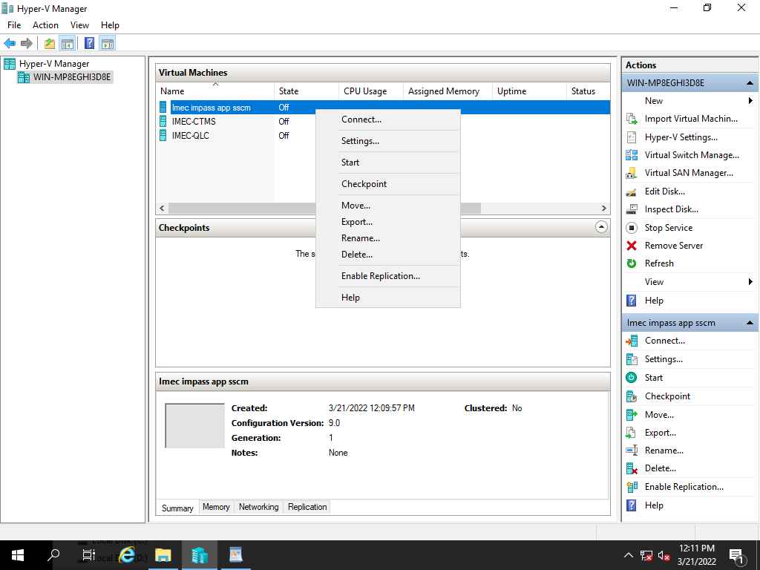

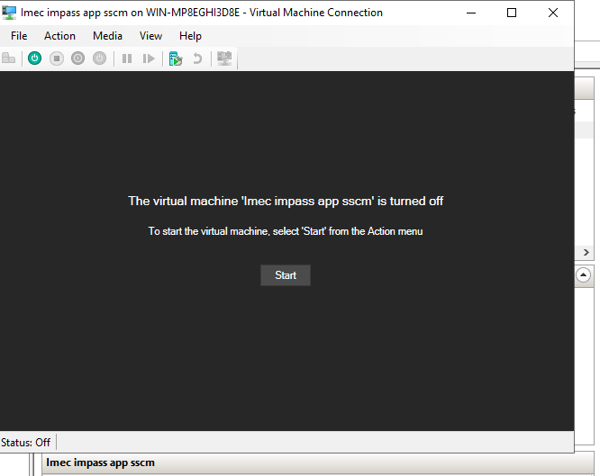

Application logging page.

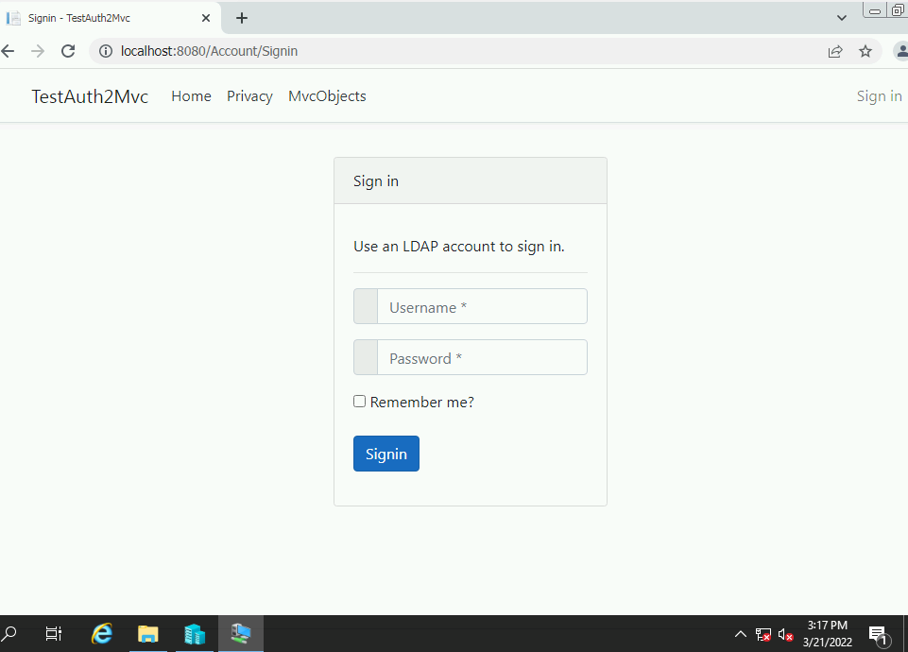

**10) Webproxy VHD Backup Restoration Process**

|  |  |  |  |  |  |  |  |
| --- | --- | --- | --- | --- | --- | --- | --- |
| Manual Backup Restoration | | | | | | | |
| SL. No | Host Name | Host | VM IP | Operating System | Hosted Application Details | Backup Type | Restoration Time |
| 7 | IMEC-WEBPROXY_NEW | VM | 10.236.156.33 | Server 2008 | webproxy IWSVA | Manual | 1. mins |

Right click on Hyper-V Manager, select New and Virtual machine.

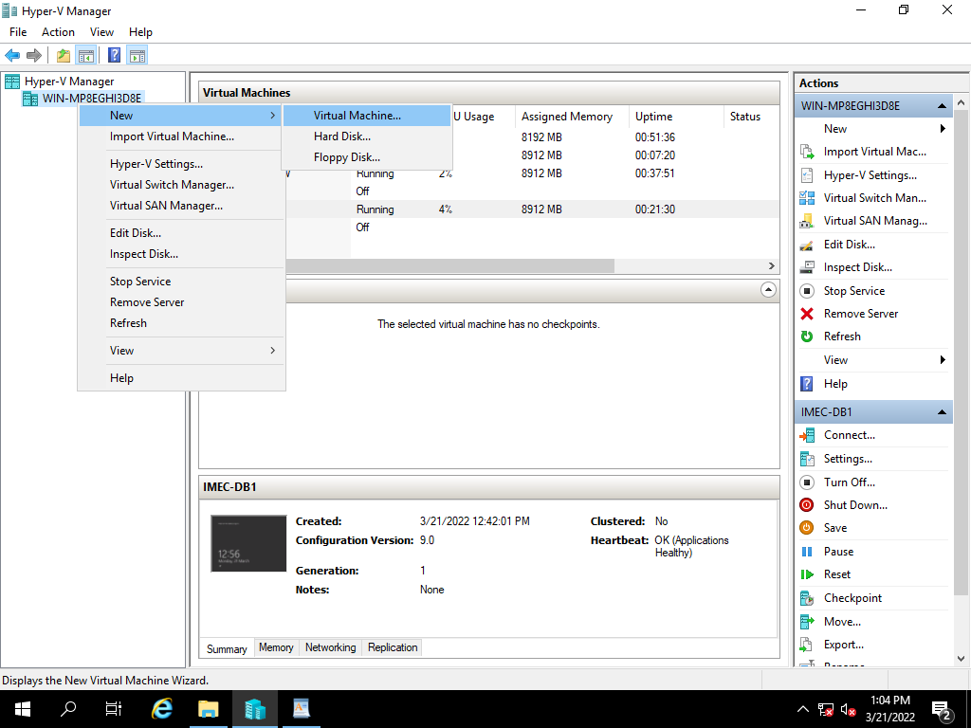

Select Next,



Specify the name of the server and click on Next,

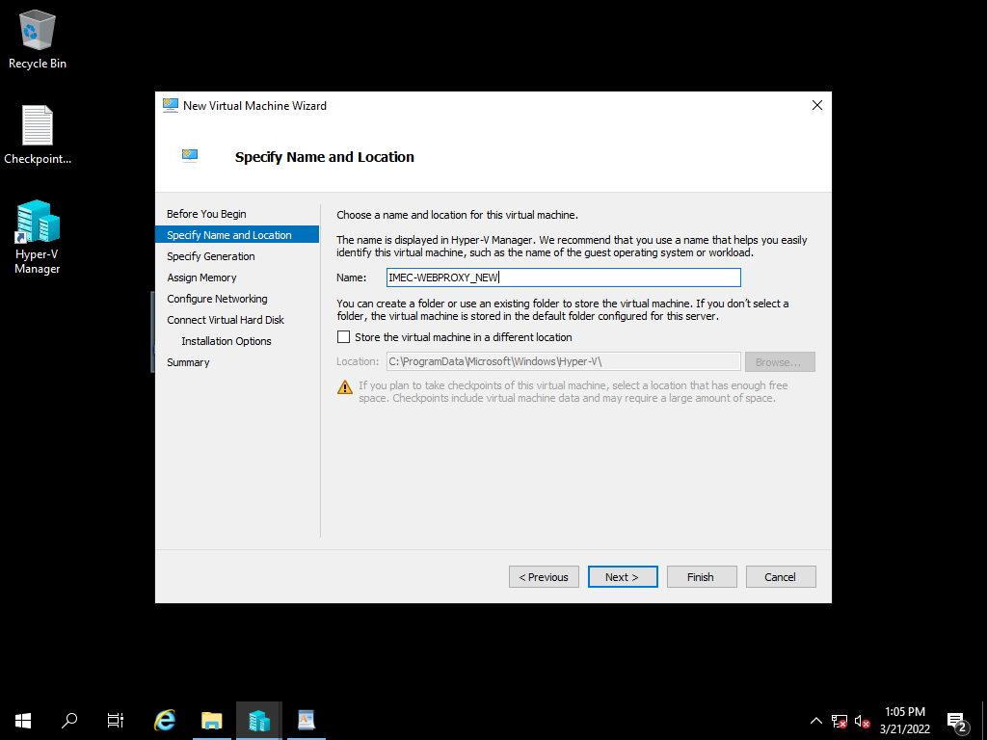

Specify the Generation of virtual machine based on existing, click on Next

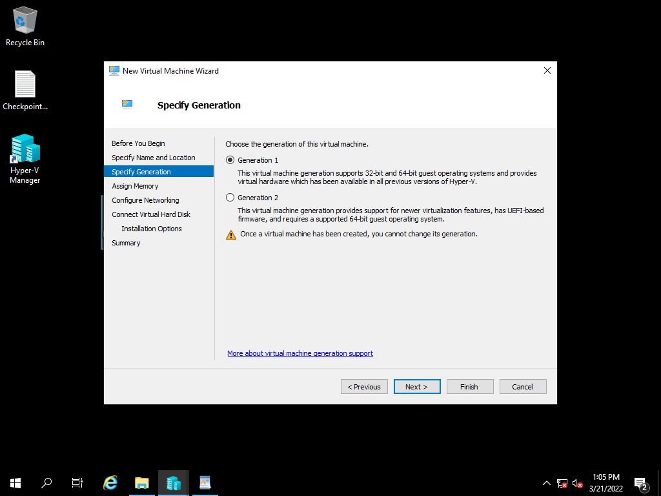

Assign the RAM Size Based on existing server, and click on Next

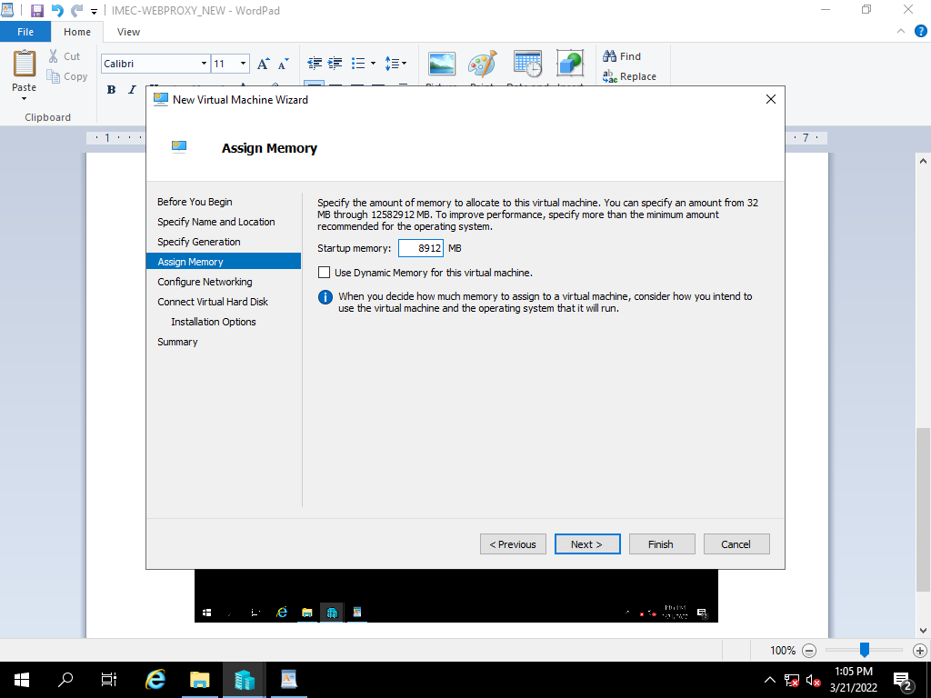

Select the network adopter based on VH Configuration and click on next.

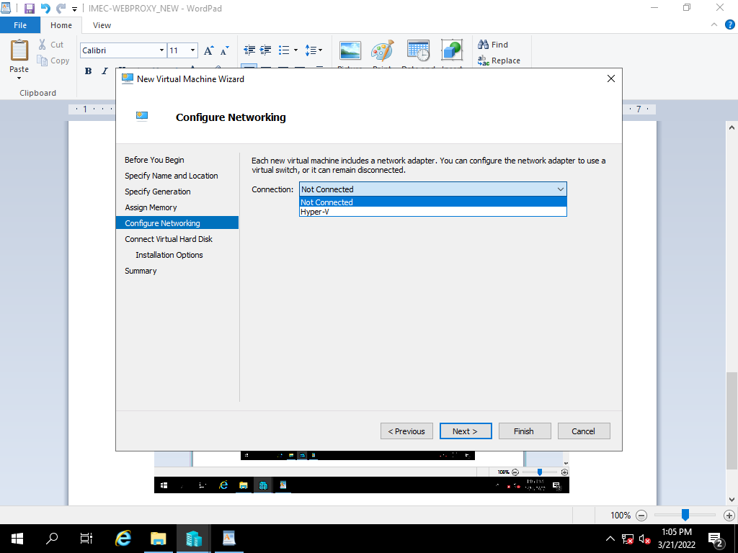

Select the use an existing virtual hard disk option and click on browse.

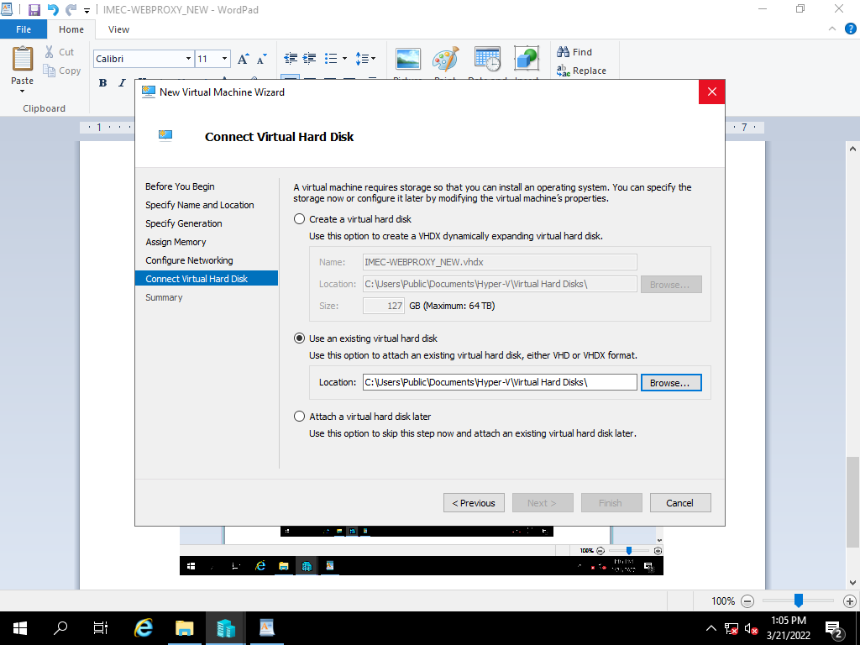

After selecting the file path, click on Next.



Review the summary and click finish to create a virtual machine.

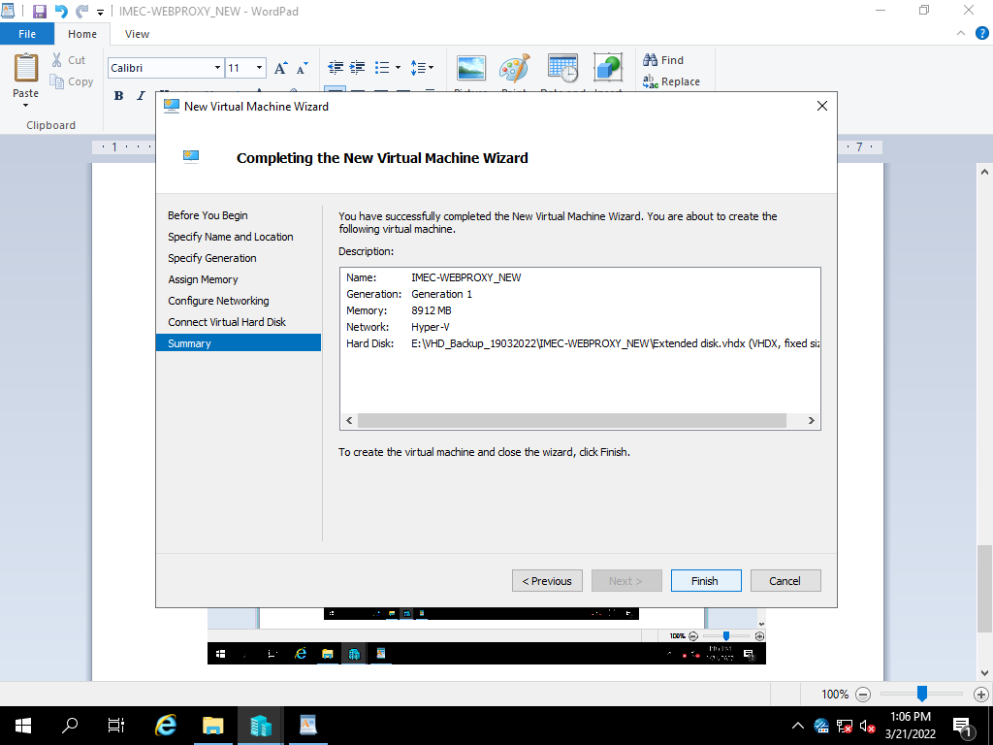

**11) AV Server VHD Backup Restoration Process**

|  |  |  |  |  |  |  |  |
| --- | --- | --- | --- | --- | --- | --- | --- |
| Manual Backup Restoration | | | | | | | |
| SL. No | Host Name | Host | VM IP | Operating System | Hosted Application Details | Backup Type | Restoration Time | |
| 8 | IMEC-AV | VM | 10.236.156.32 | Server 2008 | Antivirus -New | Manual | 1. mins | |

Right click on Hyper-V Manager, select New and Virtual machine.

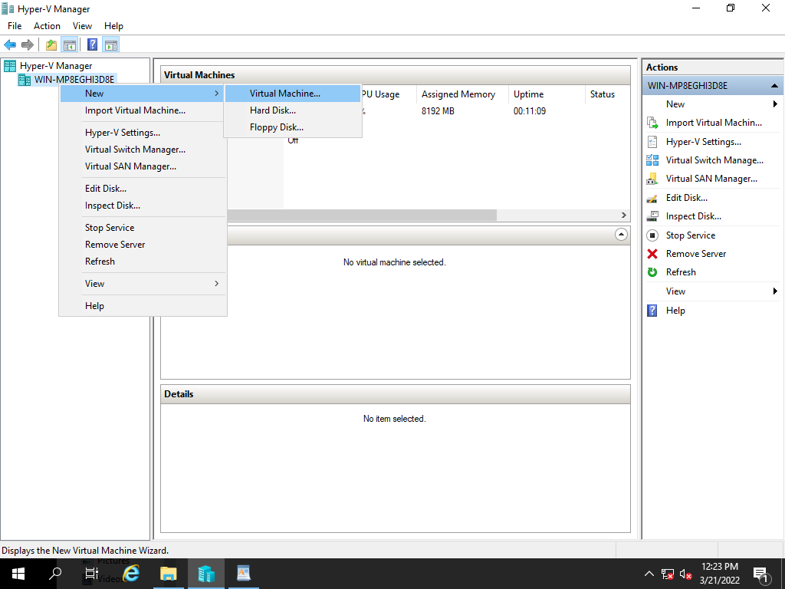

Select Next,

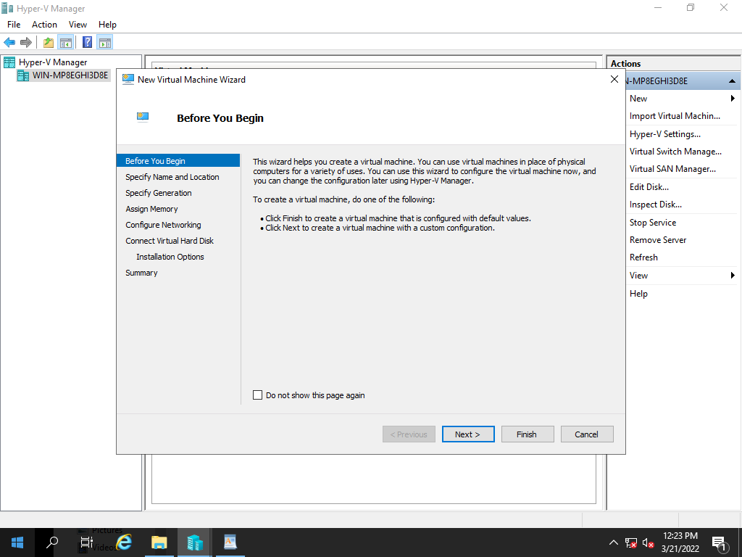

Specify the name of the server and click on Next,

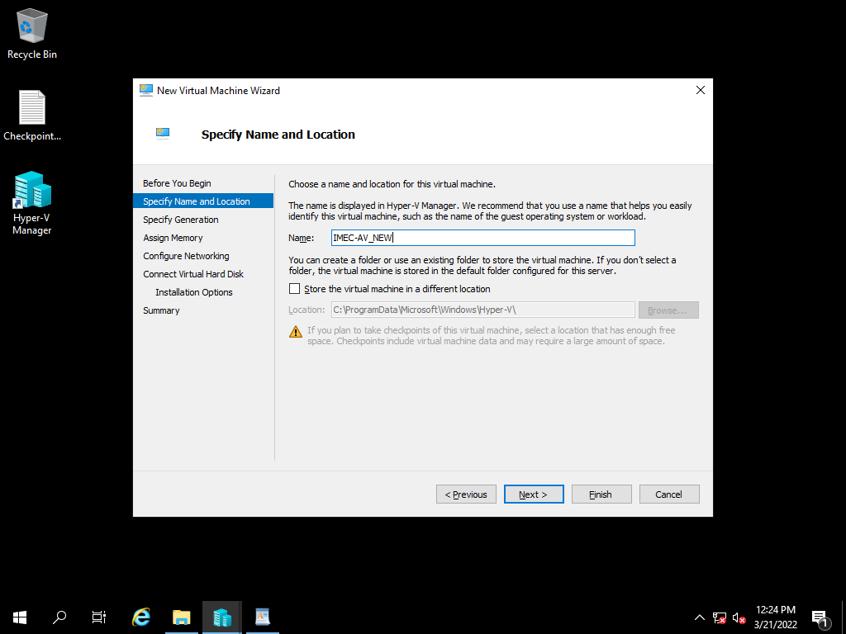

Specify the Generation of virtual machine based on existing, click on Next

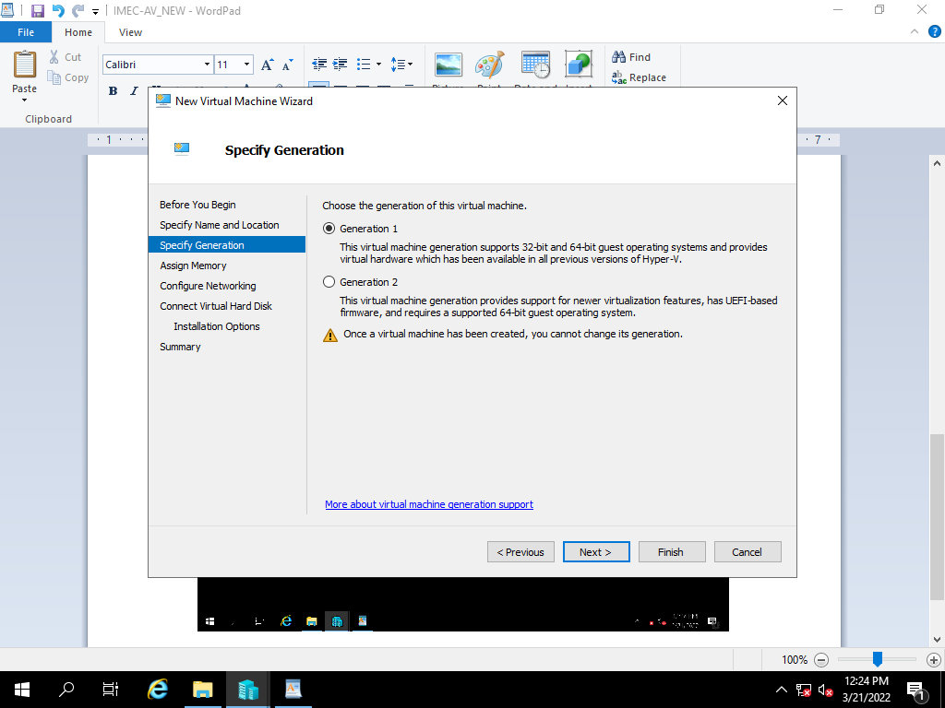

Assign the RAM Size Based on existing server, and click on Next

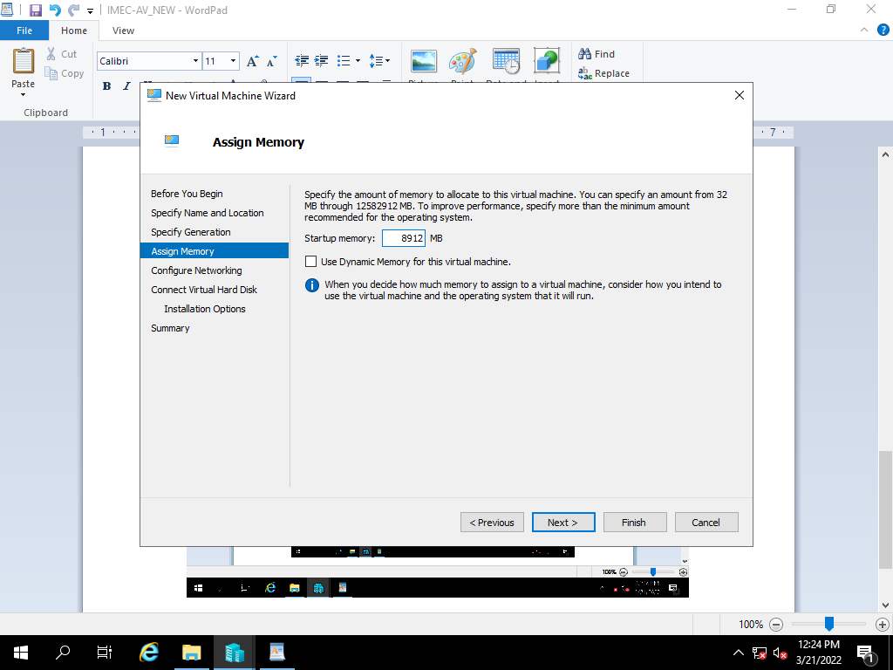

Select the network adopter based on VH Configuration and click on next.

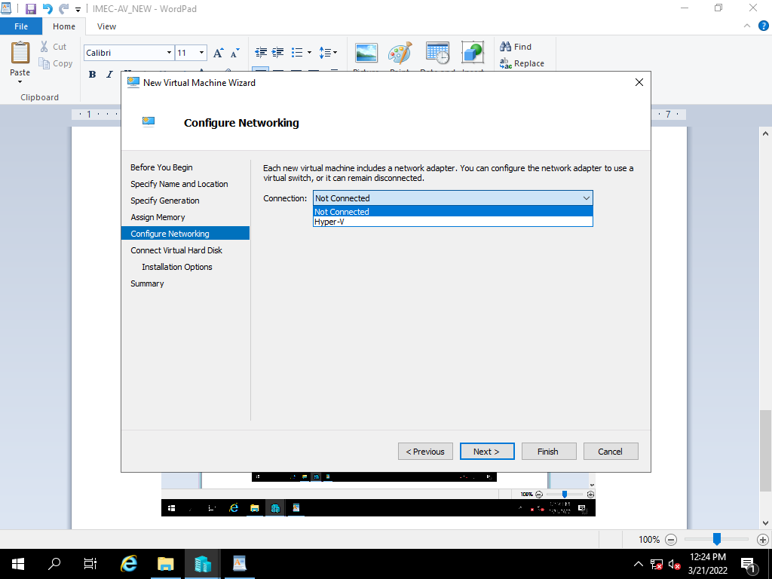

Select the use an existing virtual hard disk option and click on browse.

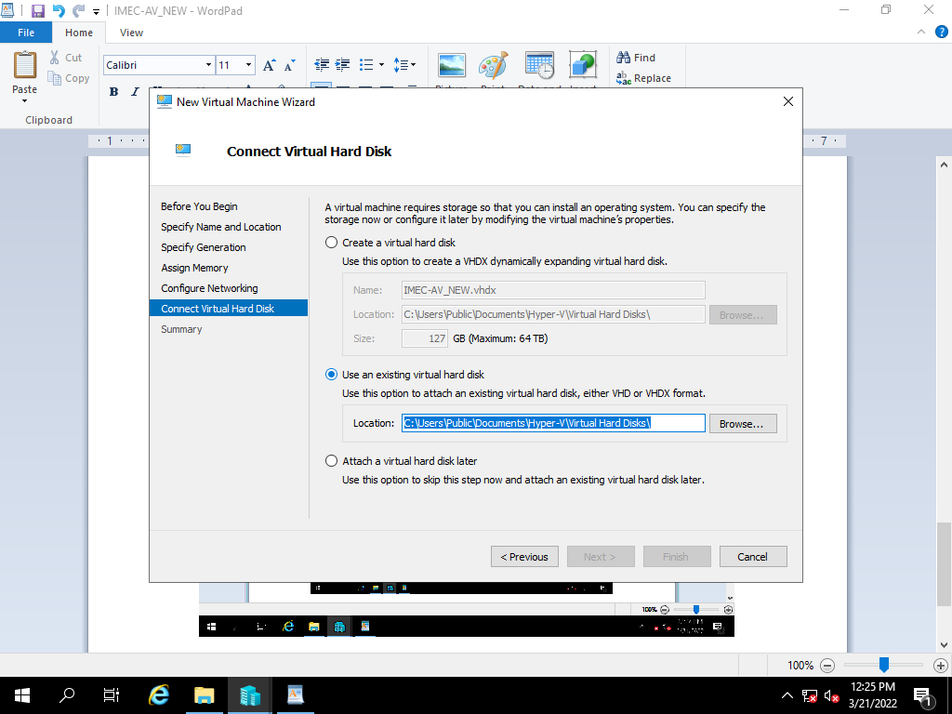

Browse and select the file and click on open

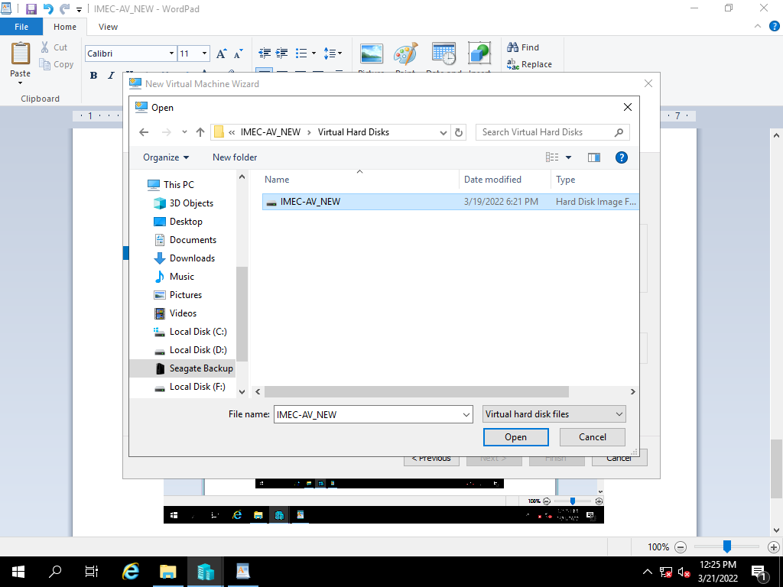

After selecting the file path, click on Next.

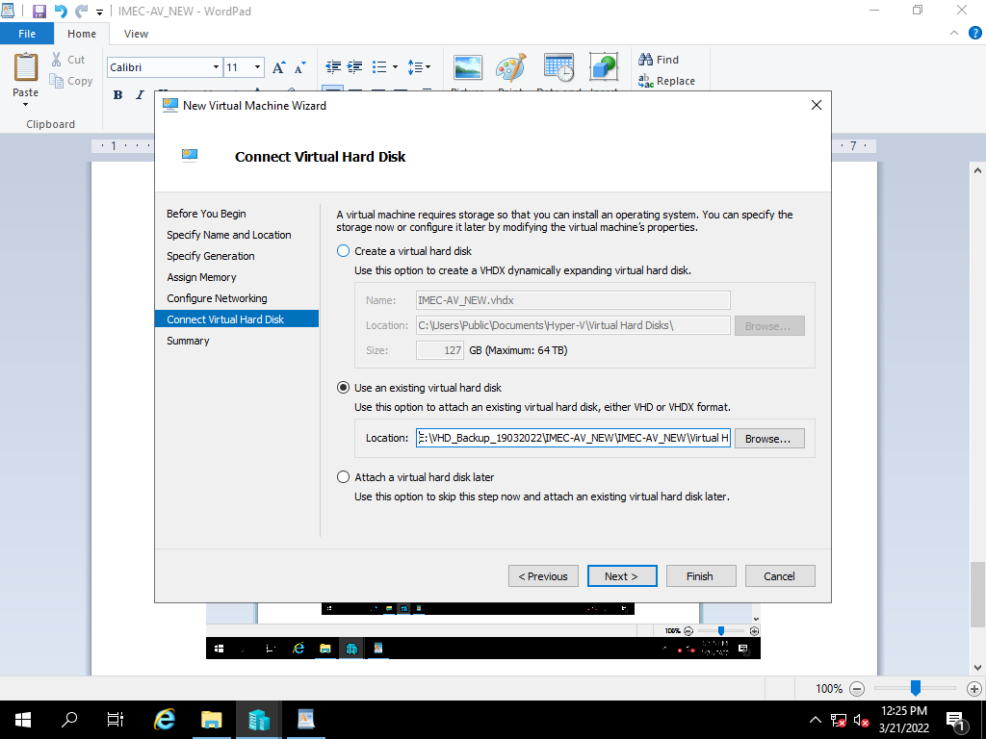

Review the summary and click finish to create a virtual machine.

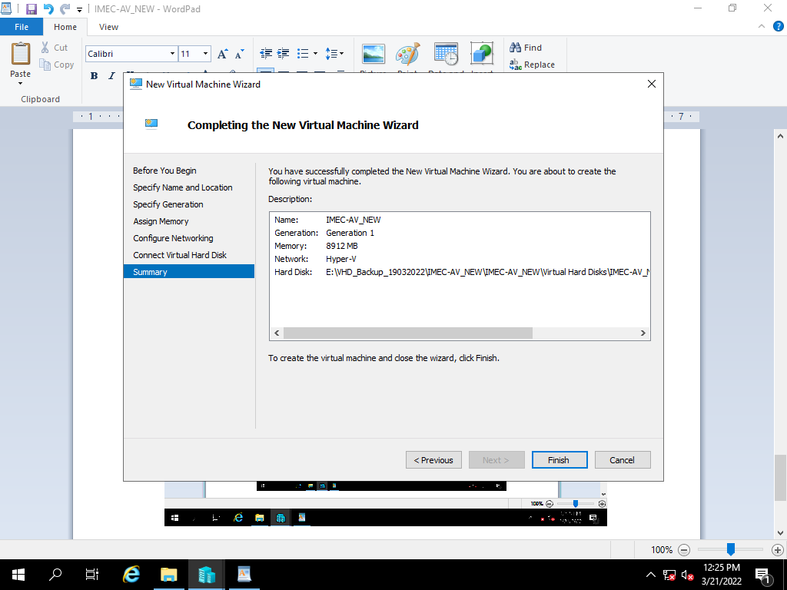

Power on the created Restore VM

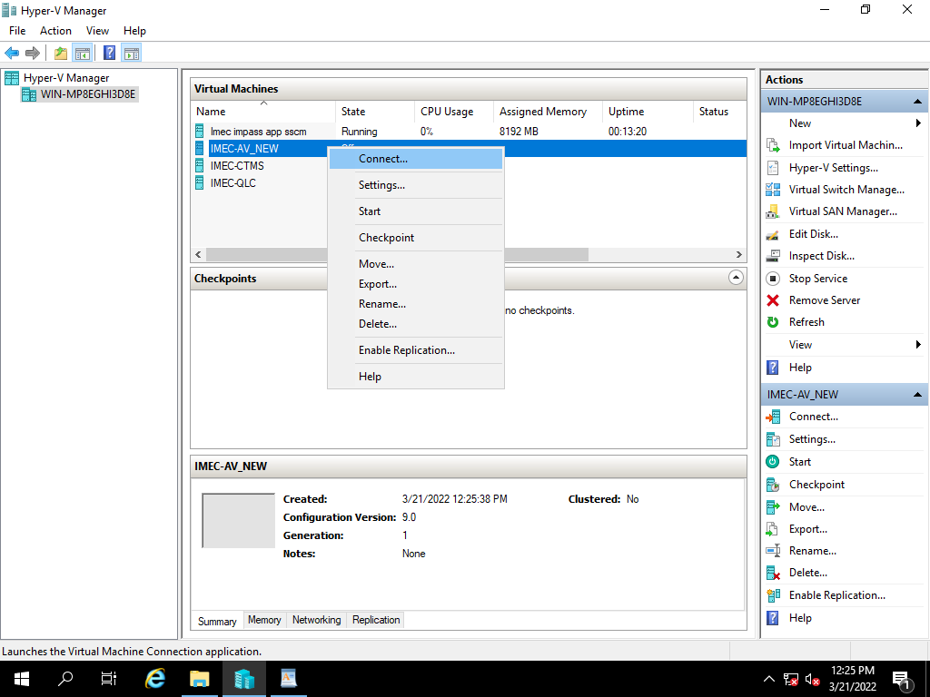

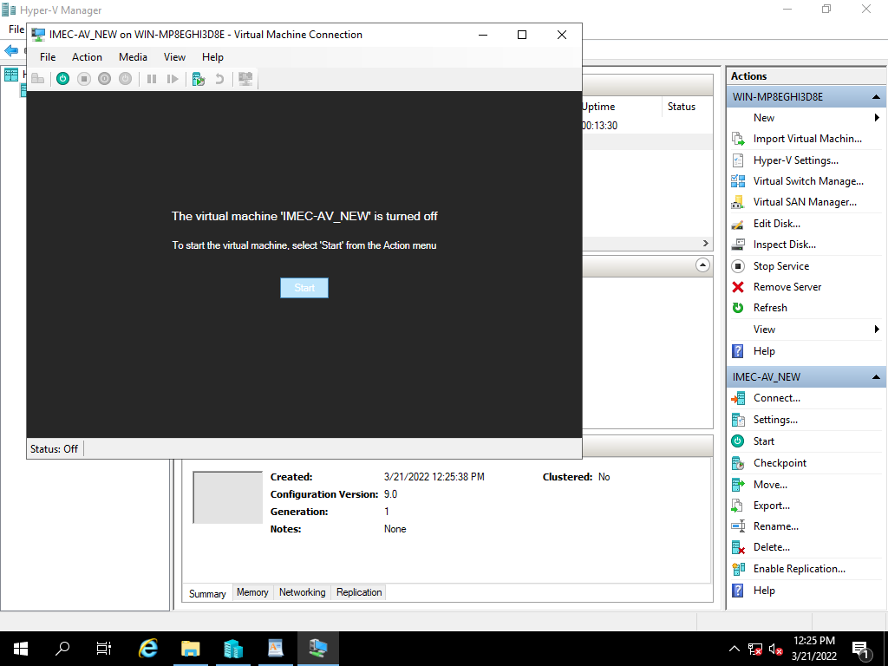

**12) IMEC-DB1 Trend Encryption VHD Backup Restoration Process**

|  |  |  |  |  |  |  |  |
| --- | --- | --- | --- | --- | --- | --- | --- |
| Manual Backup Restoration | | | | | | | |
| SL. No | Host Name | Host | VM IP | Operating System | Hosted Application Details | Backup Type | Restoration Time | |
| 9 | IMEC-DB1 | VM | 10.236.156.36 | Server 2008 | Trend Encryption | Manual | 1. mins | |

Right click on Hyper-V Manager, select New and Virtual machine.

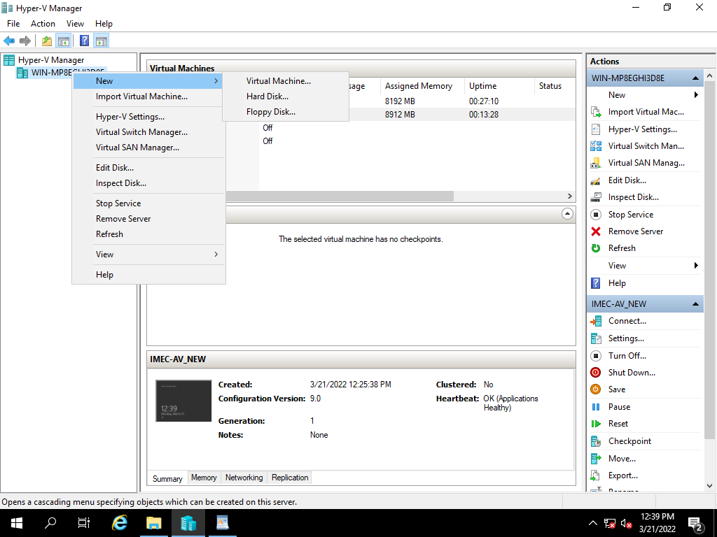

Select Next,

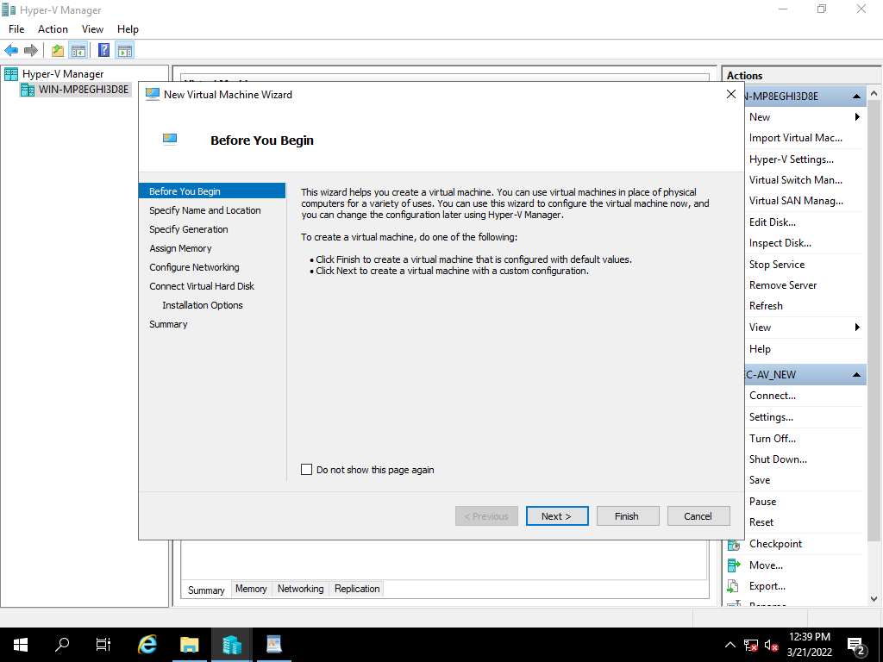

Specify the name of the server and click on Next,

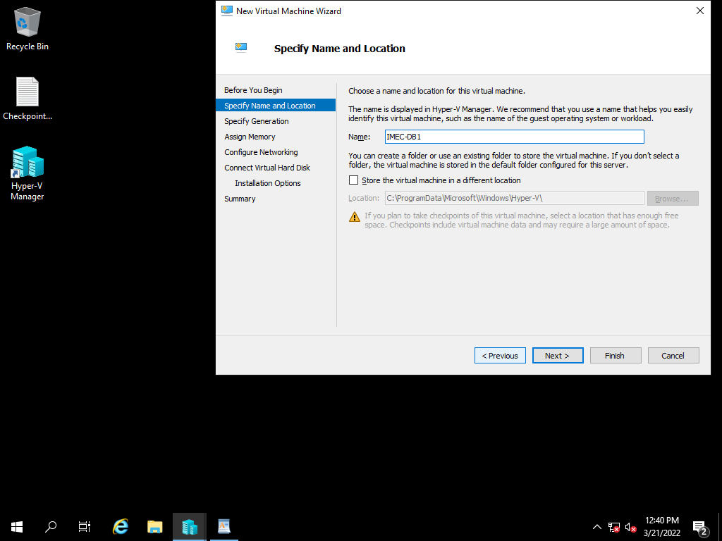

Specify the Generation of virtual machine based on existing, click on Next

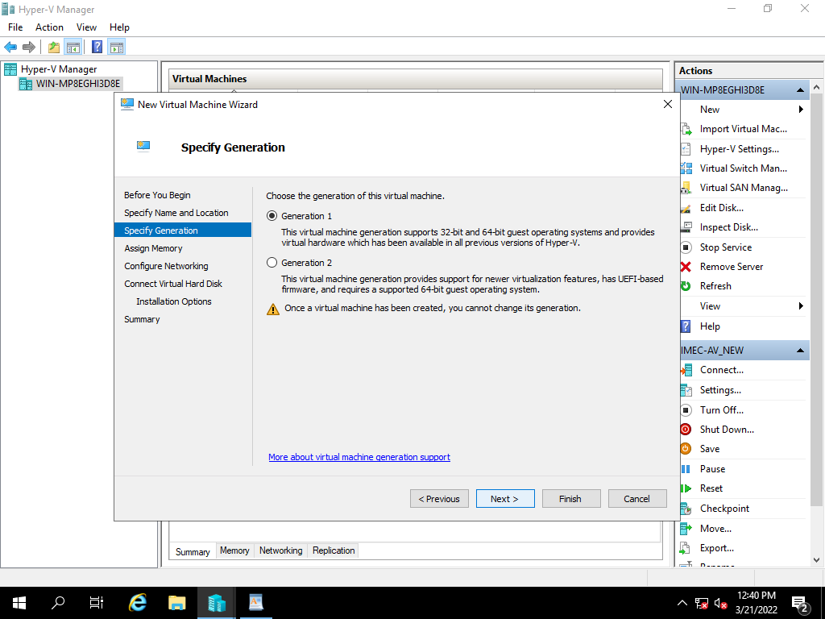

Assign the RAM Size Based on existing server, and click on Next

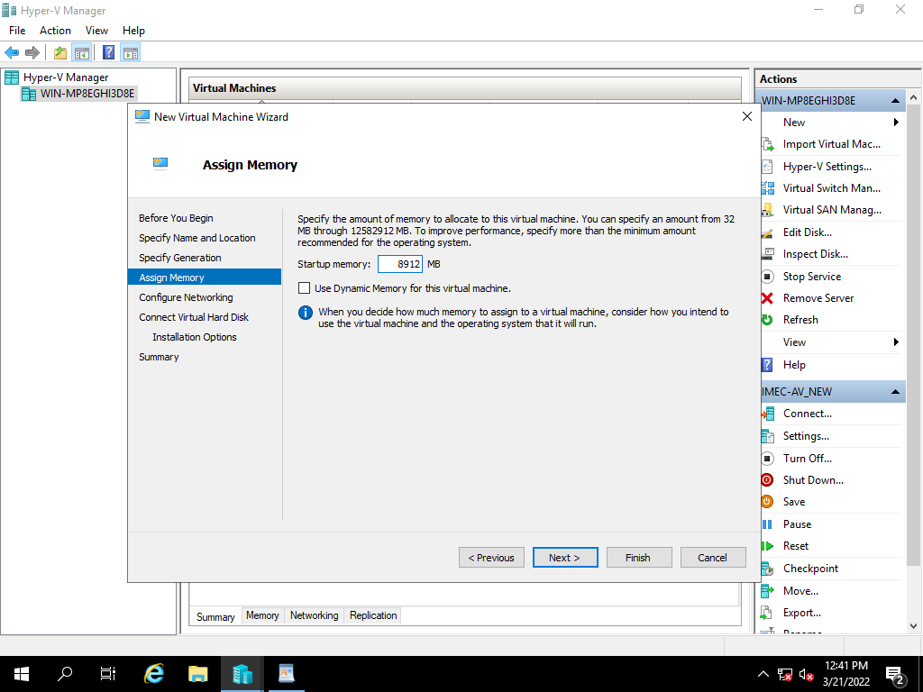

Select the network adopter based on VH Configuration and click on next.

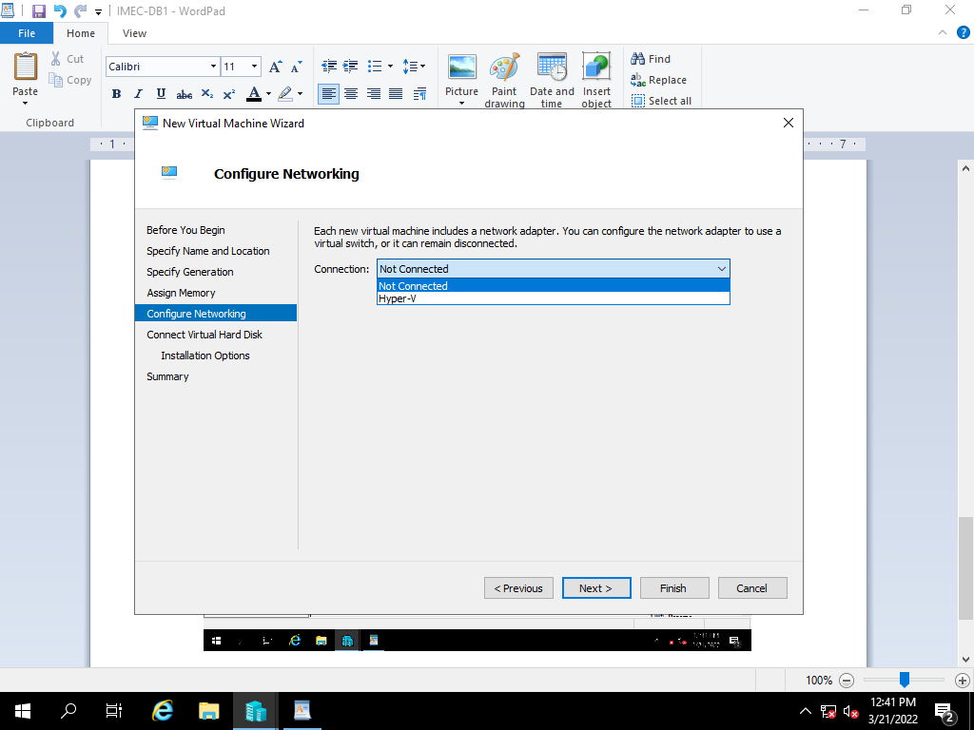

Select the use an existing virtual hard disk option and click on browse.



After selecting the file path, click on Next.

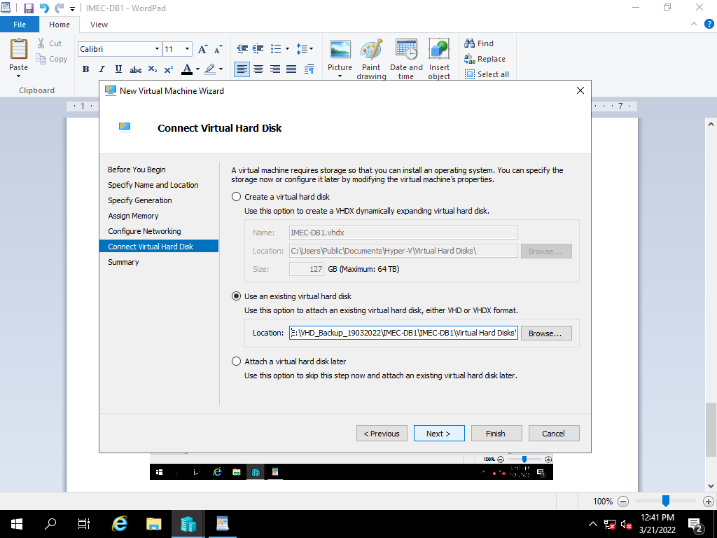

Review the summary and click finish to create a virtual machine.

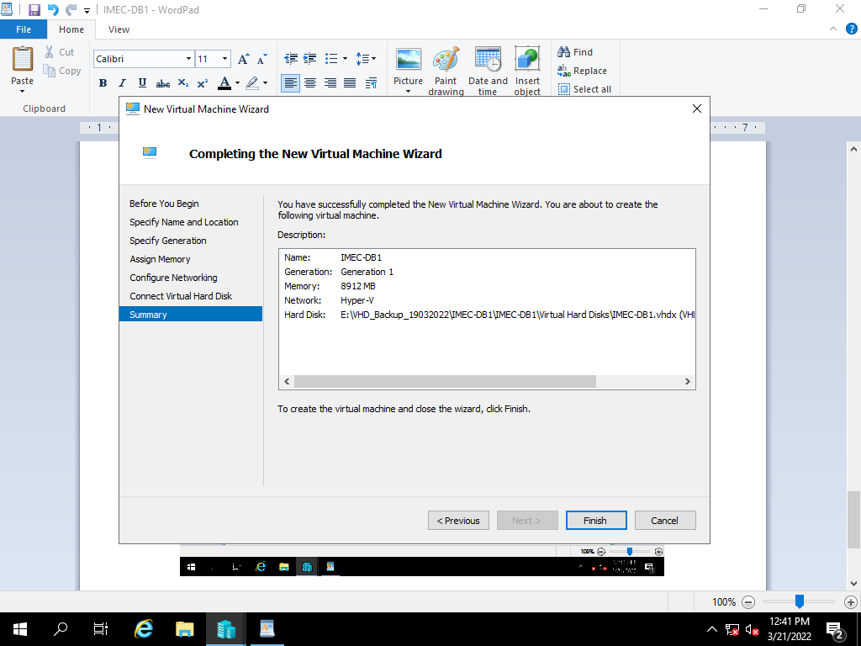

Power on the created Restore VM

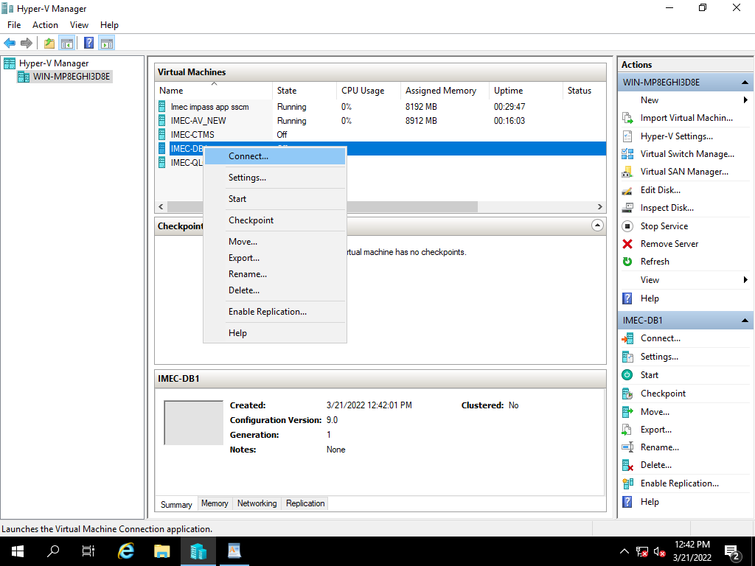

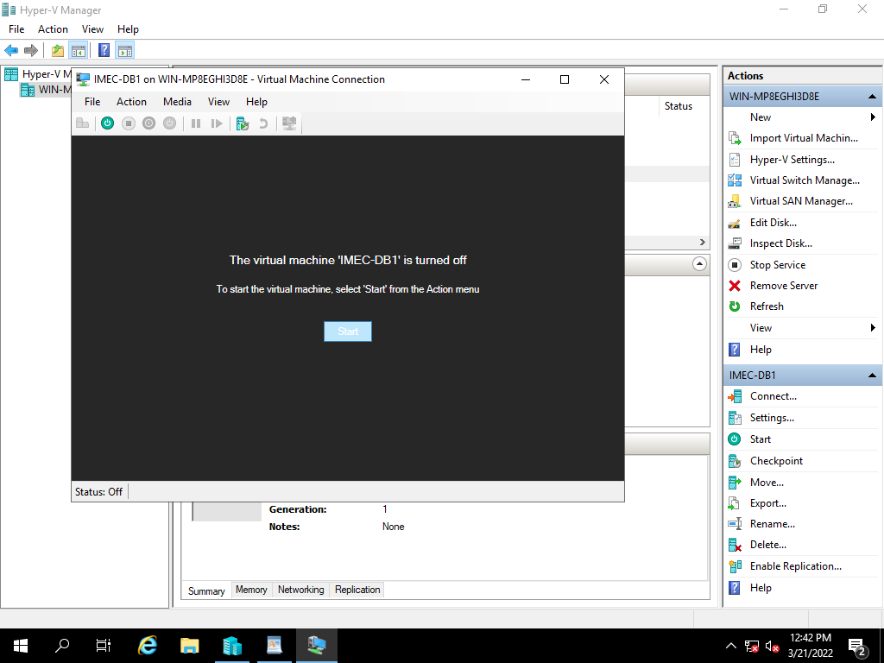

**12)IMPAS DB2 VHD Backup Restoration Process**

|  |  |  |  |  |  |  |  |
| --- | --- | --- | --- | --- | --- | --- | --- |
| Manual Backup Restoration | | | | | | | |
| SL. No | Host Name | Host | VM IP | Operating System | Hosted Application Details | Backup Type | Restoration Time | |
| 10 | IMEC-FABC011 | VM | 10.236.179.150 | Server 2008 | IMPAS Data Base (imec-DB2) | Manual | 1. mins | |

Right click on Hyper-V Manager, select New and Virtual machine.

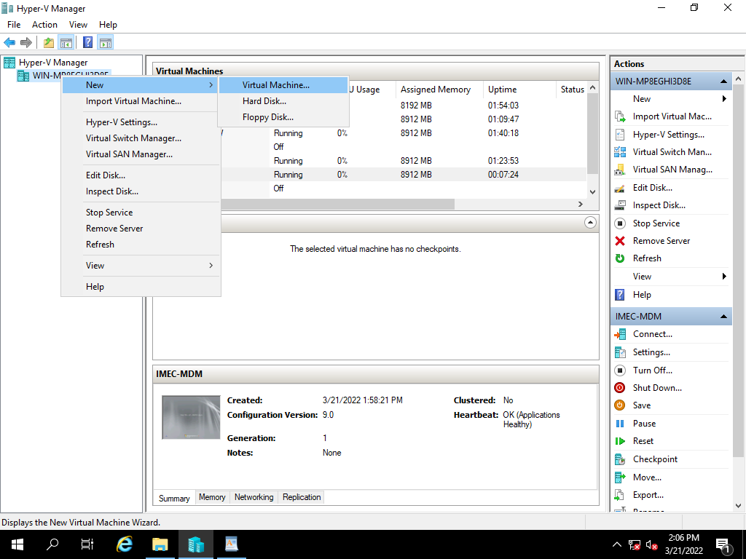

Select Next,

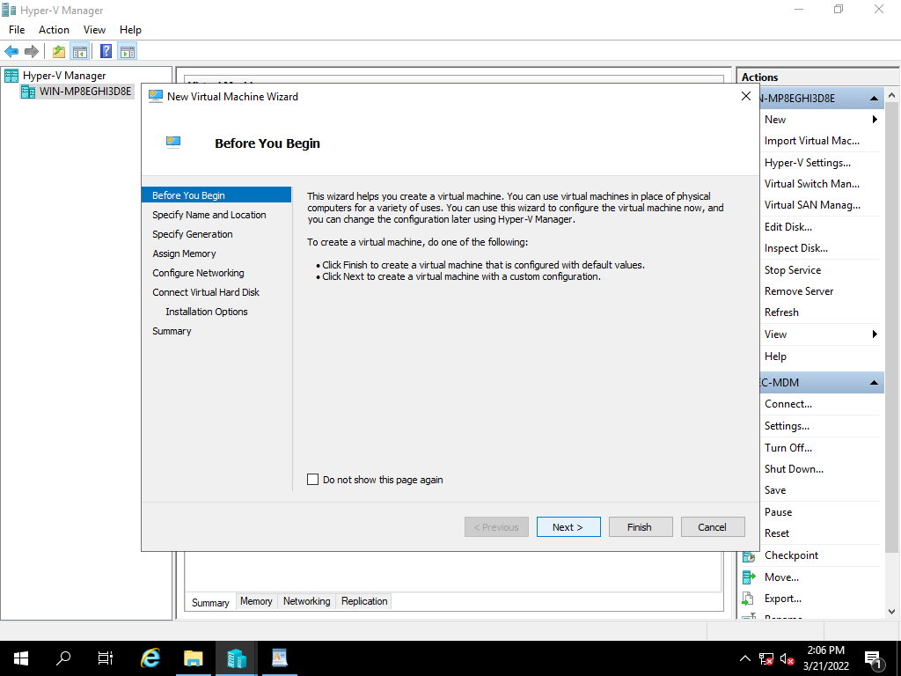

Specify the name of the server and click on Next,

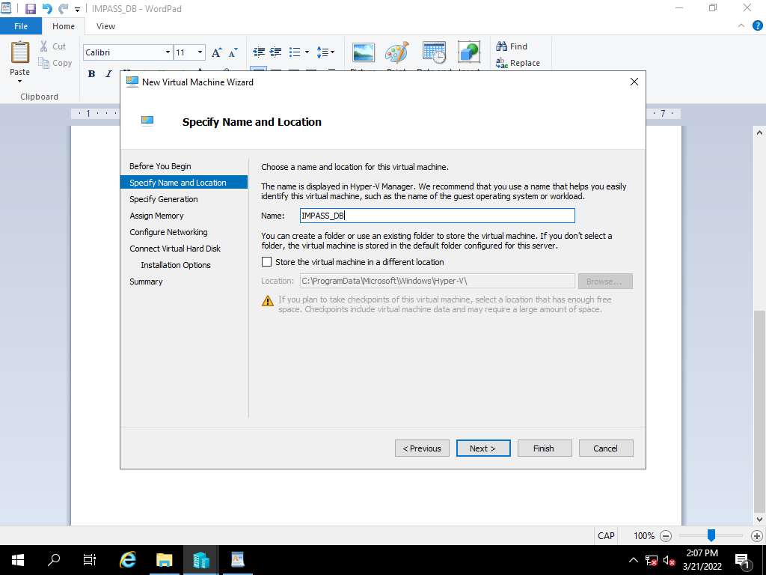

Specify the Generation of virtual machine based on existing, click on Next

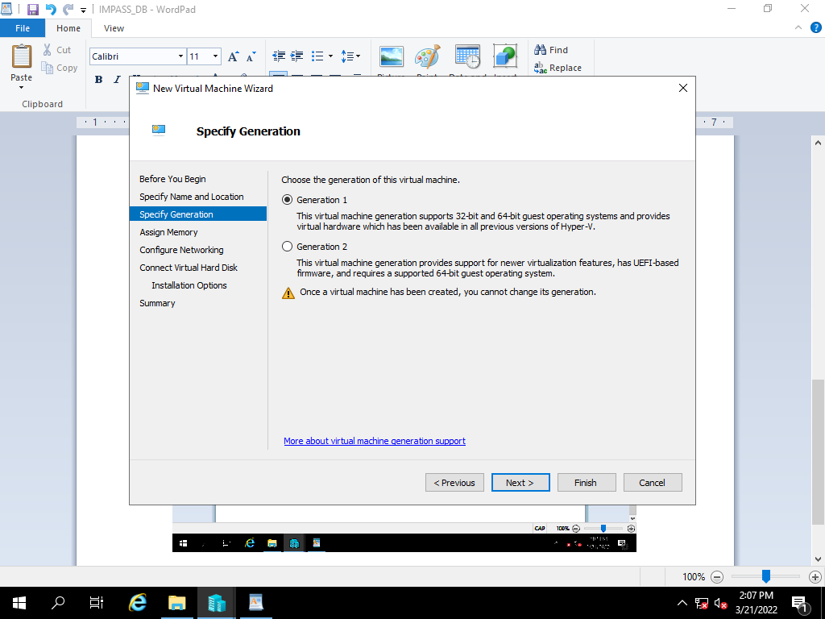

Assign the RAM Size Based on existing server, and click on Next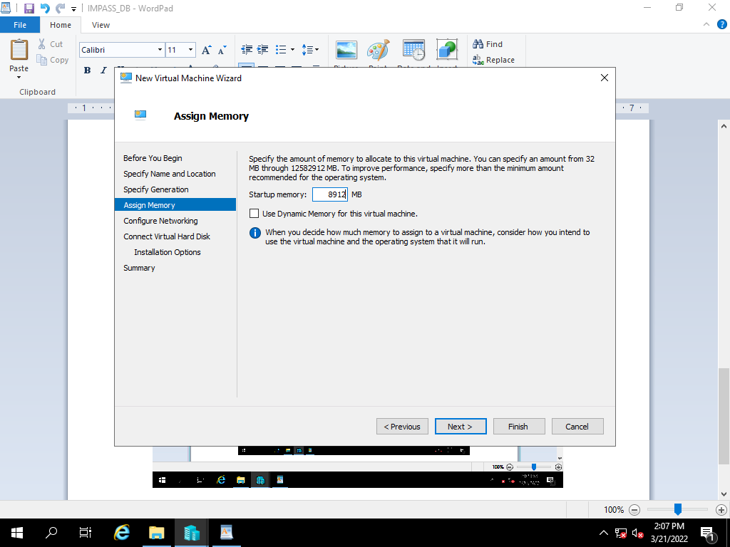

Select the network adopter based on VH Configuration and click on next.

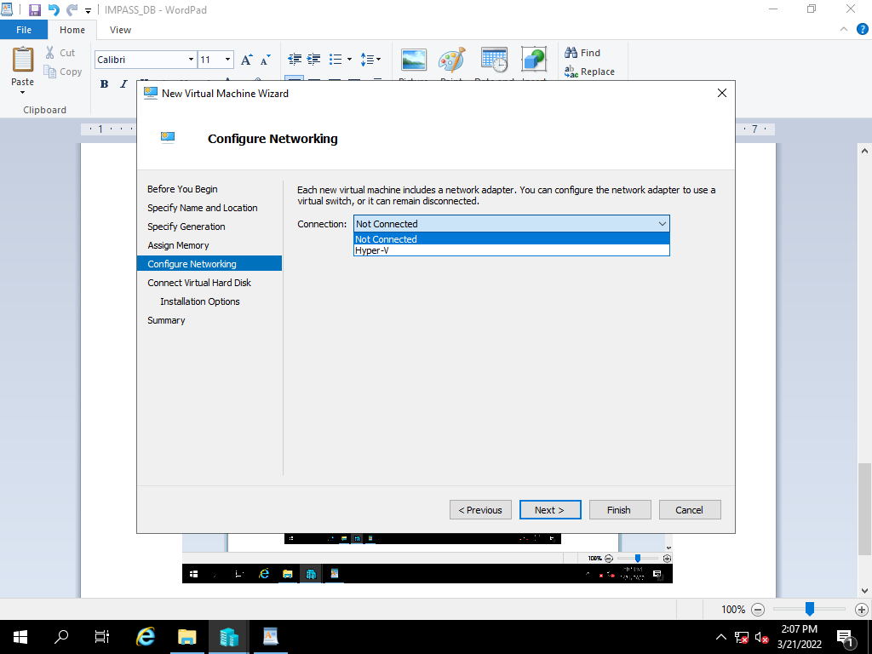

Select the use an existing virtual hard disk option and click on browse.

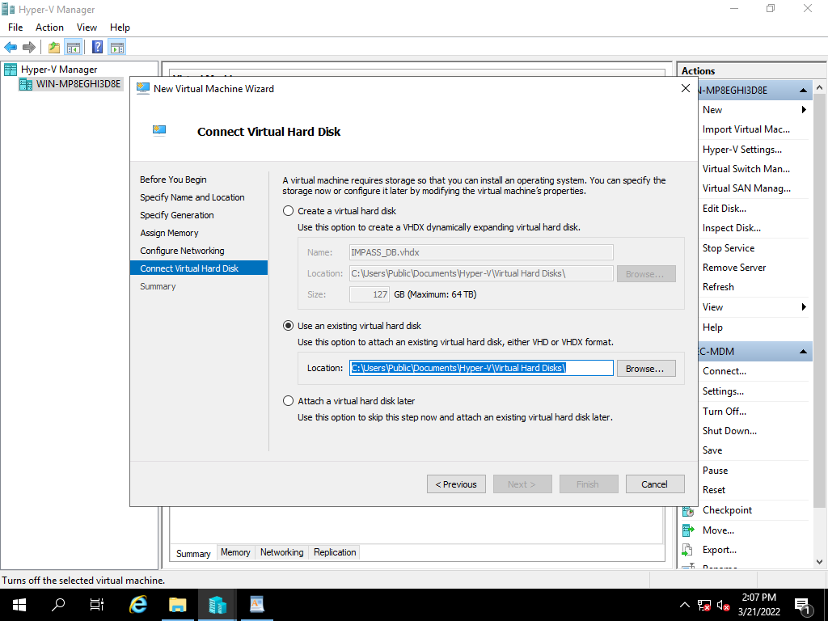

After selecting the file path, click on Next. 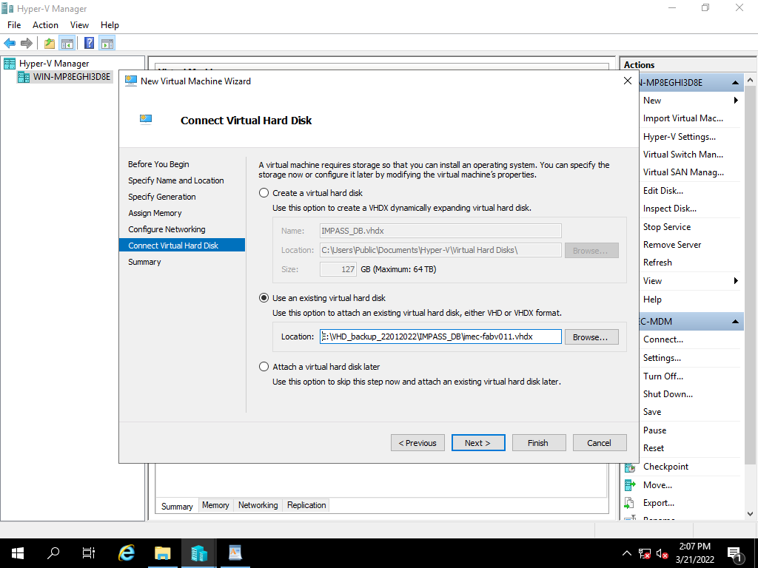

Review the summary and click finish to create a virtual machine.

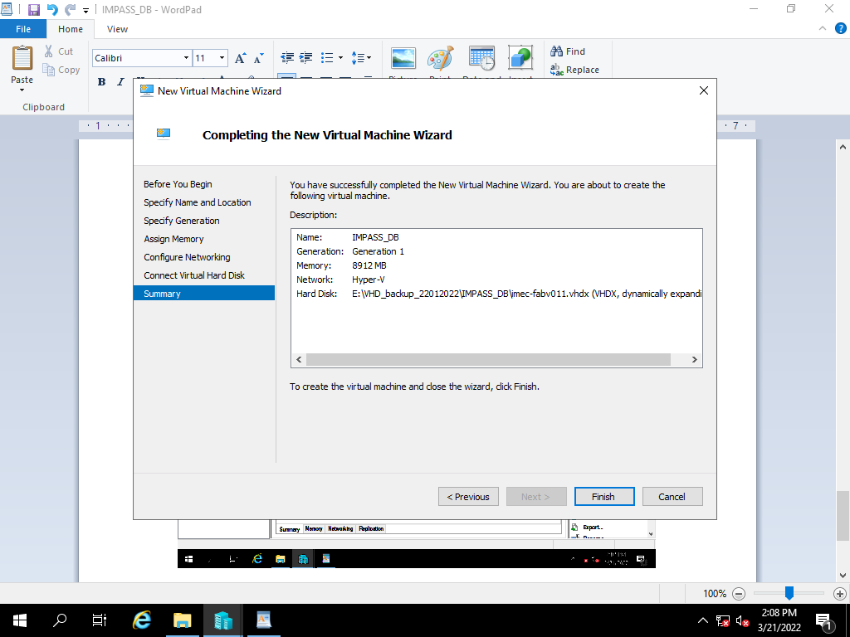

Power on the created Restore VM

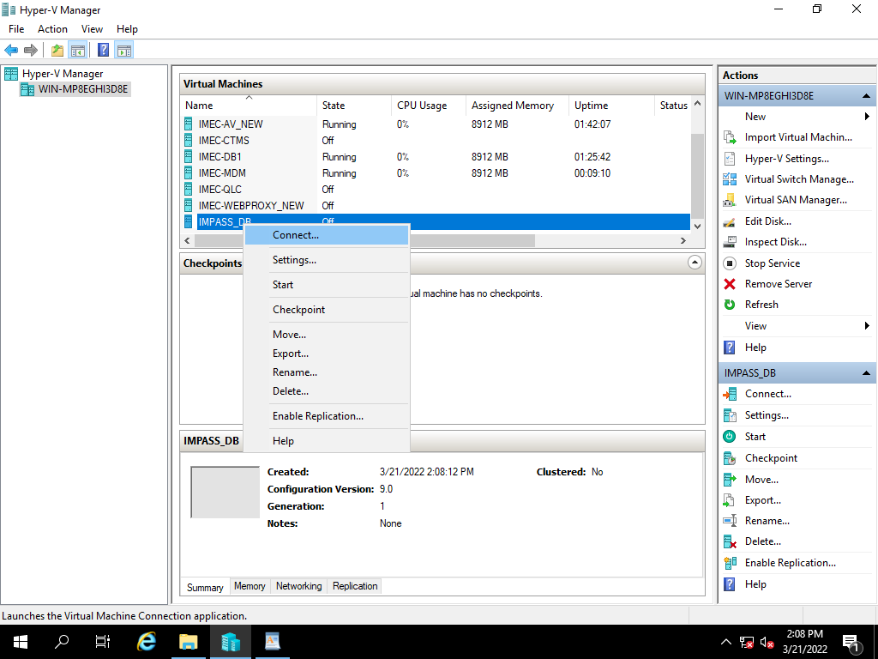

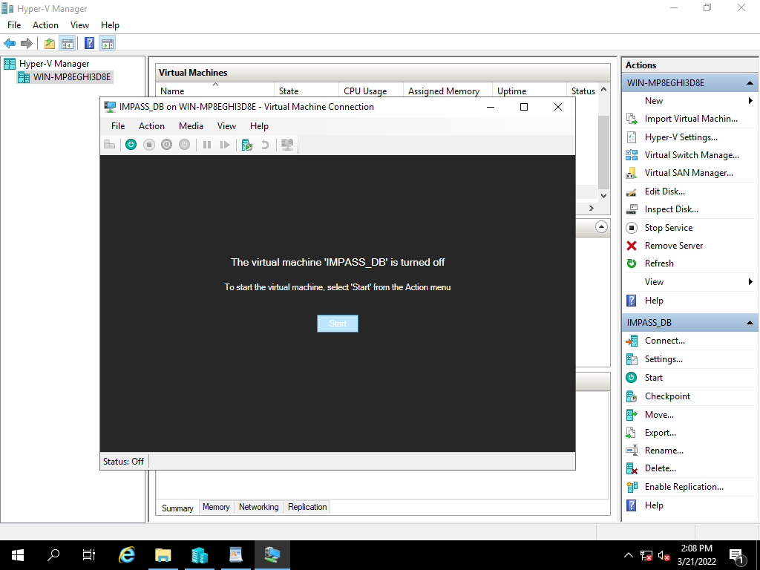

After successful restoration, Verified DB

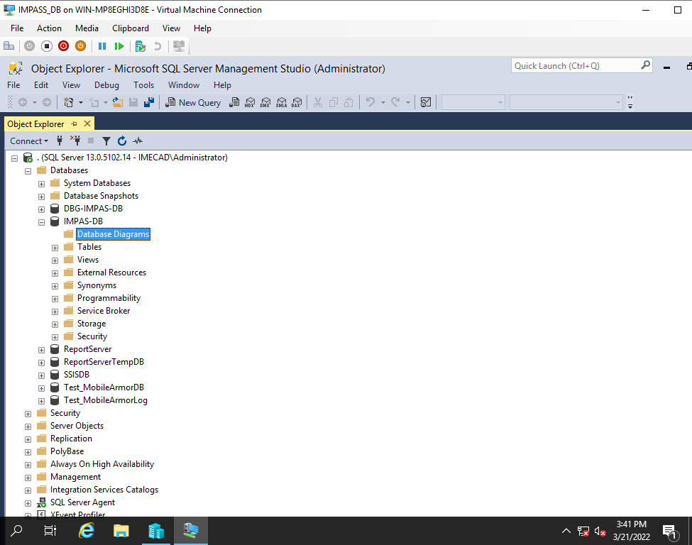

**13) IMEC -MDM Server VHD Backup Restoration Process**

|  |  |  |  |  |  |  |  |
| --- | --- | --- | --- | --- | --- | --- | --- |
| Manual Backup Restoration | | | | | | | |
| SL. No | Host Name | Host | VM IP | Operating System | Hosted Application Details | Backup Type | Restoration Time | |
| 11 | IMEC-MDM | VM | 10.236.156.15 | Server 2008 | mobile device | Manual | 1. mins | |

Right click on Hyper-V Manager, select New and Virtual machine.

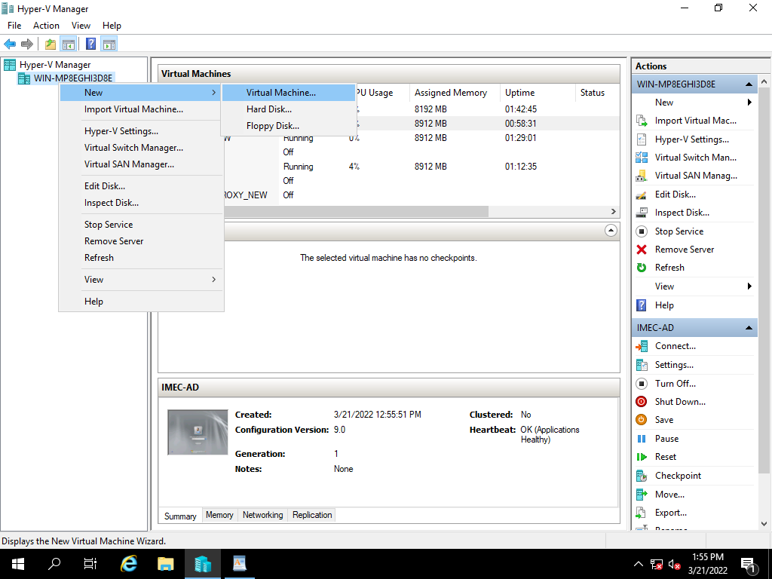

Select Next,

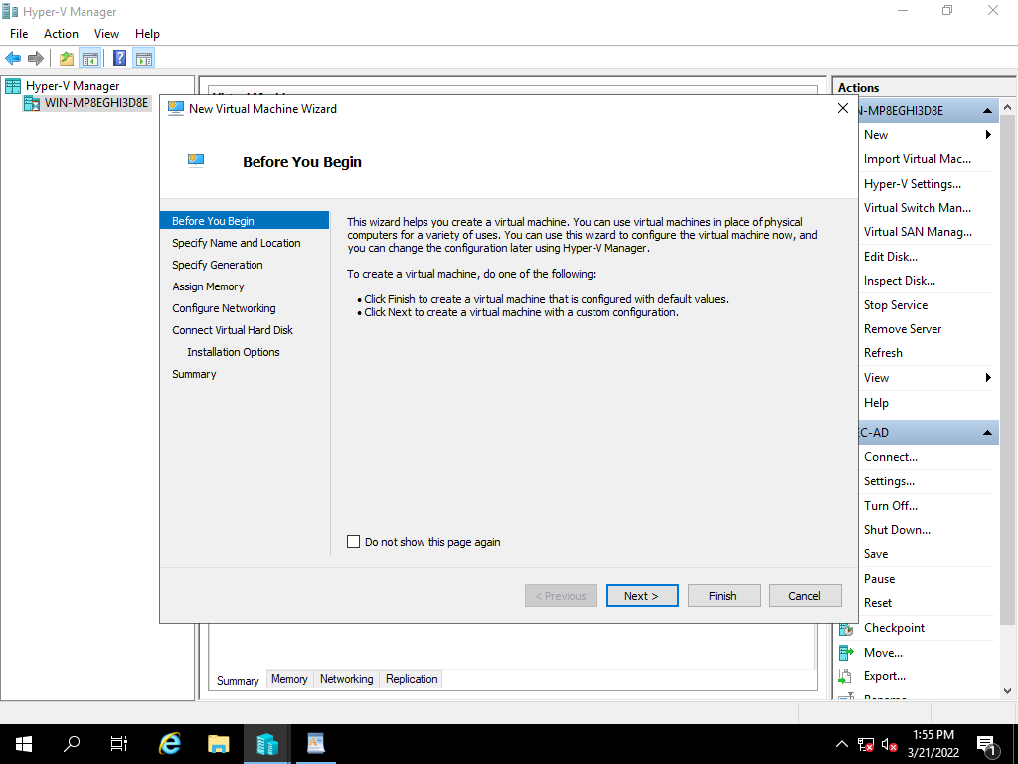

Specify the name of the server and click on Next,

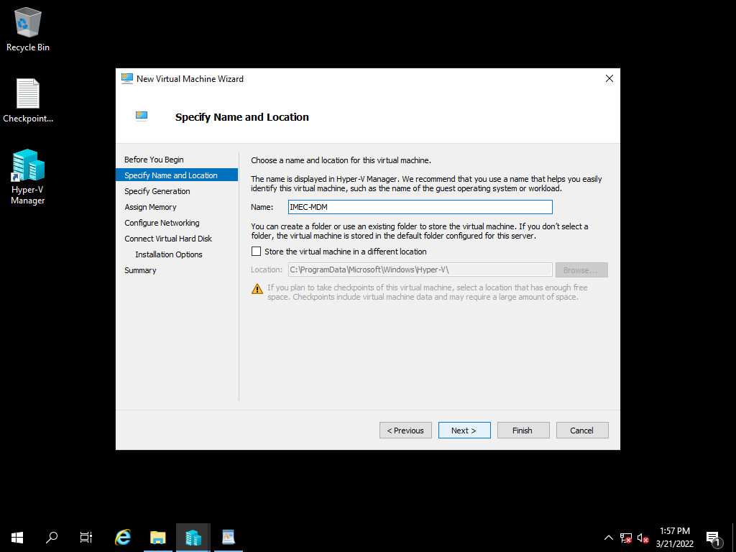

Specify the Generation of virtual machine based on existing, click on Next

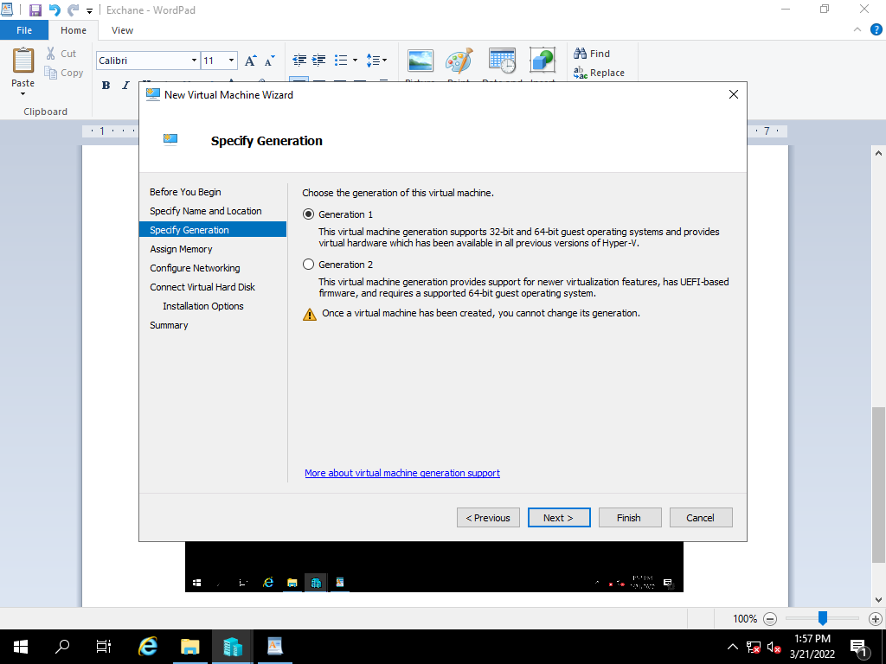

Assign the RAM Size Based on existing server, and click on Next

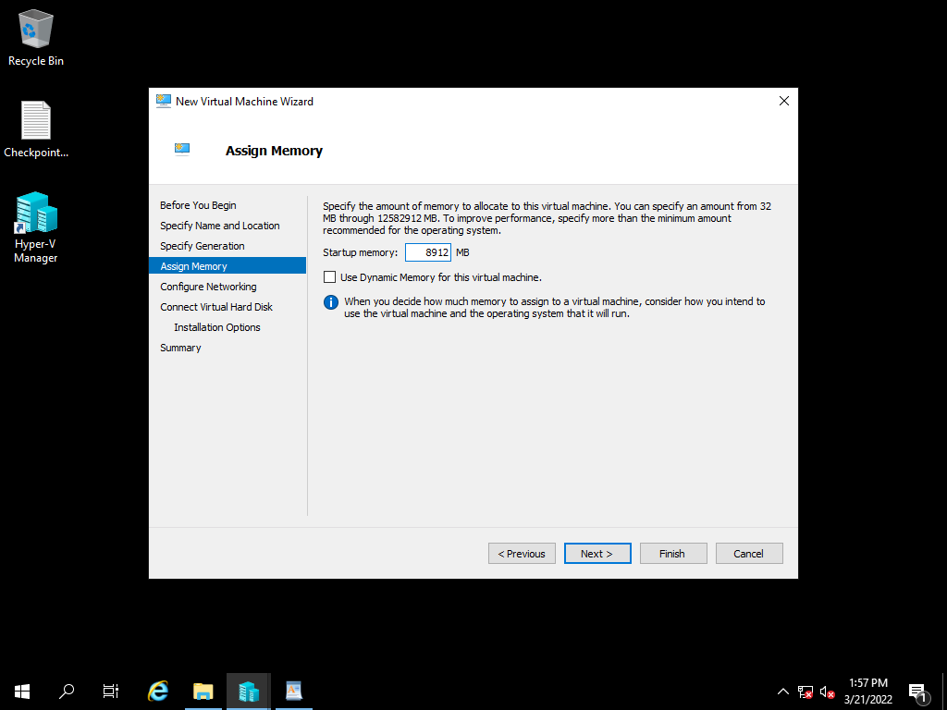

Select the network adopter based on VH Configuration and click on next.

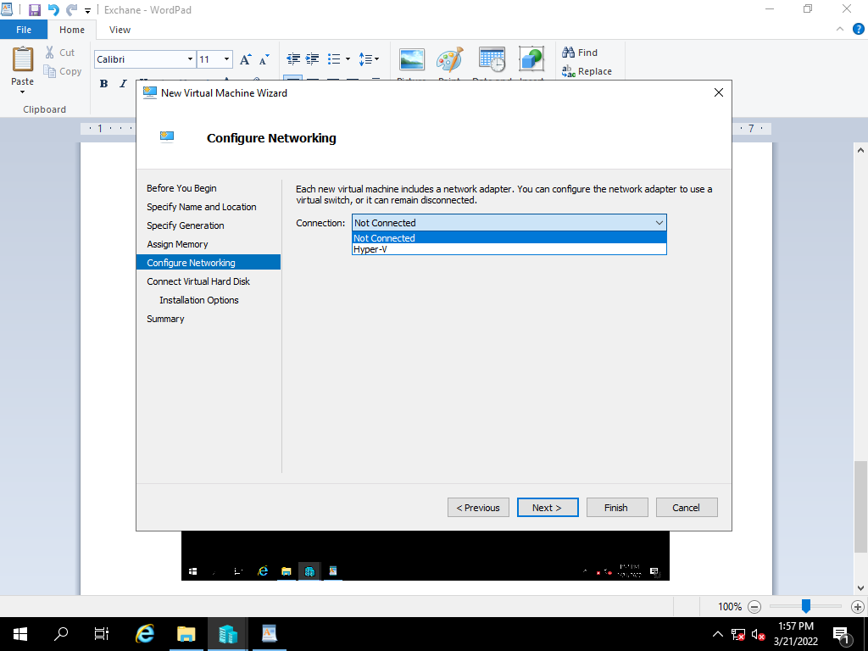

Select the use an existing virtual hard disk option and click on browse.

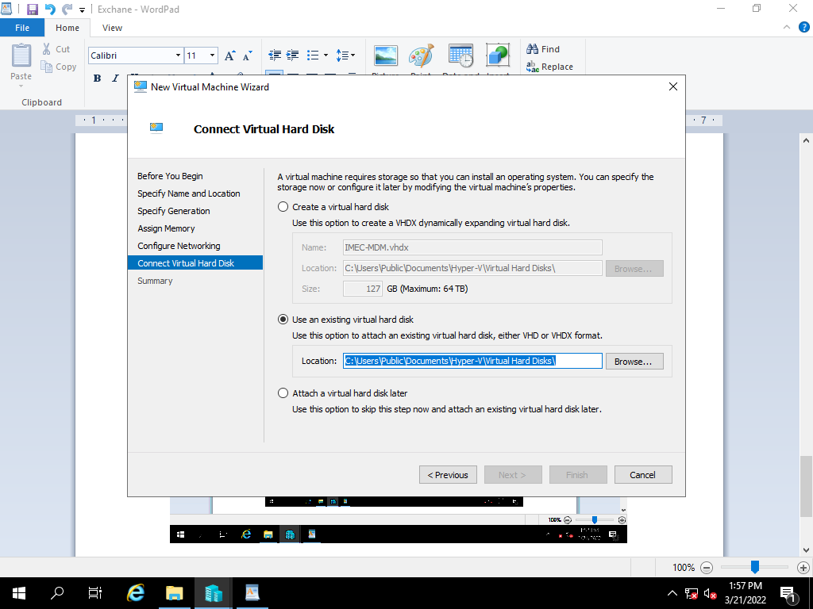

After selecting the file path, click on Next.

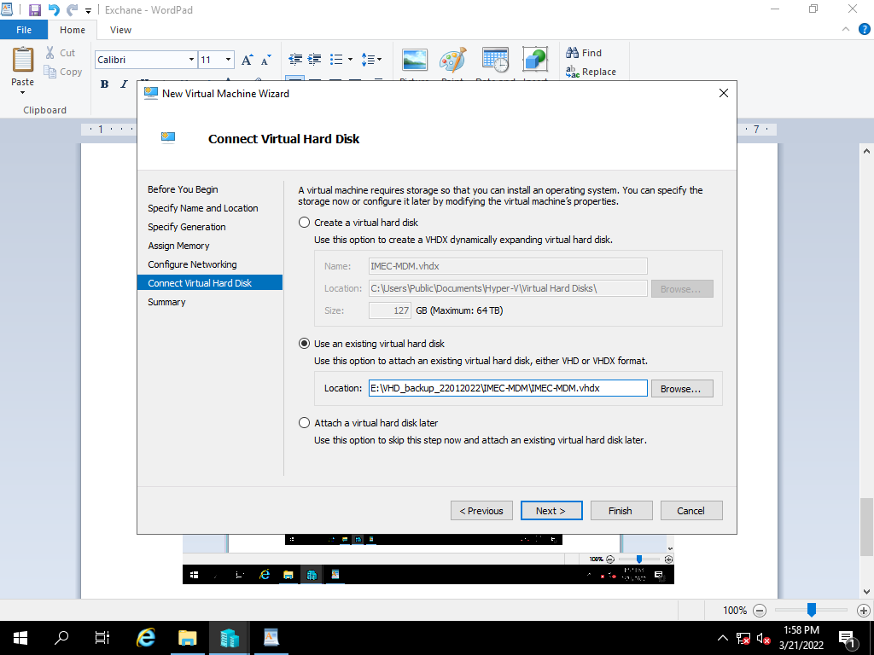

Review the summary and click finish to create a virtual machine.

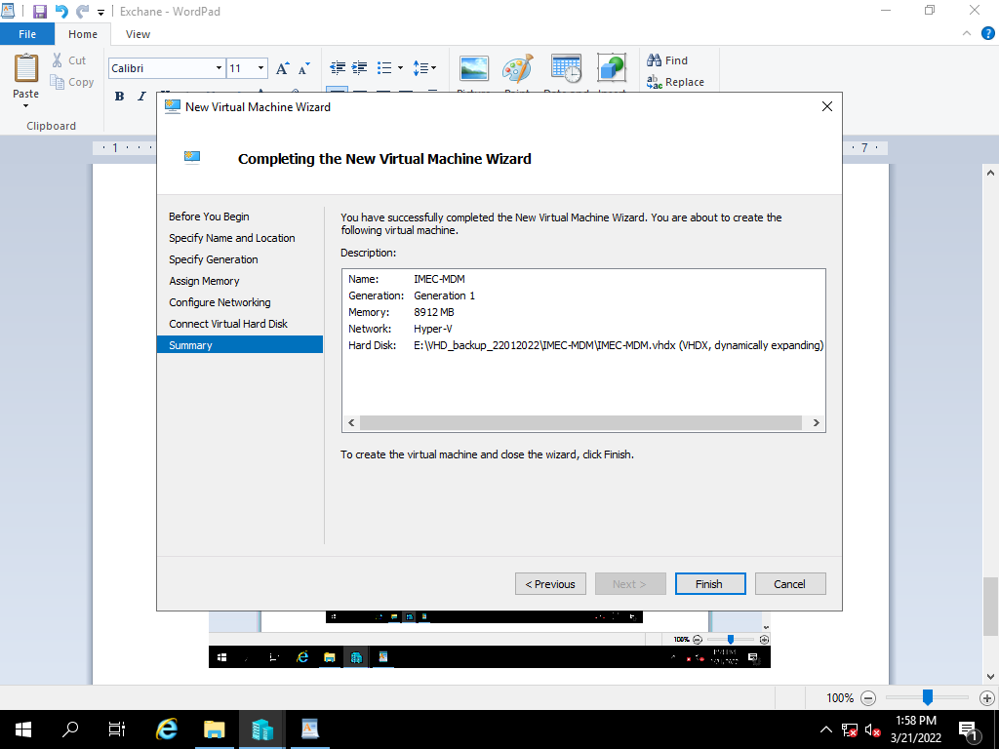

Power on the created Restore VM

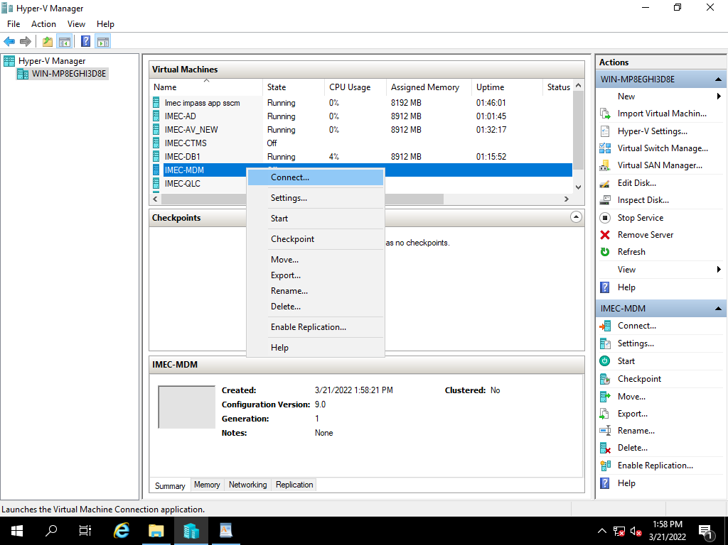

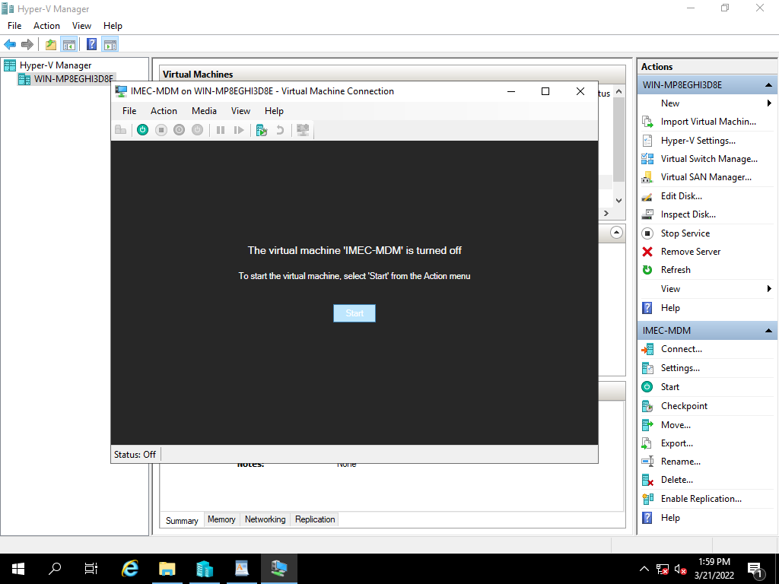

After successful restoration, Accessed AirWatch console.

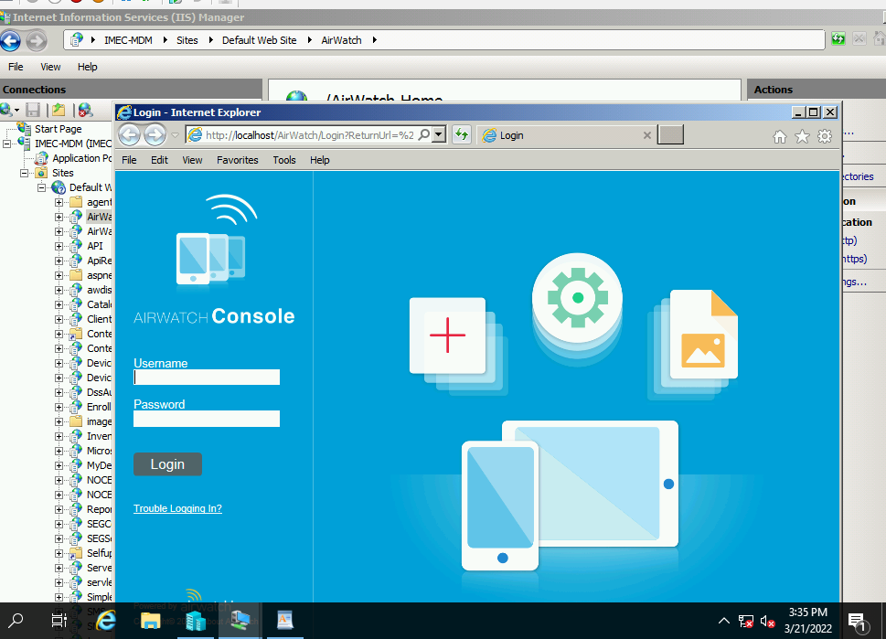

**14) Veritas File Server Backup Restoration process**

|  |  |  |  |  |  |  |  |
| --- | --- | --- | --- | --- | --- | --- | --- |
| Manual Backup Restoration | | | | | | | |
| SL. No | Host Name | Host | VM IP | Operating System | Hosted Application Details | Backup Type | Restoration Time |
| 12 | imec-fabs002-NO VM | Physical | 10.236.179.131 | Server 2008 | Factory File Server / Veritas | Manual | 1. mins |

In the console, select the server want to restore.

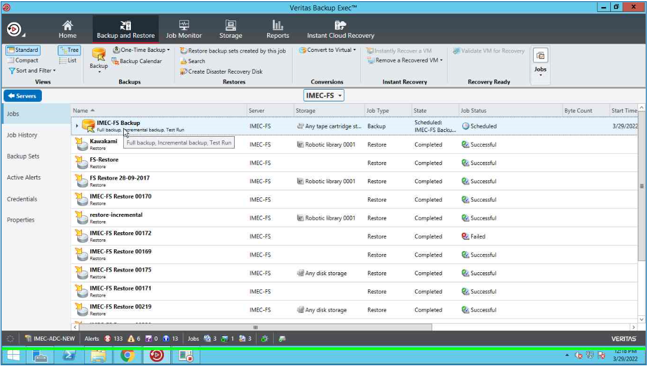

Right click on file server and select Restore option.

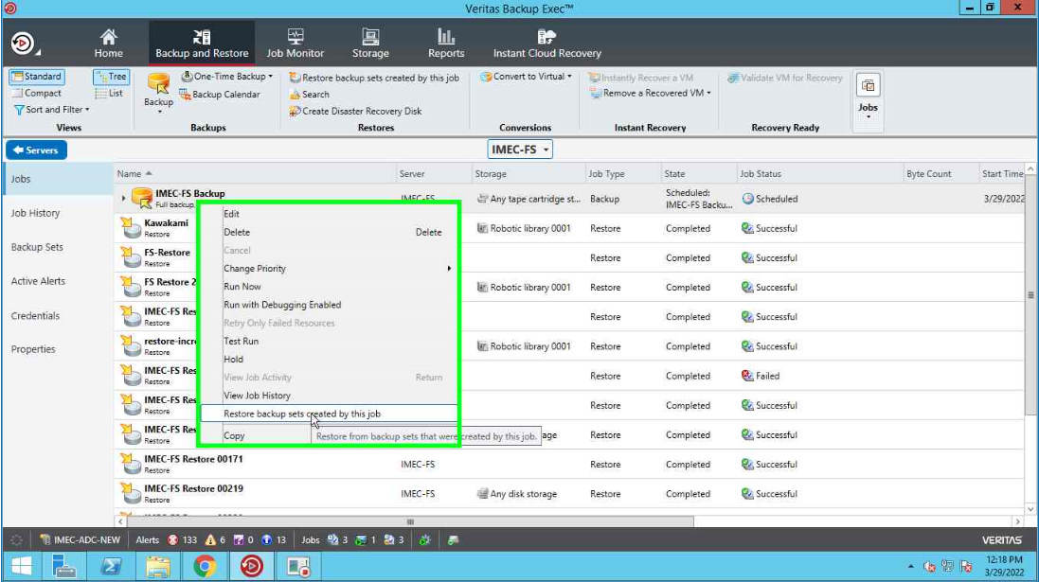

Select files, folders or volumes and click Next

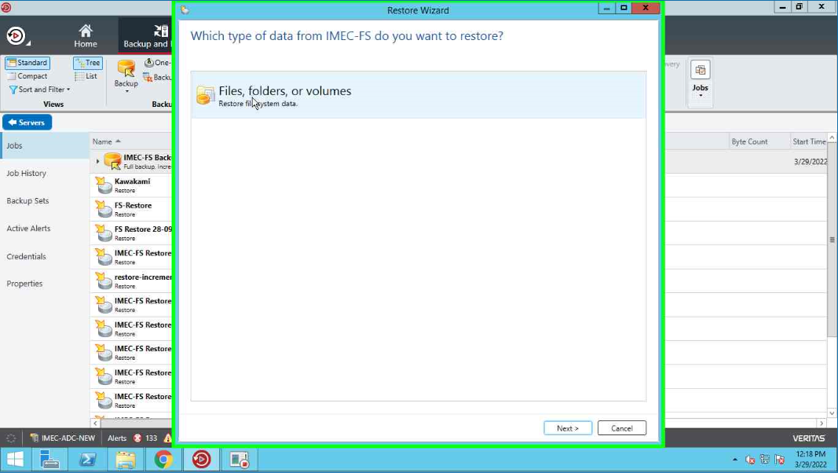

Select what do you want to restore and click Next.

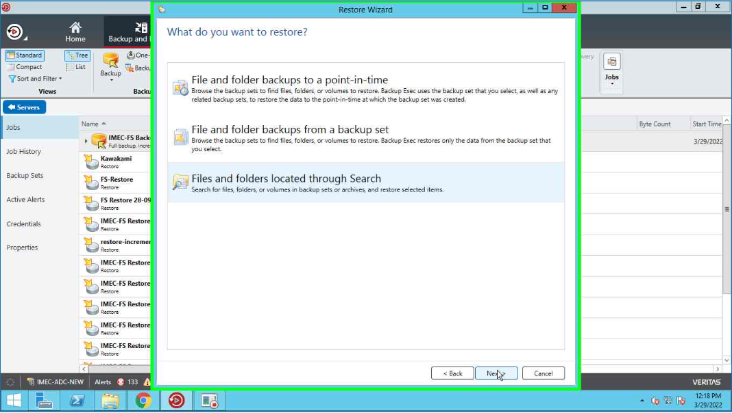

Select data and time of which files and folders we want restore and select next

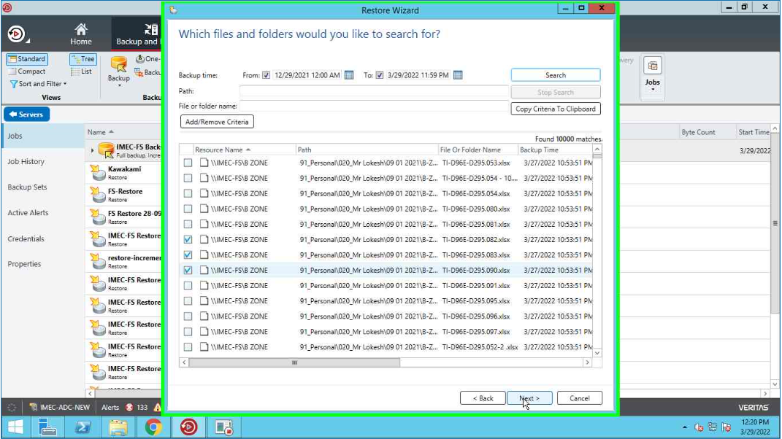

Select the destination server need to restore and browse the path to restore

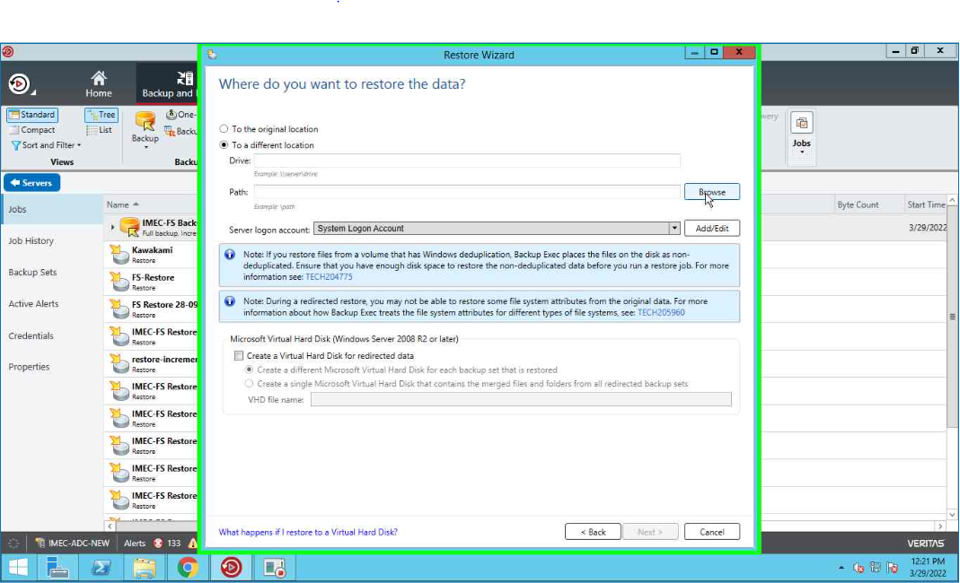

Select the path of restoration and click on OK

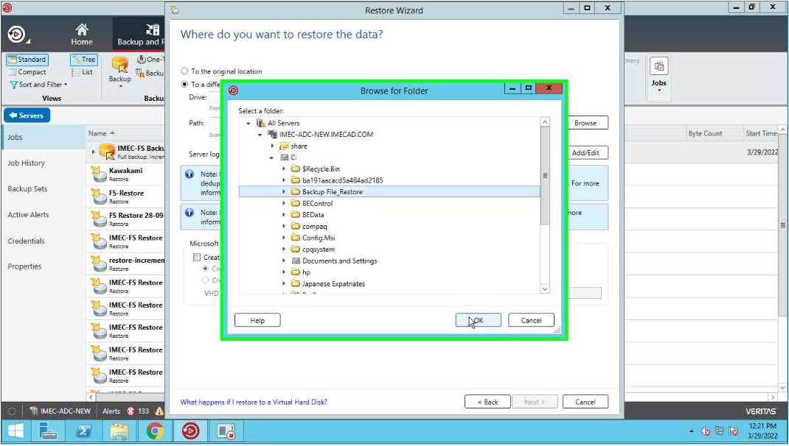

Browse the destination server path and click on Ok.

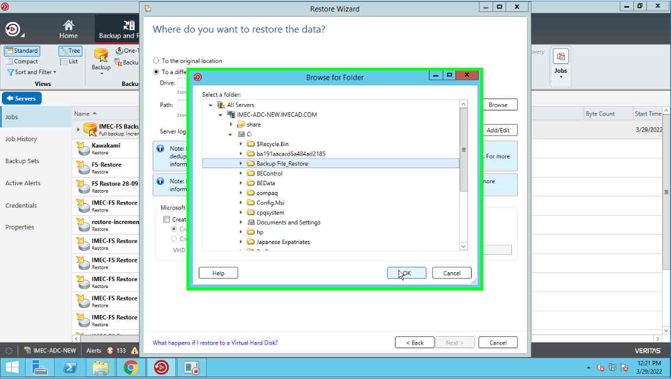

After select the destination server and path, click on Next

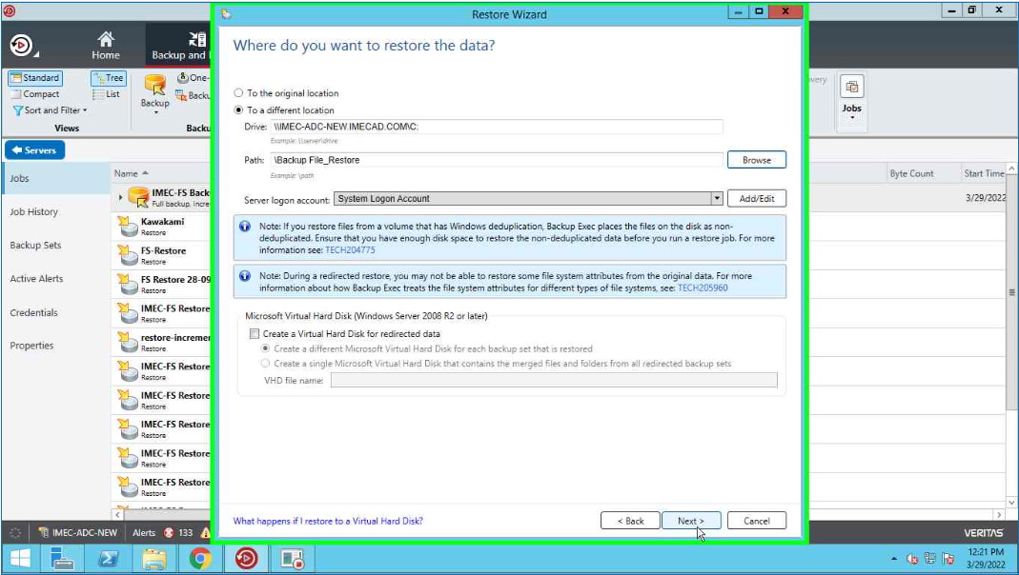

Select the necessary options and click on Next.

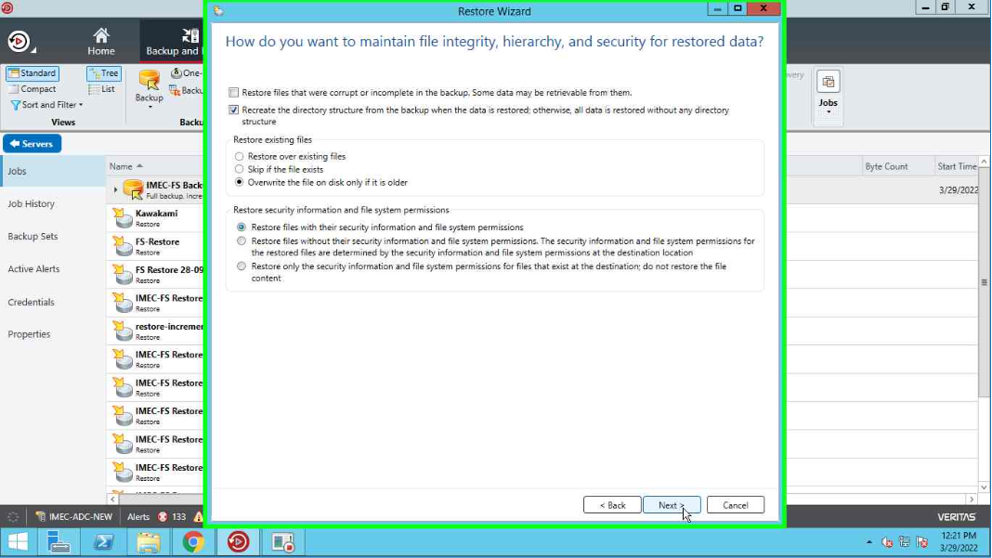

Click on Next.

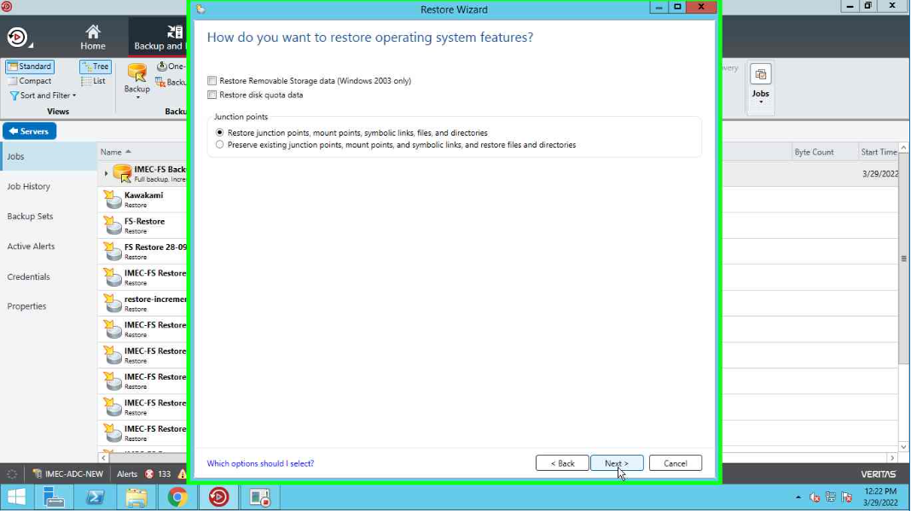

Select the user for notification after completion of restore job and click on Next

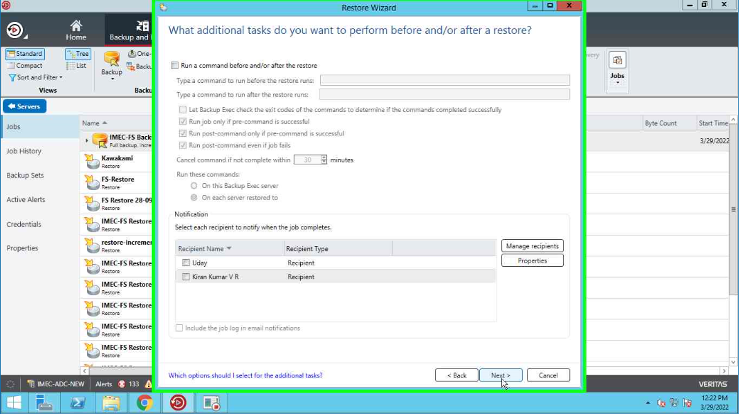

Select the schedule of the restore job and click on Next.

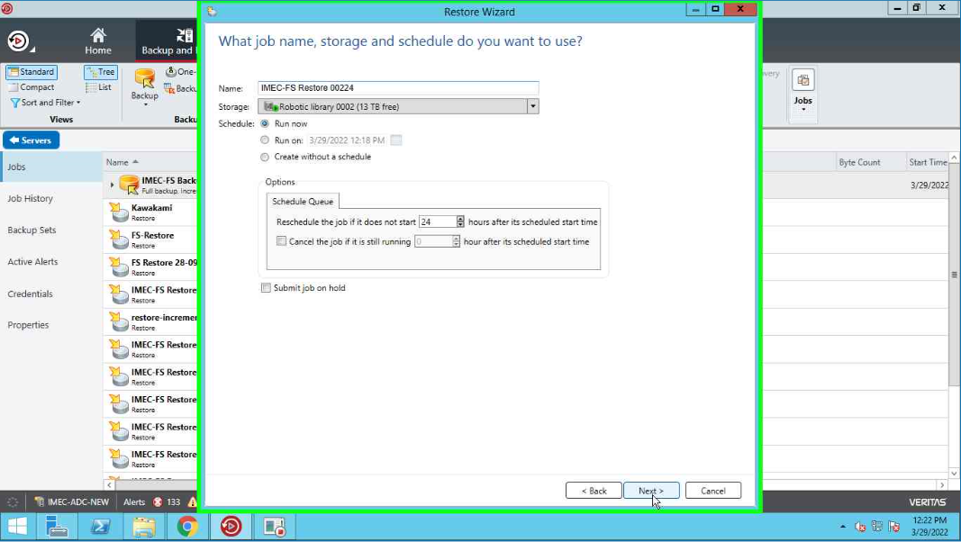

Review the restore job summary and click on finish to run the restore Job.

